Getting multiple parameters and u don’t know how many u may get
public void checkPrime(int... numbers) {
StringBuilder sb = new StringBuilder();
for (int n : numbers) {
if (isPrime(n)) {
sb.append(n).append(" ");
}
}
System.out.println(sb.toString()); }
Input reader:
BufferedReader br = new BufferedReader(new InputStreamReader(System.in));
String s = br.readLine();
int n = Integer.parseInt(s);
Multiple integers in one line
String[] parts = br.readLine().split(" ");
int a = Integer.parseInt(parts[0]);
int b = Integer.parseInt(parts[1]);
Sort Array
Arrays.sort(arr);
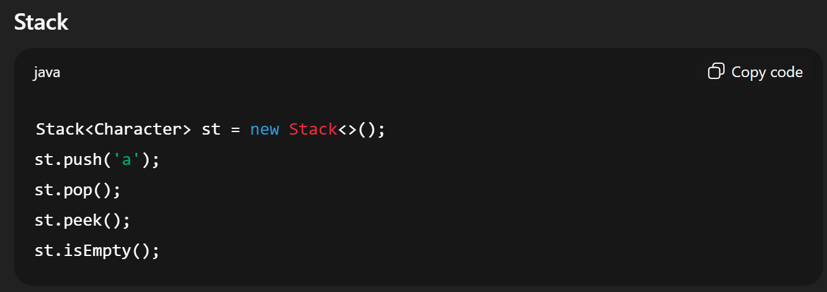
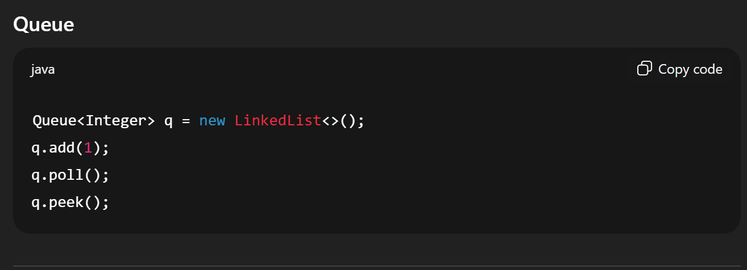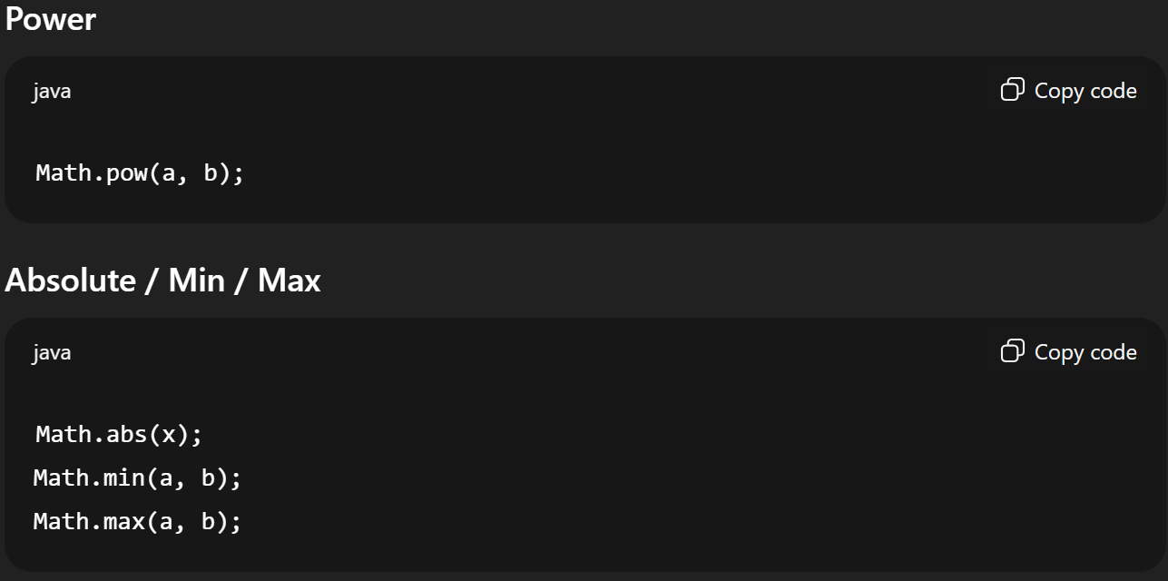
STACK
Stack<Integer> st = new Stack<>();
Stack<Character> stc = new Stack<>();
st.push(10);
int x = st.pop();
int top = st.peek();
st.isEmpty();
st.size();
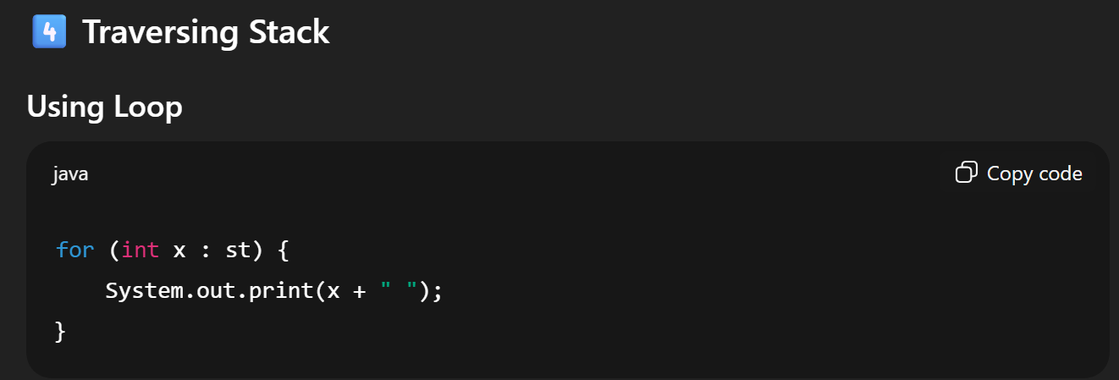
QUEUE
Queue<Integer> q = new LinkedList<>();
Queue<Character> qc = new LinkedList<>();
q.add(10); OR safer: q.offer(10);
int x = q.remove(); OR safer: int x = q.poll();
int front = q.peek();
q.isEmpty();
q.size();
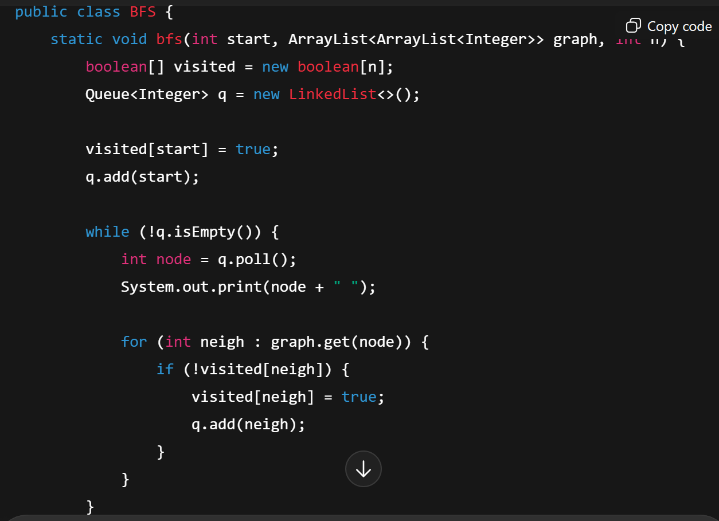
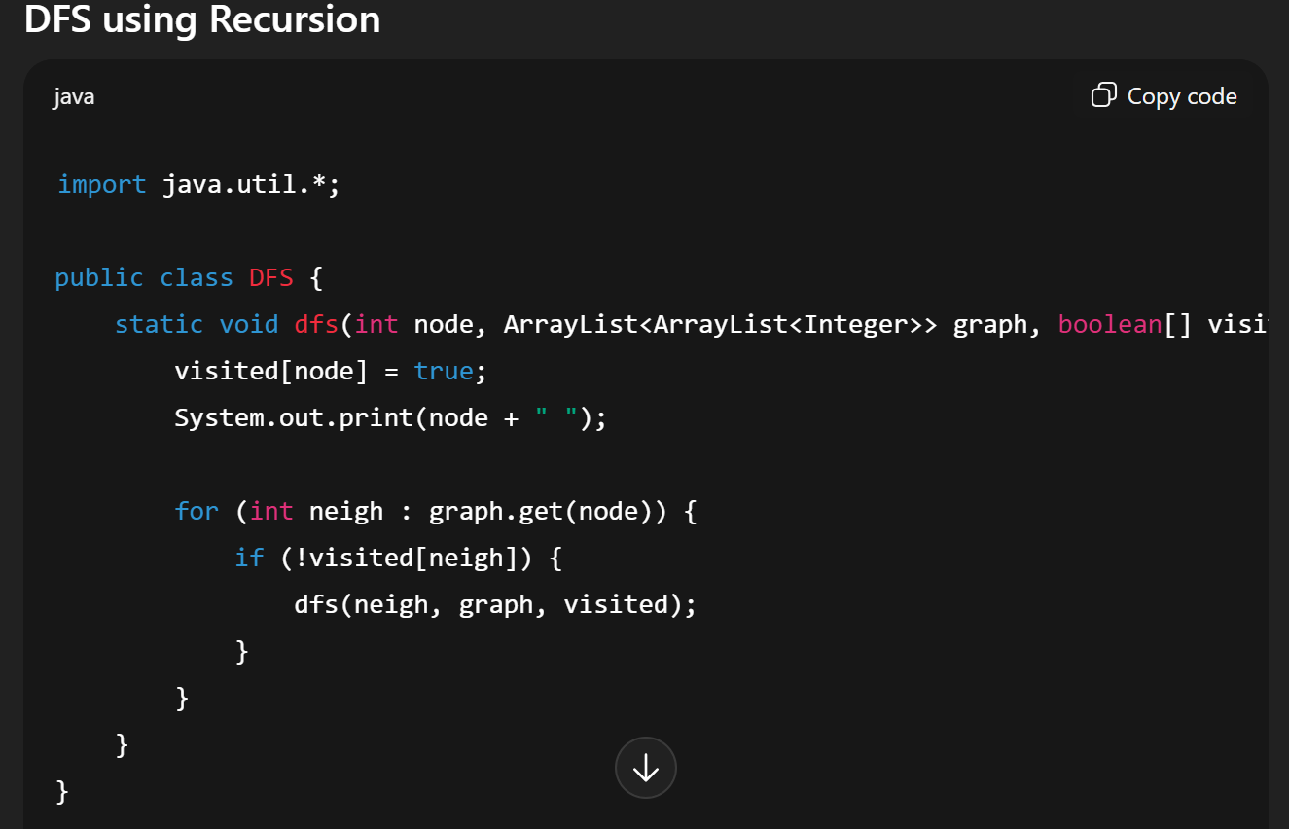
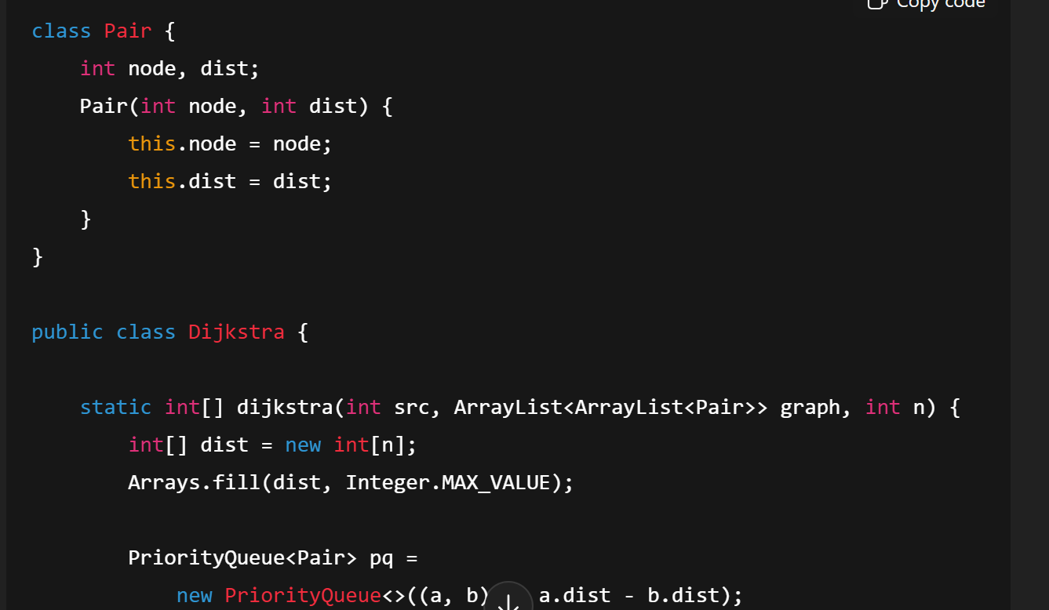
DFS on matrix
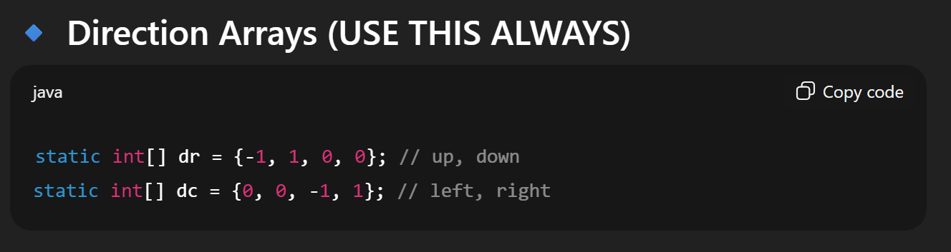
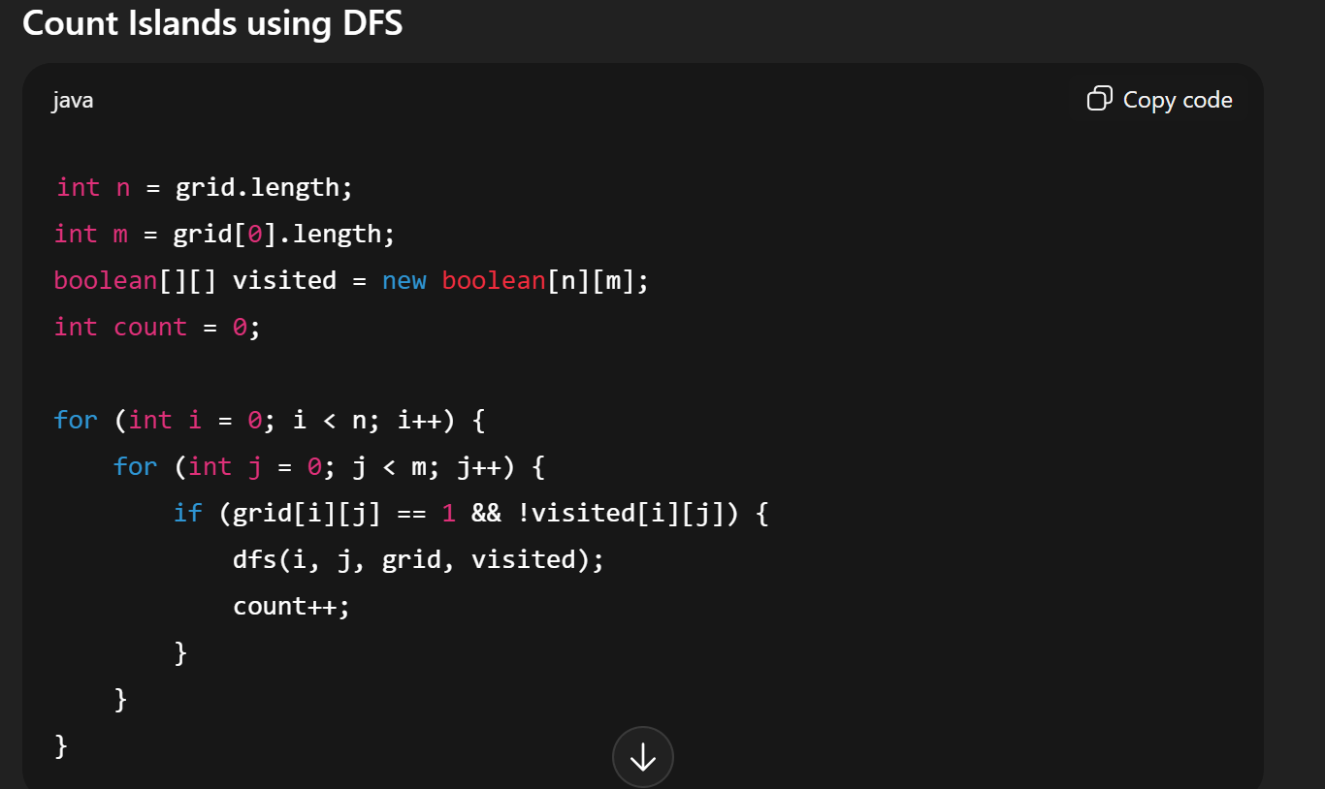
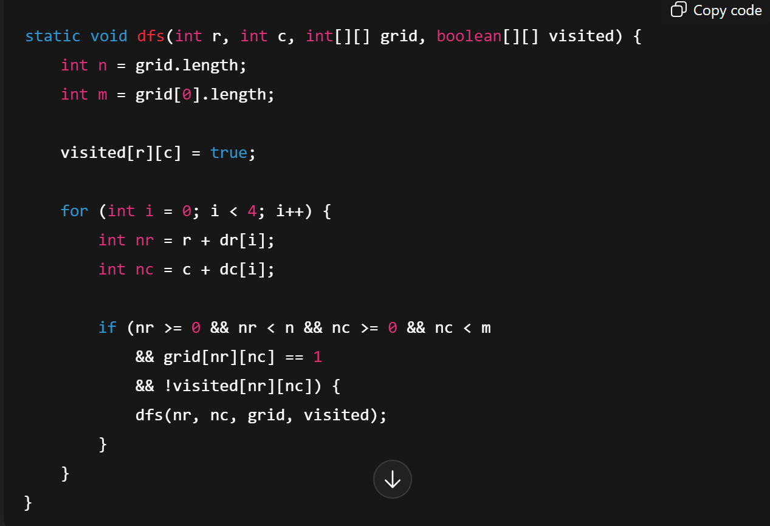
BFS on matrix
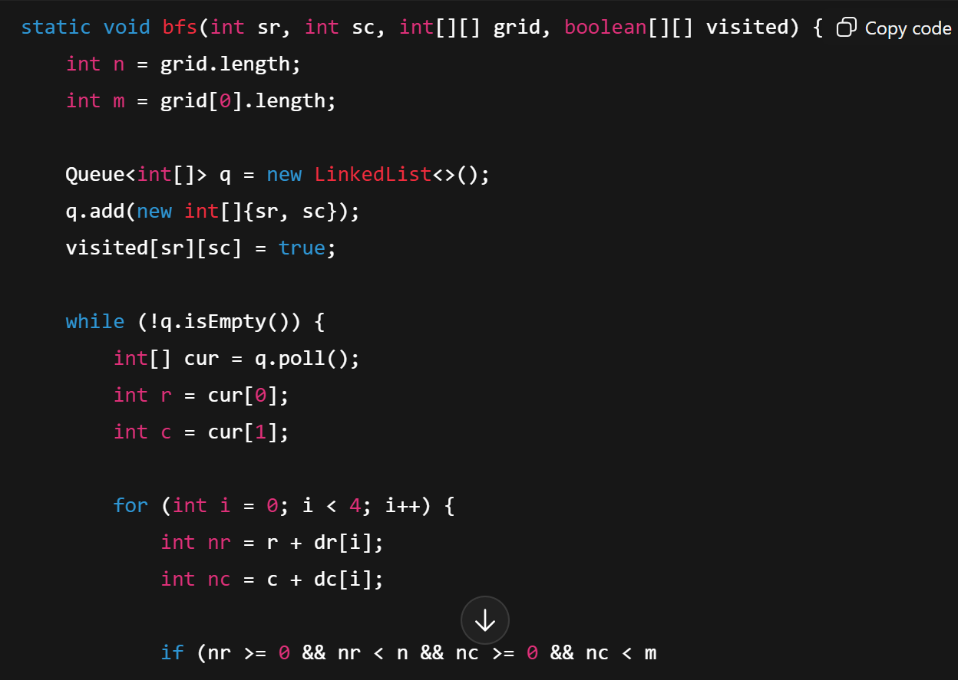
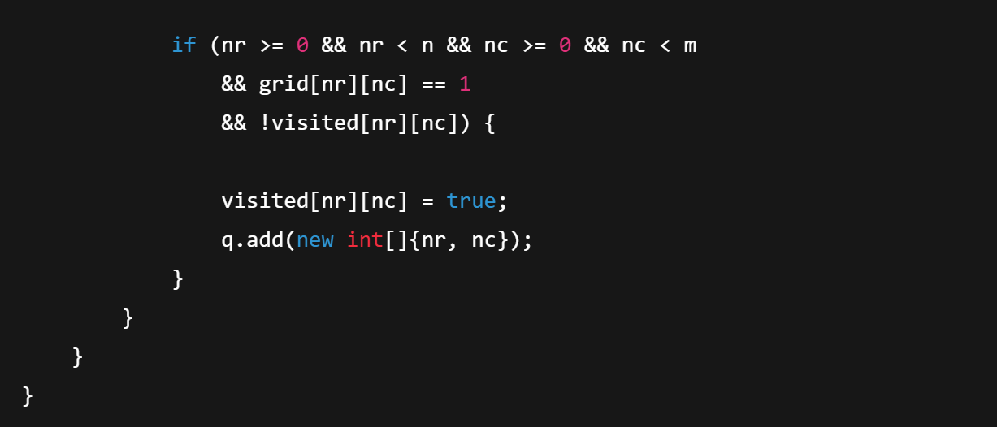
ArrayList
ArrayList is a resizable array implementation of the List interface.
ArrayList<String> fruits = new ArrayList<>();
fruits.add("Apple");
System.out.println(fruits);
fruits.add(1, "Pineapple"); // Insert at index 1
String firstFruit = fruits.get(0); // Get element at index 0
fruits.set(1, "Grapes"); // Replace element at index 1
fruits.remove("Mango"); // Remove by value
fruits.remove(0); // Remove by index
int size = fruits.size();
boolean isEmpty = fruits.isEmpty();
boolean hasApple = fruits.contains("Apple");
fruits.clear();

private List<Product> products; //making list of a class
public User(int userId) {
this.userId = userId;
this.products = new ArrayList<>();
}
public void addProduct(Product product) {
products.add(product);
}

LOOP FOR ARRAYLIST
for (String fruit : fruits) {
System.out.println(fruit);
}// or use simple for loop

ITERATOR FOR ARRAYLIST
import java.util.Iterator;
Iterator<String> it = list.iterator();
while (it.hasNext()) {
System.out.println(it.next());
}

VECTOR LIST
vector is also a resizable array (like ArrayList)
Vector<String> vector = new Vector<>();
vector.add("Apple");
Vector<Type> v = new Vector<>(20); // initial capacity = 20
/same functions as arraylist
LINKED LIST
LinkedList<String> list = new LinkedList<>();
for (String item : list) {
System.out.println(item);
}
Iterator<String> it = list.iterator();
while (it.hasNext()) {
System.out.println(it.next());
}

// 4. Descending Iterator
Iterator<String> dit = list.descendingIterator();
while (dit.hasNext()) {
System.out.println(dit.next());
}
HASHTABLE
Hashtable stores data as key–value pairs.
Hashtable<Integer, String> table = new Hashtable<>();
table.put(1, "Apple");
System.out.println(table);
Hashtable<K, V> table = new Hashtable<>(); // default capacity 11, load factor0.75
Hashtable<K, V> table = new Hashtable<>(20); // initial capacity 20
for (Map.Entry<Integer, String> entry : table.entrySet()) {
System.out.println(entry.getKey() + " -> " + entry.getValue());
}
// 3. For-each loop on keys
for (Integer key : table.keySet()) {
System.out.println(key + " -> " + table.get(key));
}
table.put(1, "Apple");
table.remove(1);

HASHMAP
HashMap stores data as key–value pairs
Allows one null key and multiple null values

QUIZ QUESTION
write code in java for creating a generic class vector to store data of any numeric type . vector can be initialized to a given capacity c but it can grow beyond c when more elements are added to it. provide an iterator to iterate the vector in the reverse order.

import java.util.Iterator;
class MyVector<T extends Number> implements Iterable<T> {
private Object[] data; // underlying array
private int size; // number of elements
public MyVector(int capacity) {
if (capacity <= 0) capacity = 10;
data = new Object[capacity];
size = 0;
}
// add element (grow if needed)
public void add(T value) {
if (size == data.length) {
grow();
}
data[size++] = value;
}

@SuppressWarnings("unchecked")
public T get(int index) {
if (index < 0 || index >= size) throw new IndexOutOfBoundsException();
return (T) data[index];
}
// grow array (like vector in C++)
private void grow() {
Object[] newData = new Object[data.length * 2];
for (int i = 0; i < data.length; i++) {
newData[i] = data[i];
}
data = newData;
}
// return reverse iterator
@Override
public Iterator<T> iterator() {
return new ReverseIterator();
}
private class ReverseIterator implements Iterator<T> {
private int current = size - 1;

@Override
public boolean hasNext() {
return current >= 0;
}

@SuppressWarnings("unchecked")
@Override
public T next() {
if (!hasNext()) throw new NoSuchElementException();
return (T) data[current--];
}
}
}
Java String Methods (Built-in Functions)
Method | Description | Example
length() | Returns length of string | "Hello".length(); // 5
isEmpty() | Checks if string is empty | "".isEmpty(); // true
isBlank() (Java 11+) | Checks if string is empty or only whitespace | " ".isBlank(); // true

Method | Description | Example
charAt(int index) | Get character at index | "Java".charAt(2); // 'v'

equals(Object another) | Compare strings (case-sensitive) | "Hi".equals("hi"); // false
equalsIgnoreCase(String another) | Case-insensitive comparison | "Hi".equalsIgnoreCase("hi"); // true
compareTo(String another) | Lexicographic compare | "a".compareTo("b"); // -1
compareToIgnoreCase(String another) | Ignore case compare | "A".compareToIgnoreCase("a"); // 0
regionMatches(...) | Compare substring regions | "Hello".regionMatches(0, "Heaven", 0, 2); // true

Method | Description | Example
contains(CharSequence seq) | Check if substring exists | "Hello".contains("el"); // true
startsWith(String prefix) | Check prefix | "Java".startsWith("Ja"); // true
startsWith(String prefix, int offset) | Check prefix from offset | "Java".startsWith("va", 2); // true
endsWith(String suffix) | Check suffix | "Hello".endsWith("lo"); // true
indexOf(int ch) | First index of character | "Hello".indexOf('l'); // 2
indexOf(String str) | First index of substring | "Hello".indexOf("lo"); // 3
indexOf(int ch, int fromIndex) | From position | "Hello".indexOf('l', 3); // 3
lastIndexOf(int ch) | Last index of character | "Hello".lastIndexOf('l'); // 3
lastIndexOf(String str) | Last index of substring | "Hello".lastIndexOf("l"); // 3
lastIndexOf(int ch, int fromIndex) | Backward search | "Hello".lastIndexOf('l', 2); // 2

Method | Description | Example
substring(int begin) | Substring from index | "Hello".substring(2); // "llo"
substring(int begin, int end) | Substring range | "Hello".substring(1, 4); // "ell"

Method | Description | Example
toUpperCase() | Convert to uppercase | "java".toUpperCase(); // "JAVA"
toLowerCase() | Convert to lowercase | "JAVA".toLowerCase(); // "java"

Method | Description | Example
trim() | Remove leading/trailing spaces | " hi ".trim(); // "hi"
stripLeading() (Java 11+) | Remove leading spaces | " hi".stripLeading(); // "hi"
stripTrailing() (Java 11+) | Remove trailing spaces | "hi ".stripTrailing(); // "hi"

Method | Description | Example
replace(char old, char new) | Replace character | "java".replace('a','o'); // "jovo"
replace(CharSequence old, CharSequence new) | Replace substring | "car race".replace("car","bike"); // "bike race"
replaceFirst(String regex, String replacement) | Replace first match | "aabb".replaceFirst("a","z"); // "zabb"
replaceAll(String regex, String replacement) | Replace all matches | "aabb".replaceAll("a","z"); // "zzbb"

Method | Description | Example
split(String regex) | Split string into array | "a,b,c".split(","); // ["a","b","c"]
split(String regex, int limit) | Limit splits | "a,b,c".split(",",2); // ["a","b,c"]
join(CharSequence delimiter, ...) | Join with delimiter | String.join("-", "a","b","c"); // "a-b-c"

Method | Description | Example
toCharArray() | Convert to char array | "Java".toCharArray(); // ['J','a','v','a']
getBytes() | Convert to byte array | "ABC".getBytes();
valueOf(...) (static) | Convert other type to string | String.valueOf(123); // "123"
format(String format, Object... args) | Formatted string | String.format("Hi %s", "John"); // "Hi John"

Method | Description | Example
matches(String regex) | Check regex match | "123".matches("\\d+"); // true
contentEquals(CharSequence cs) | Compare with another sequence | "Hello".contentEquals("Hello"); // true

Method | Description | Example
concat(String str) | Concatenate strings | "Hi".concat(" there"); // "Hi there"
repeat(int count) (Java 11+) | Repeat string | "ha".repeat(3); // "hahaha"

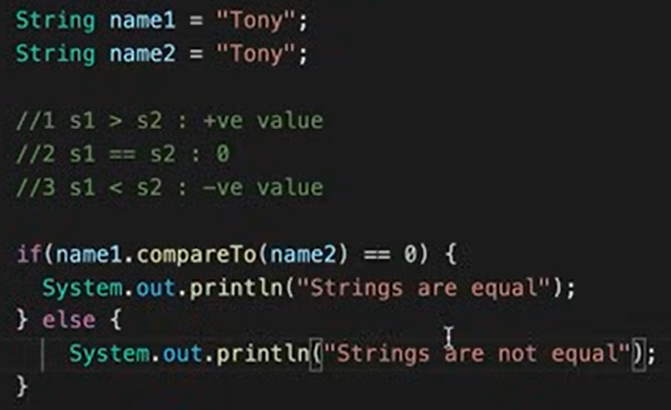
// making “hello world” into “hello worrrld”
public class Main {
public static void main(String[] args) {
String str = "hello world";

// break into two parts
String part1 = str.substring(0, 8); // "hello wo"
String part2 = str.substring(8); // "rld"

// add extra "rr
String result = part1 + "rr" + part2;
System.out.println(result); // hello worrrld
}
}
OR
public class Main {
public static void main(String[] args) {
sb = new StringBuilder("hello world");
sb.insert(8, "rr"); // insert "rr" at index 8
System.out.println(sb.toString()); // hello worrrld
}
}

String builder functions
Method |  | Description | Example
length() |  | Number of characters | sb.length();
capacity() |  | Current storage capacity | sb.capacity();
ensureCapacity(int min) |  | Ensures at least min capacity | sb.ensureCapacity(100);
trimToSize() |  | Reduces capacity to current length | sb.trimToSize();
setLength(int newLength) | Changes length (truncate or pad with \u0000) |  | sb.setLength(3);

Method | Description | Example
append(String s) | Add string at end | sb.append(" World");
append(char c) | Add character | sb.append('!');
append(int i) | Add integer as string | sb.append(123);
append(Object o) | Add object (calls toString()) | sb.append(someObj);

insert(int offset, String s) | Insert string at position | sb.insert(5, " Java");
insert(int offset, char c) | Insert char | sb.insert(0, 'H');
insert(int offset, int i) | Insert number | sb.insert(2, 100);

delete(int start, int end) | Remove substring (start inclusive, end exclusive) | sb.delete(5, 8);
deleteCharAt(int index) | Remove one character | sb.deleteCharAt(2);

reverse() |  | Reverse string |  | "Hello" → "olleH"
Method |  | Description |  | Example
replace(int start, int end, String str) |  | Replace substring |  | sb.replace(6, 11, "Java");
charAt(int index) | Get character |  | sb.charAt(0);
setCharAt(int index, char c) | Change character |  | sb.setCharAt(1, 'a');
substring(int start) | Extract substring |  | sb.substring(6);
substring(int start, int end) | Extract substring range |  | sb.substring(0, 5);

indexOf(String str) | First occurrence | sb.indexOf("Java");
indexOf(String str, int fromIndex) | First occurrence from index | sb.indexOf("o", 5);
lastIndexOf(String str) | Last occurrence | sb.lastIndexOf("o");
lastIndexOf(String str, int fromIndex) | Last occurrence before index | sb.lastIndexOf("o", 3);

Taking input from user
- Using Scanner class (most common way for beginners)
Scanner sc = new Scanner(System.in); // Create Scanner object

// Different input methods:
int num = sc.nextInt(); // integer
double d = sc.nextDouble(); // double
float f = sc.nextFloat(); // float
long l = sc.nextLong(); // long
short s = sc.nextShort(); // short
byte b = sc.nextByte(); // byte
boolean bool = sc.nextBoolean(); // boolean
String word = sc.next(); // single word
String line = sc.nextLine(); // whole line (until Enter)

sc.close(); // always close scanner
- Using BufferedReader (faster for competitive programming)
BufferedReader br = new BufferedReader(new InputStreamReader(System.in));

String str = br.readLine(); // Read a line
int num = Integer.parseInt(br.readLine()); // Read integer
double d = Double.parseDouble(br.readLine()); // Read double
}
File reading
- Using scanner
File file = new File("input.txt"); // File object
Scanner sc = new Scanner(file); // Scanner reads file

while (sc.hasNextLine()) {
String line = sc.nextLine(); // Read line by line
System.out.println(line);
}

sc.close();
- Buffer
BufferedReader br = new BufferedReader(new FileReader("input.txt"));

String line;
while ((line = br.readLine()) != null) {
System.out.println(line);
}

br.close();

file writing
FileWriter fw = new FileWriter("output.txt"); // overwrite mode
fw.write("Hello World!\n");
fw.write("Writing another line.");
fw.close();
FileWriter fw = new FileWriter("output.txt", true); // append mode
OR
BufferedWriter bw = new BufferedWriter(new FileWriter("output.txt"));
bw.write("Hello from BufferedWriter!");
bw.newLine(); // adds a new line
bw.write("Second line here.");
bw.close();

// content in file is something like “1,title,starttime,endtime” //assignment se dekh lo
DateTimeFormatter formatter = DateTimeFormatter.ofPattern("yyyyMMdd+HHmm");
while ((line = br.readLine()) != null) {
String[] parts = line.split(",");
int id = Integer.parseInt(parts[0].trim()); //trim removes extra white spaces
String title = parts[1].trim();
LocalDateTime start = LocalDateTime.parse(parts[2].trim(), formatter);
LocalDateTime end = LocalDateTime.parse(parts[3].trim(), formatter);
// you can run a loop from 0 to parts.length

2d arrays
Rectangular :
// Declaration
int[][] arr;
// Declaration + Initialization with size
int[][] arr = new int[3][4]; // 3 rows, 4 columns

// Declaration + Initialization with values
int[][] arr = {
{1, 2, 3},
{4, 5, 6},
{7, 8, 9}
};
for (int i = 0; i < arr.length; i++) { // rows
for (int j = 0; j < arr[i].length; j++) { // columns
System.out.print(arr[i][j] + " ");
}
System.out.println();
}
Jagged array
int[][] arr = new int[3][]; // 3 rows, but columns undefined
arr[0] = new int[2]; // row 0 has 2 columns
arr[1] = new int[4]; // row 1 has 4 columns
arr[2] = new int[3]; // row 2 has 3 columns
for (int i = 0; i < arr.length; i++) { // rows
for (int j = 0; j < arr[i].length; j++) { // columns
System.out.print(arr[i][j] + " ");
}
System.out.println();
}

DATE AND TIME FUNCTIONS
LocalDate date = LocalDate.now(); // Current date (YYYY-MM-DD)
LocalTime time = LocalTime.now(); // Current time (HH:mm:ss.nnn)
LocalDateTime dateTime = LocalDateTime.now(); // Date + time
LocalDate d1 = LocalDate.of(2025, 9, 13); // YYYY, MM, DD
LocalTime t1 = LocalTime.of(10, 30, 45); // HH, MM, SS
LocalDateTime dt = LocalDateTime.of(2025, 9, 13, 10, 30);
int year = date.getYear();
Month month = date.getMonth(); // Enum: SEPTEMBER
int monthVal = date.getMonthValue(); // 9
int day = date.getDayOfMonth(); // 13
DayOfWeek dow = date.getDayOfWeek(); // SATURDAY
int hour = time.getHour();
int minute = time.getMinute();
int second = time.getSecond();
LocalDate tomorrow = date.plusDays(1);
LocalDate lastWeek = date.minusWeeks(1);
LocalDate nextMonth = date.plusMonths(1);

LocalTime plusTwoHours = time.plusHours(2);
LocalDateTime nextYear = dateTime.plusYears(1);
Period p = Period.between(d1, d2); // Period (Y-M-D) // dates me difference
Duration dur = Duration.between(t1, t2); // Duration (time difference)
Collections.sort(arraylist1);
Collections.sort(users, (u1, u2) -> Integer.compare(u2.getUserId(), u1.getUserId()));
User class have a user id and we want to sort in descending order
Rule of compare (a, b ) is that:
- Its negative if a<b
-zero if a==b
-positive if a>b
ITERATOR
ArrayList<String> list = new ArrayList<>();
list.add("Apple");
Iterator<String> it = list.iterator();
// Traverse
while (it.hasNext()) {
String fruit = it.next();
System.out.println(fruit);
}
it.remove(); //REMOVES LAST ELEMENT
it.forEachRemaining(System.out::println); //Performs action on all remaining elements
displaying all occurences of str2 in str1 and displaying their index
int index = str1.indexOf(str2);
while (index != -1) {
frequency++;
indexes.add(index);
index = str1.indexOf(str2, index + 1); } // Displaying results JOptionPane.showMessageDialog(null, "Frequency = " + frequency + "\nIndexes = " + indexes); }
exceptions
Common Checked Exceptions:
- IOException → Errors in Input/Output operations. (important one)
  - FileNotFoundException
  - EOFException
- SQLException → Database errors.
- ClassNotFoundException → When class not found at runtime.
- InterruptedException → Thread interrupted.
- ParseException → Error while parsing text/dates.
- InstantiationException → Trying to create object of abstract class/interface.
- NoSuchMethodException → Method not found with reflection.
- Exception -> handles everything

🔹 2. Unchecked Exceptions (Runtime Exceptions)
- Subclasses of RuntimeException.
Common Runtime Exceptions:
- NullPointerException → Accessing object reference that is null.
- ArrayIndexOutOfBoundsException → Accessing invalid array index.
- ArithmeticException → Division by zero, etc.
- ClassCastException → Invalid type casting.
- IllegalArgumentException → Wrong arguments passed.
  - NumberFormatException → Invalid string to number conversion.
- IllegalStateException → Object state not valid for operation.
- UnsupportedOperationException → Unsupported collection operation.
- StringIndexOutOfBoundsException → Invalid string index.

Try {}
Catch(Exception e){
System.out.println(e.getMessage())
}
Finally{} //it always run no matter the situation
Finally written to write clean up code or close files etc
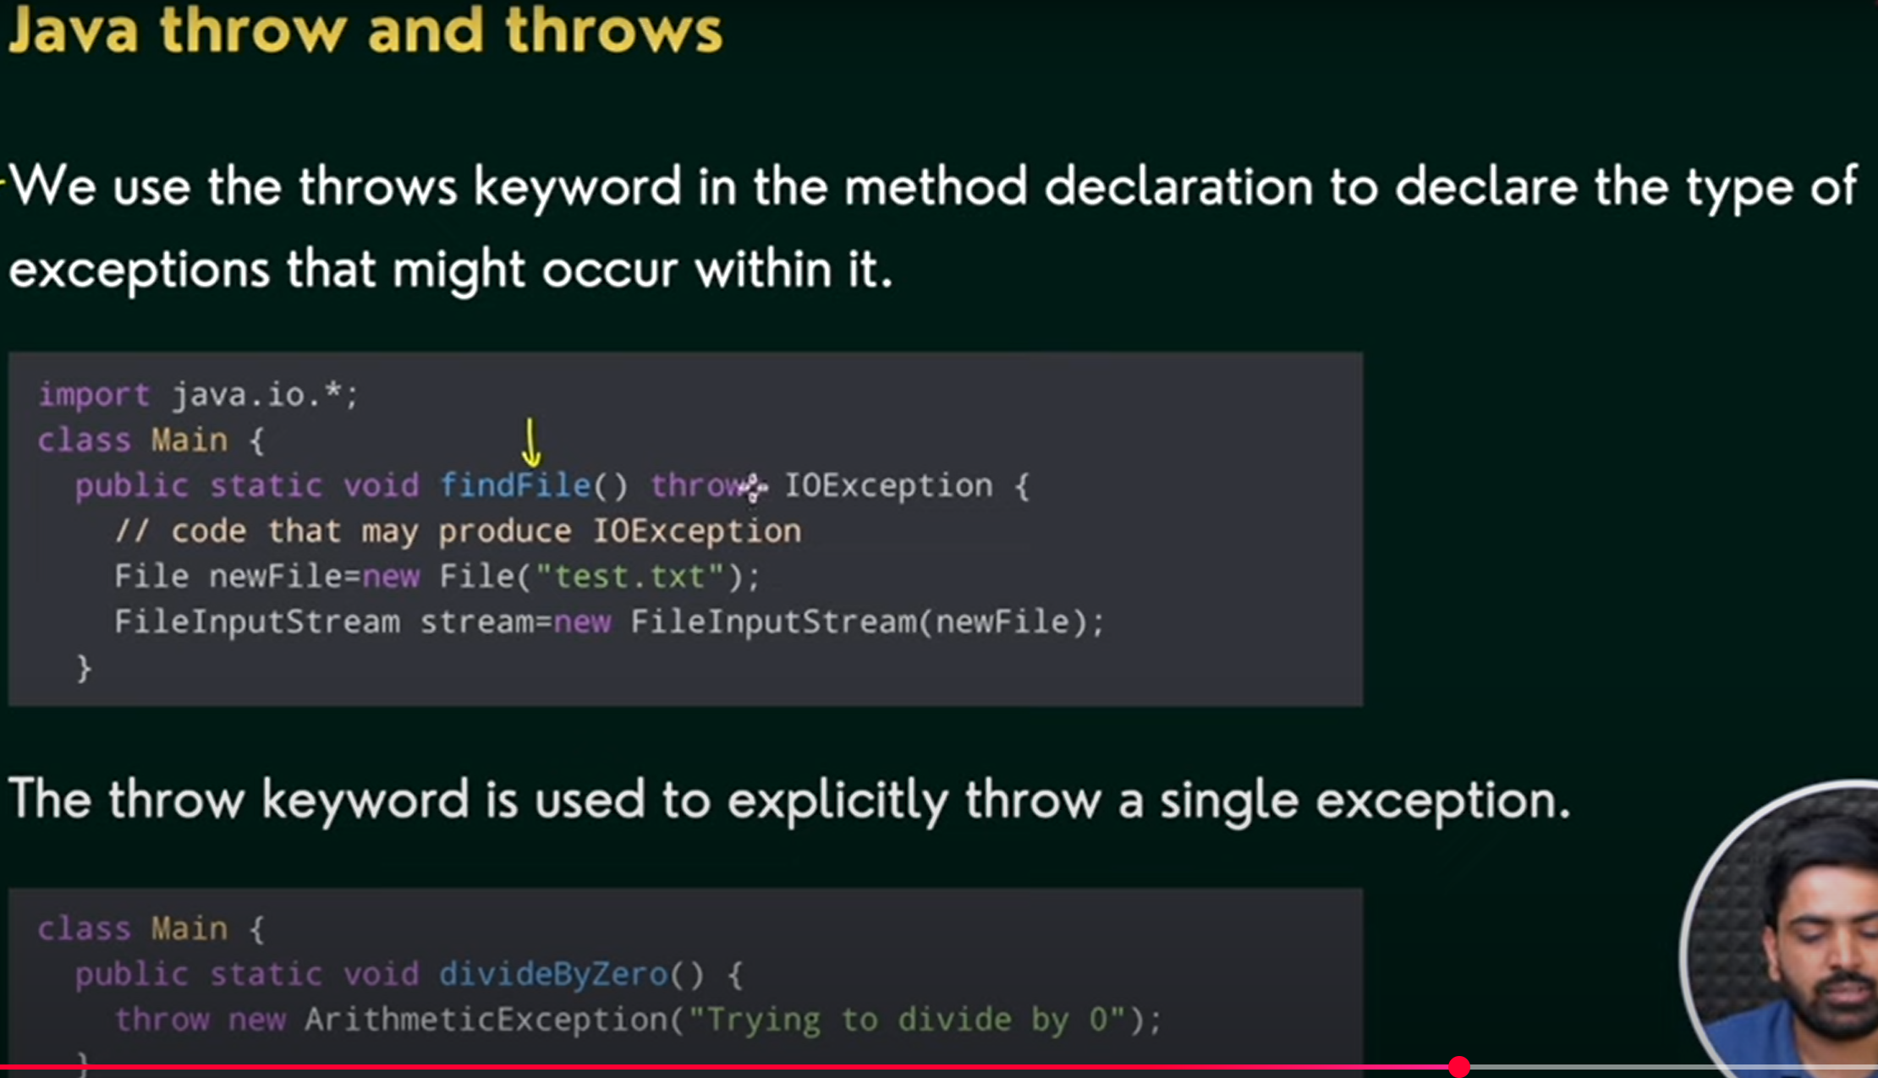
Throws tell that this func might throw exception so apne level par jab call kar rahe ho is func ko to us particular exception ka try catch lagao
Best practice issue in custom exception constructor
- Printing System.out.println("User defined exception"); inside the user defined exception class’s constructor is not good practice.
- Exception classes should only store information, not print/log it. Logging should be done where the exception is caught.

Git
Version Control:
● Identify and store artifacts in secure repository
● Manage artifacts versions
● Keep track of changes made to artifacts to facilitate audits
● Support concurrent changes to artifacts while ensuring consistency
● Ensure reproducibility of builds

Git init bare -- myApp // it creates a repository with name myapp
Git clone myApp c1 //c1 is name of our clone

//to push project in empty repo
Git init
git remote add origin https://github.com/aykaimran/scd-assignment1.git
add , commit , push
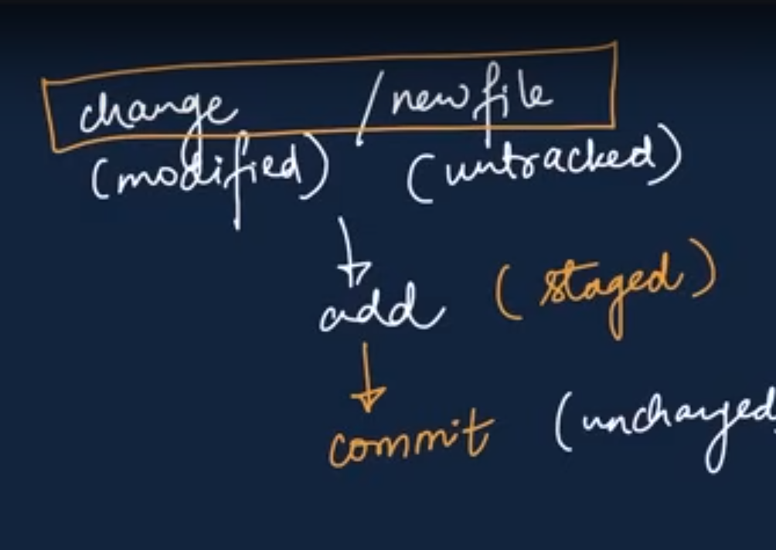
Sirf add and commit karne se github par changes nahi nazar ayegi. U have to write
Git push origin main / git push origin master or any branch
This will upload your laptop’s code on github. The “origin” here is name of our copy we made. It can be anything
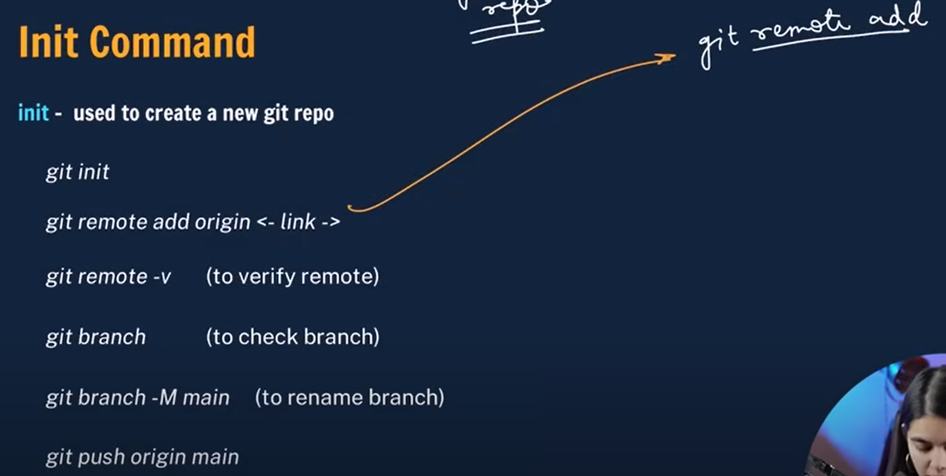

Merging and branching
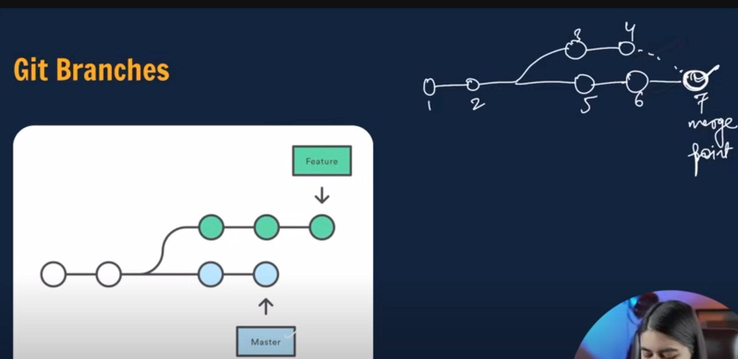

Git checkout <branchname> //aik branch se doosri me jana
Git checkout -b <branchname> //create new branch
Git branch -d <branchname> //delete branch

Agar feature 1 branch me change kuya hai or aap checkout kar ke feature 2 me chale jate to feature 2 me vo change nazar nahi ayega. Main me bhi ya koi or branch me vo nazwr nahi ayega

To merge you have two ways
- Git diff <branchname> //compare commits, branches, files and more
Git merge main
- Second way is to do it on github
Issue of this second way is keh changes aap ki github me jo hoi vo aap ke laptop par update nahi hoi. For that use
Git pull origin main

Undoing changes on git
Case 1: staged changes (abhi add kiya tha commit nahi)
Git reset / git reset filename
Case 2: commited changes (add+ commit kar diya)
Git reset head ~1 // aik commit peeche chale jate hai on the branch we are on
Case 3: multiple commits peeche jana
Jab git log karoge to har commit ka aik hash number ho ga us ko use karege to go peeche. Eg from 4th commit to 1st commit jana to 1st ka hash code use karege and write
Git reset <hash code> //git se changes hat gai but vscode me se changes nahi hati
Git reset -- hard <hash code> //abh vscode se bhi changes hat jaegi
Notes from class
Agar readme.txt delete kar di hai from directory but not repo (ig) then do
Git restore readme.txt
Agar repo se remove karni
Git rm readme.txt //this file is staged to be deleted. Then commit
Cd c1 // c1 is a clone of myApp made above in start
Cd .. //wapis jana directory me
Cd c2 // shift to another clone c2
// notes not from class
Forking is making a rough copy of someone else’s repo into your own repo

✅ Key Advantages of Using Git
1- Distributed Version Control
Every developer has a full copy of the repository (including history).
Work is not dependent on a central server; you can commit and browse history offline.
2- Fast and Efficient
Most operations (commits, diffs, merges, branching) are done locally → very fast compared to centralized systems (like SVN).
3- Branching and Merging
Creating, switching, and merging branches is lightweight and efficient.
Encourages workflows like feature branches, Git Flow, trunk-based development, etc.
4- Collaboration
Multiple developers can work in parallel on different branches.
Git makes it easy to integrate changes, review code, and resolve conflicts.
5- Data Integrity
Every file and commit is checksummed with SHA-1/SHA-256 hashes.
History is tamper-evident and secure.
6- Flexibility
Supports many workflows: centralized, feature branching, fork & pull, CI/CD pipelines.
Works with small solo projects as well as huge enterprise projects.
7- Staging Area
You can carefully select what to include in a commit.
Allows partial commits, making history cleaner.
8- Powerful History and Tracking
Can track changes line by line (git blame).
Restore files or the whole project to any previous state.
Easy to experiment and roll back mistakes.
9- Open Source & Widely Adopted
Free, cross-platform, and supported by platforms like GitHub, GitLab, Bitbucket.
Huge ecosystem of tools, integrations, and community support.

🔖 What is a Git Tag?
A tag is like a label or bookmark attached to a commit.
🎯 Why do we use tags?
• To mark release versions of software
• To mark important milestones
• To easily go back to a stable version
• To share a fixed point in history with others

Integration manager:
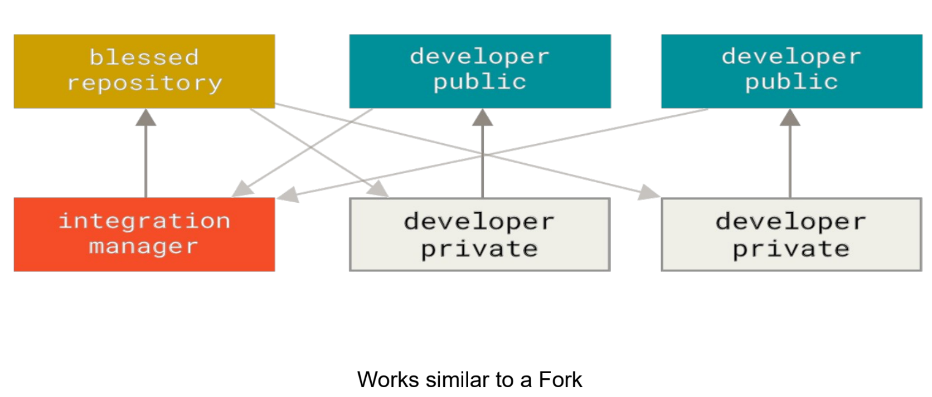
• Each developer works in their private repo
• They share work via a public repo
• An integration manager collects good changes
• Only approved changes go into the blessed (main) repository
• Others update from the blessed repo
👉 Like a controlled fork system: many contribute, one approves.

Dictator & Lieutenants
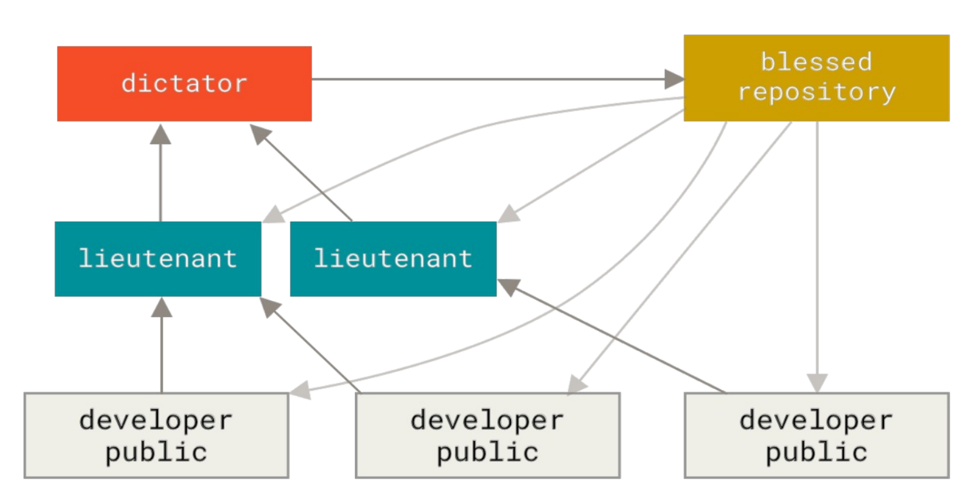
• Developers send work to lieutenants
• Lieutenants review and forward good changes
• Dictator makes final decision
• Approved code goes to blessed (main) repository
👉 One final boss, trusted helpers in between

-------------------
Aik class inventory ki hai which extends product. Aik class discountedprod hai which extends product. Inventory ki array banai hai or us me products+ discounted hai. We need to filter out only discounted ones how to do it?
Inventory<Product> inventory = new Inventory<>();
inventory.addProduct(new Product(1, "Laptop", 899.99));
inventory.addProduct(new DiscountedProduct(2, "Headphones", 79.99, 0.075f));
inventory.addProduct(new DiscountedProduct(3, "Charger", 99.99, 0.05f));
inventory.addProduct(new Product(4, "Smartphone", 499.99));
sol:
// (1) Get list of all discounted products
List<DiscountedProduct> discountedProducts = new ArrayList<>();
for (Product p : inventory.getAllProducts()) {
if (p instanceof DiscountedProduct) { // important thing to see
discountedProducts.add((DiscountedProduct) p);
}
}
GUI
import javax.swing.*;
public class App {
public static void main(String[] args) {
// Create the window (JFrame)
JFrame frame = new JFrame("My First Swing Window");
frame.setSize(400, 200);
frame.setTitle(“MY WINDOW”);
frame.setResizable(false);
frame.setDefaultCloseOperation(JFrame.EXIT_ON_CLOSE); //cross dubane se frame close ho jata
// frame ka logo change karna
ImageIcon image=new ImageIcon(“path of image”)
Frame.setIconImage(image.getImage());
//to change background colour of frame
Frame.getContentPane().setBackground(Color.green);
Frame.getContentPane().setBackground(new Color(0,0,0));//rgb and hex here too\
// Create a panel to hold components
JPanel panel = new JPanel();

// Add a components
JLabel label = new JLabel("Enter your name:");
Label.setIcon(image) //change icon of label
JTextField textField = new JTextField(15);
JButton button = new JButton("Submit");
button.addActionListener(e -> {
String name = textField.getText();
JOptionPane.showMessageDialog(frame, "Hello, " + name + "!");
});
// Add components to panel
panel.add(label);
panel.add(textField);
panel.add(button);
// Add panel to frame
frame.add(panel);
frame.setVisible(true);
}
}
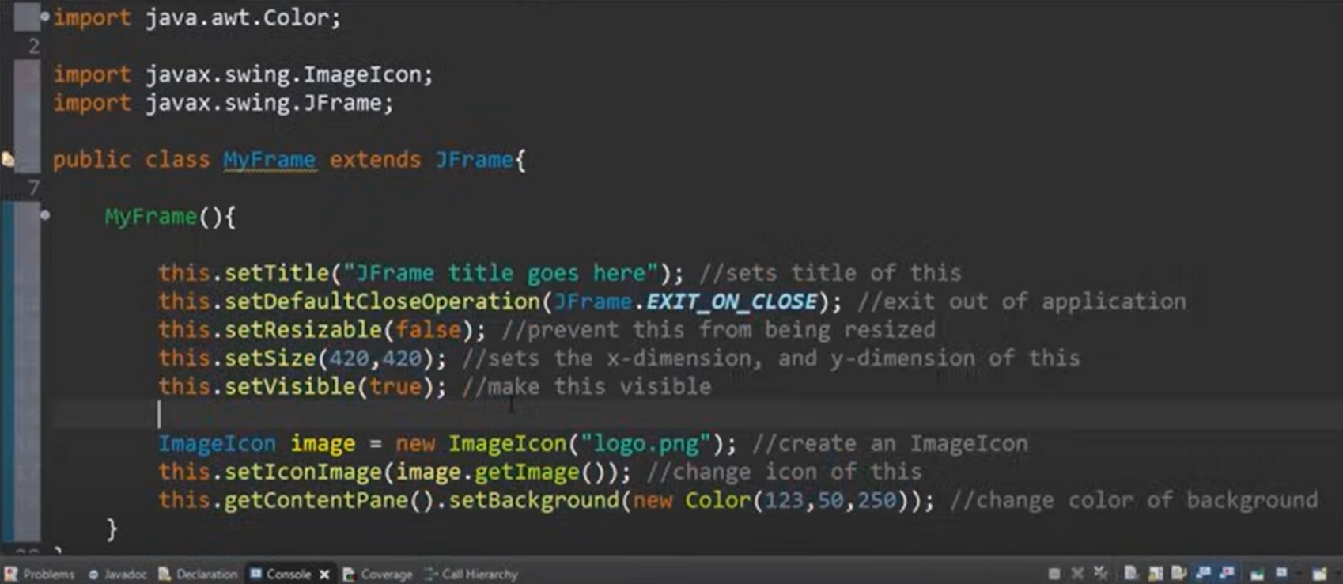
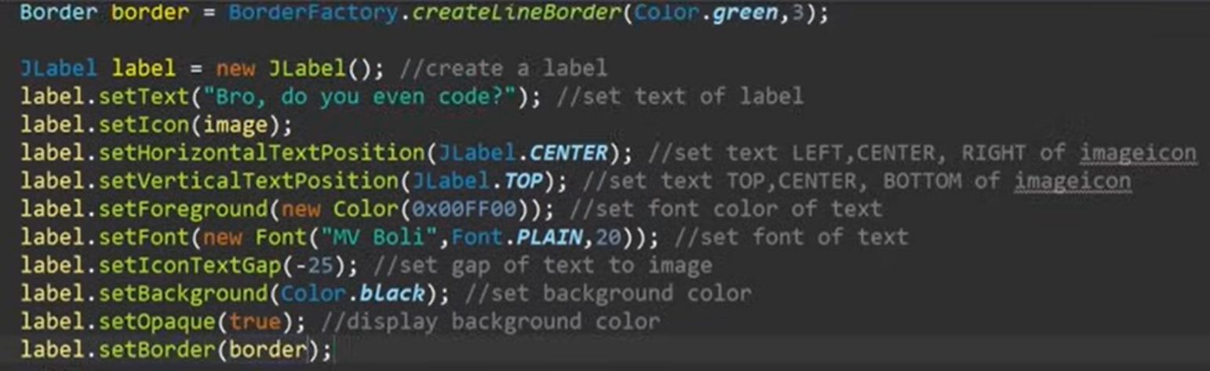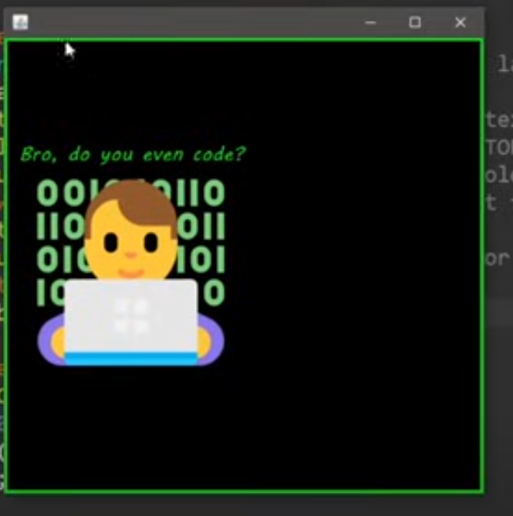
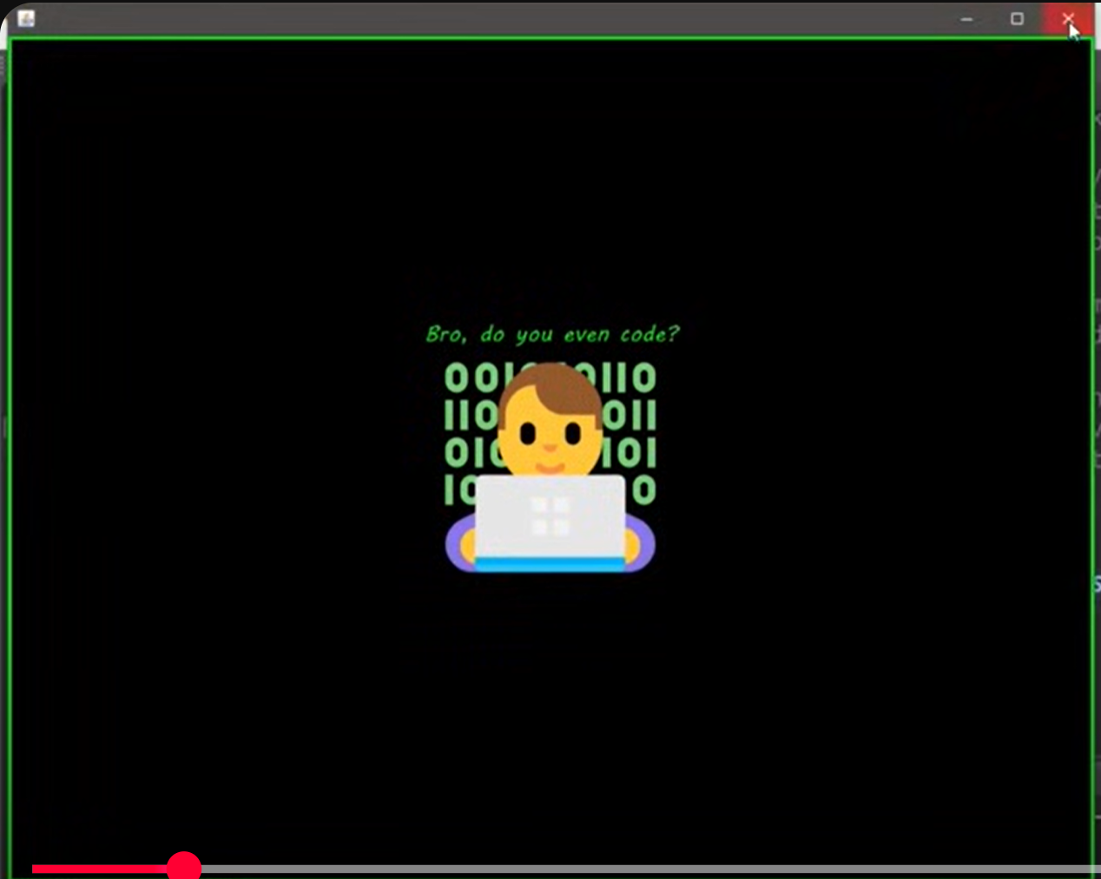
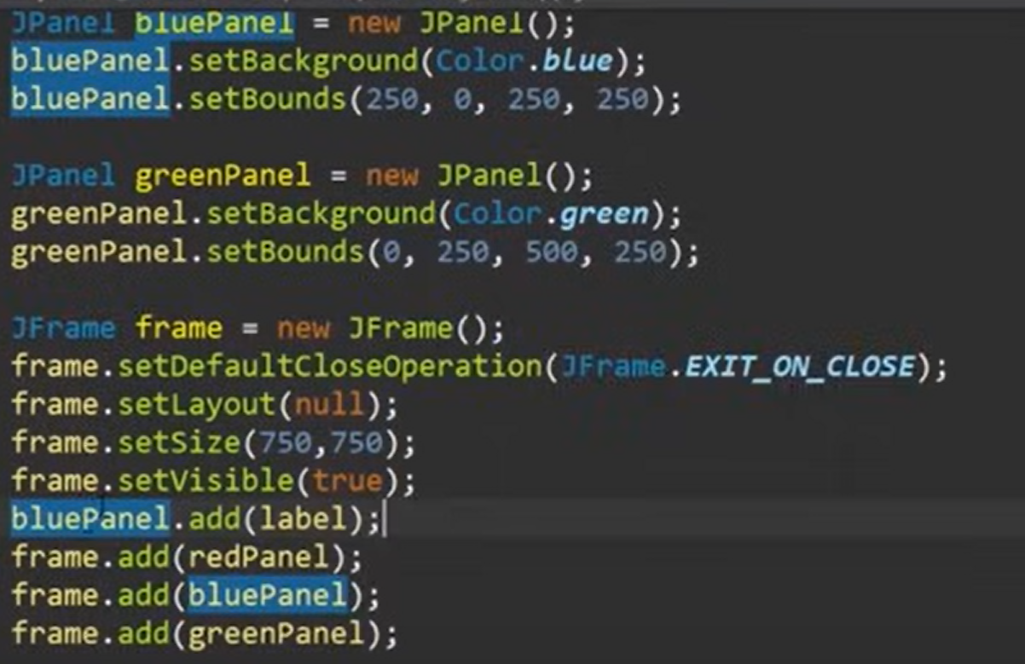
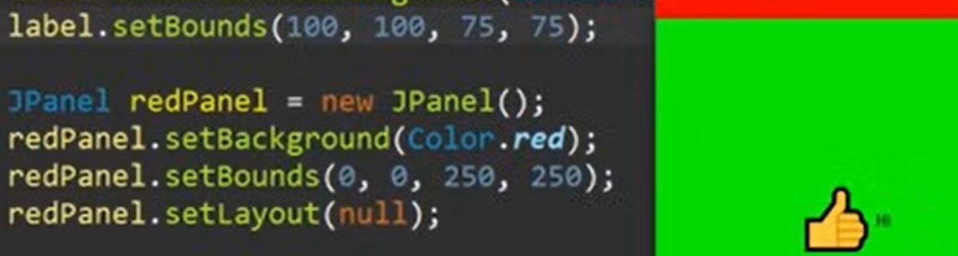
Set bounds set a label on particular coordinates
Mid question :
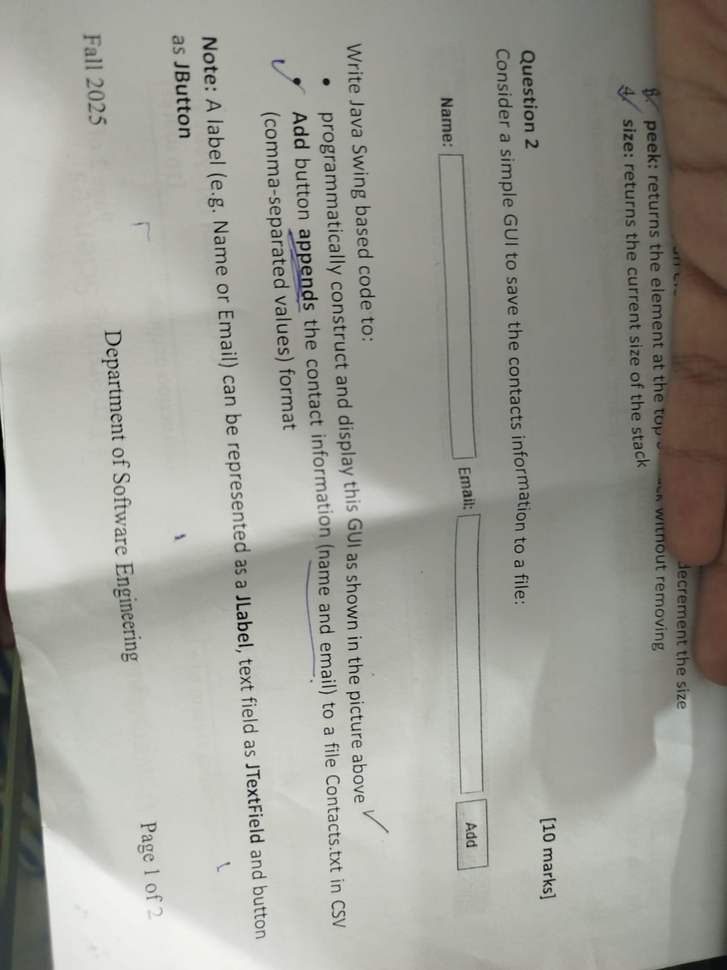
public class ContactSaver extends JFrame {

private JTextField nameField, emailField;
private JButton addButton;

public ContactSaver() {
// Frame settings
setTitle("Contact Saver");
setSize(400, 200);
setDefaultCloseOperation(JFrame.EXIT_ON_CLOSE);
setLayout(new GridLayout(3, 2, 10, 10));

// Components
JLabel nameLabel = new JLabel("Name:");
JLabel emailLabel = new JLabel("Email:");

nameField = new JTextField();
emailField = new JTextField();

addButton = new JButton("Add");

// Add components to frame
add(nameLabel);
add(nameField);
add(emailLabel);
add(emailField);
add(new JLabel("")); // empty cell for alignment
add(addButton);

// Button action
addButton.addActionListener(new ActionListener() {
@Override
public void actionPerformed(ActionEvent e) {
saveContact();
}
});
setVisible(true);
}

private void saveContact() {
String name = nameField.getText().trim();
String email = emailField.getText().trim();
if (name.isEmpty() || email.isEmpty()) {
JOptionPane.showMessageDialog(this, "Please enter both Name and Email.");
return;
}
try (FileWriter fw = new FileWriter("Contacts.txt", true);
BufferedWriter bw = new BufferedWriter(fw);
PrintWriter out = new PrintWriter(bw)) {

out.println(name + "," + email); // CSV format

JOptionPane.showMessageDialog(this, "Contact saved successfully!");

// Clear fields
nameField.setText("");
emailField.setText("");

} catch (IOException ex) {
JOptionPane.showMessageDialog(this, "Error saving contact: " + ex.getMessage());
}
}

public static void main(String[] args) {
SwingUtilities.invokeLater(() -> new ContactSaver());
}
}
Table
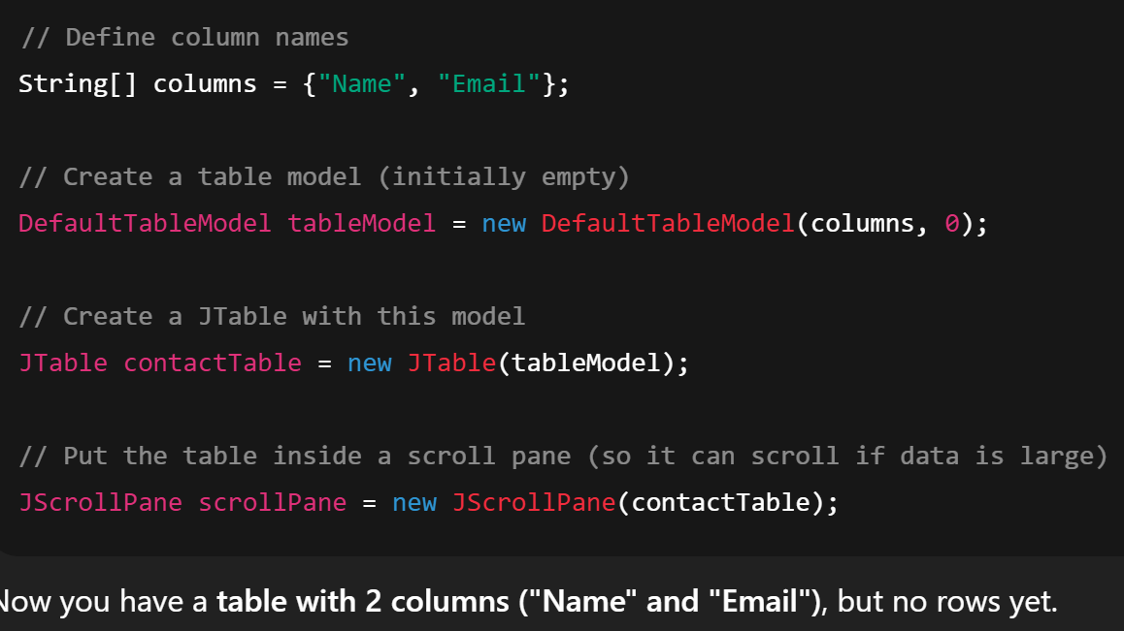
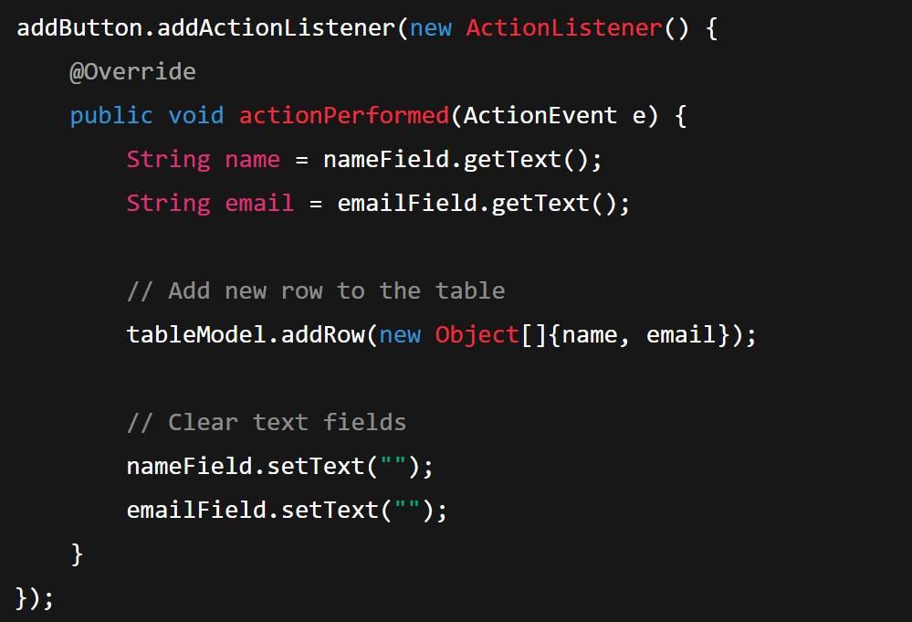
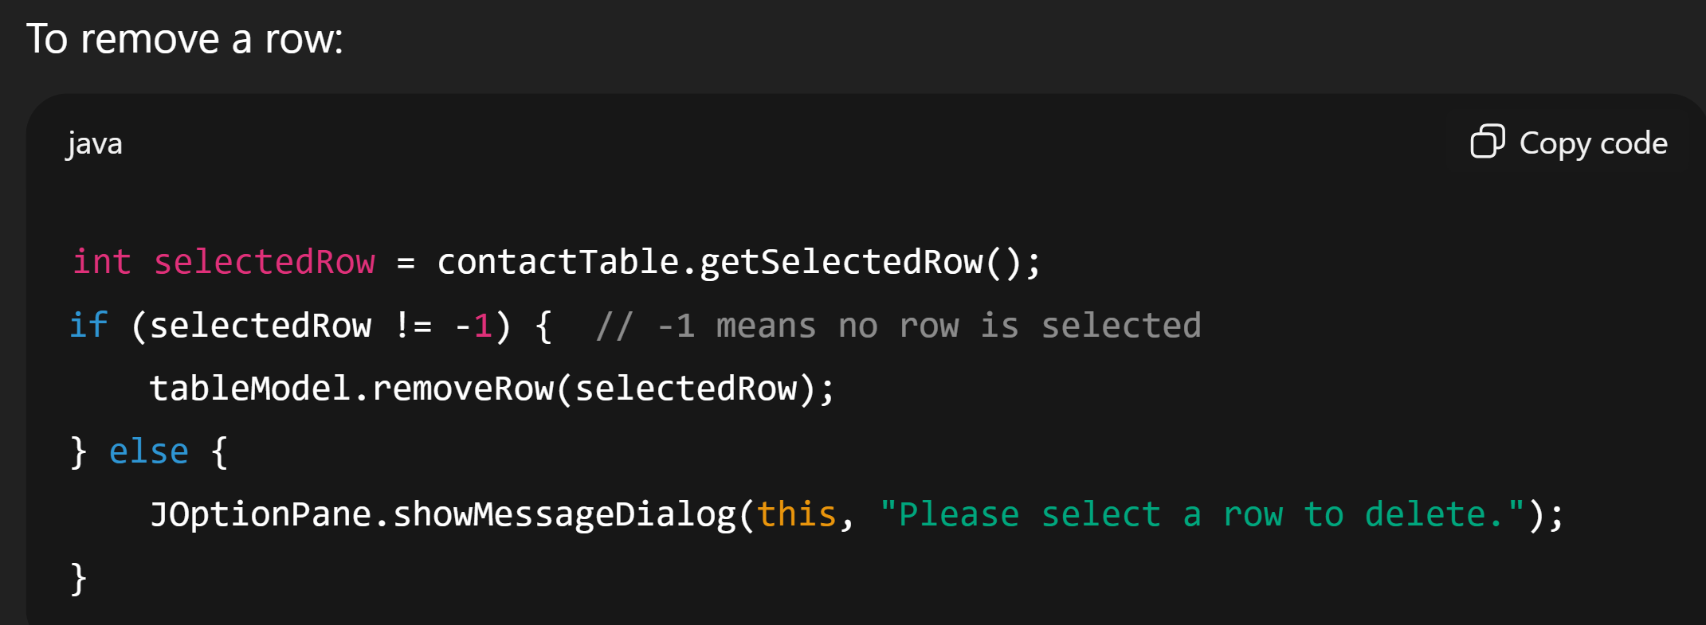
BETTER VERSION OF TABLE
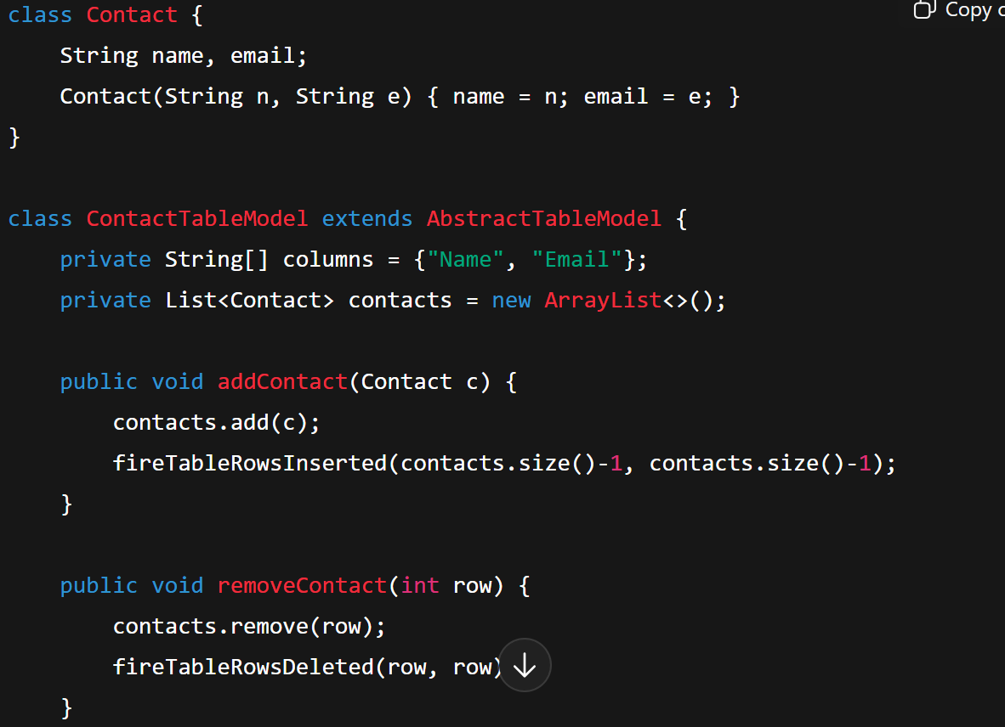
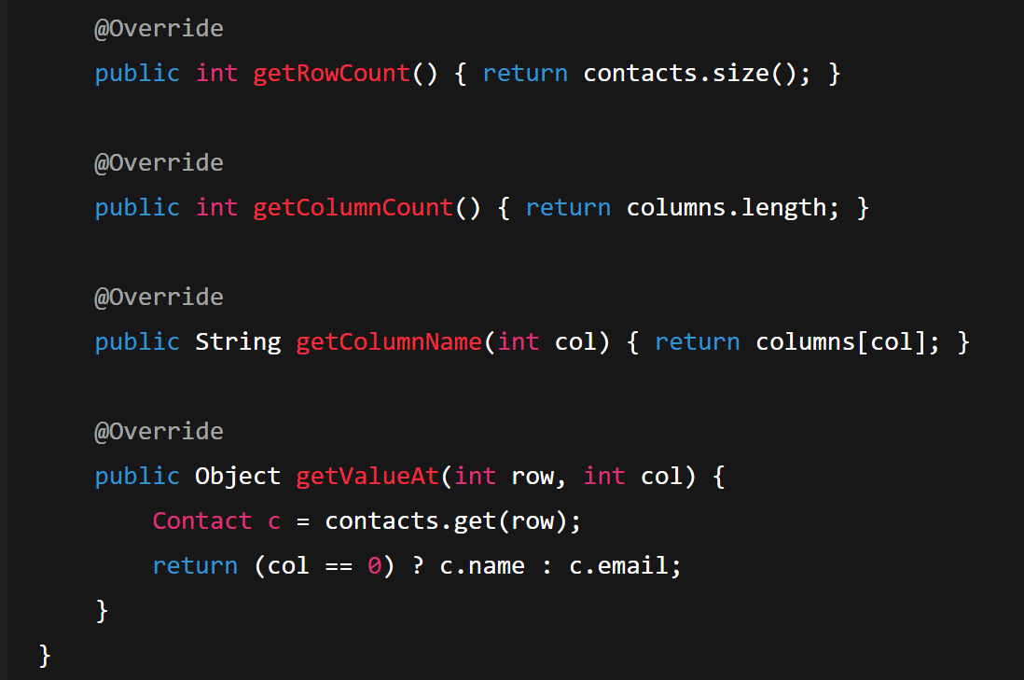
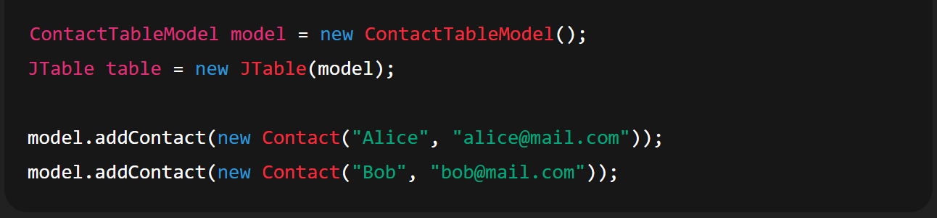
LAYOUTS
🔹 What is a Layout Manager?
A Layout Manager automatically decides:
- Where to place components (like buttons, text fields, etc.)
- How big each component should be
- How components resize when the window is resized
So you don’t need to manually set the exact x,y position of everything.
🔹 Common Layout Managers (Beginner-Friendly)
Here are the main ones you’ll use at the start:
1. FlowLayout
- Think of it like writing text in a line.
- Components are placed left to right in a row.
- If the row is full, it goes to the next line.
✔️ Good for small toolbars or simple forms.
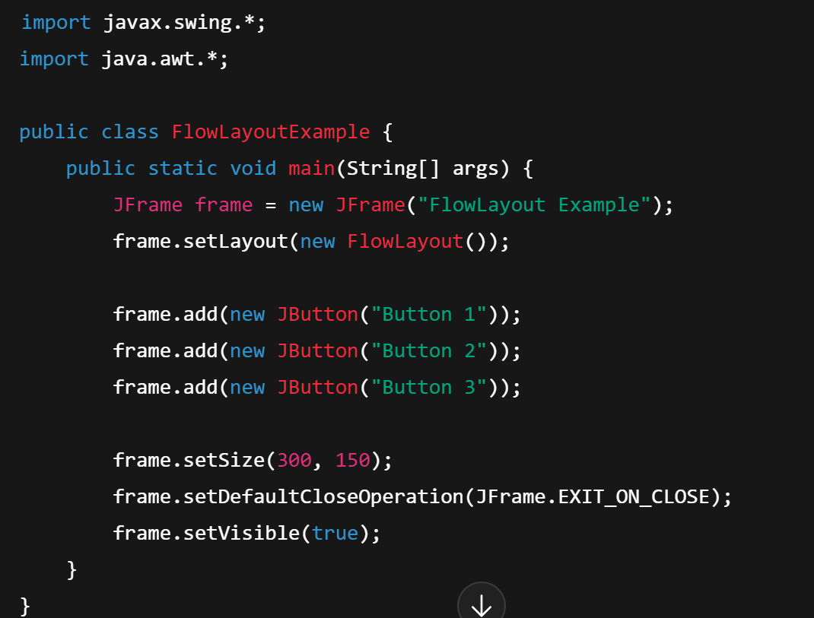
2. BorderLayout
- Divides the window into 5 regions:
North, South, East, West, Center
- You must specify where the component goes.
✔️ Good for applications with a menu bar, main content, and status bar.
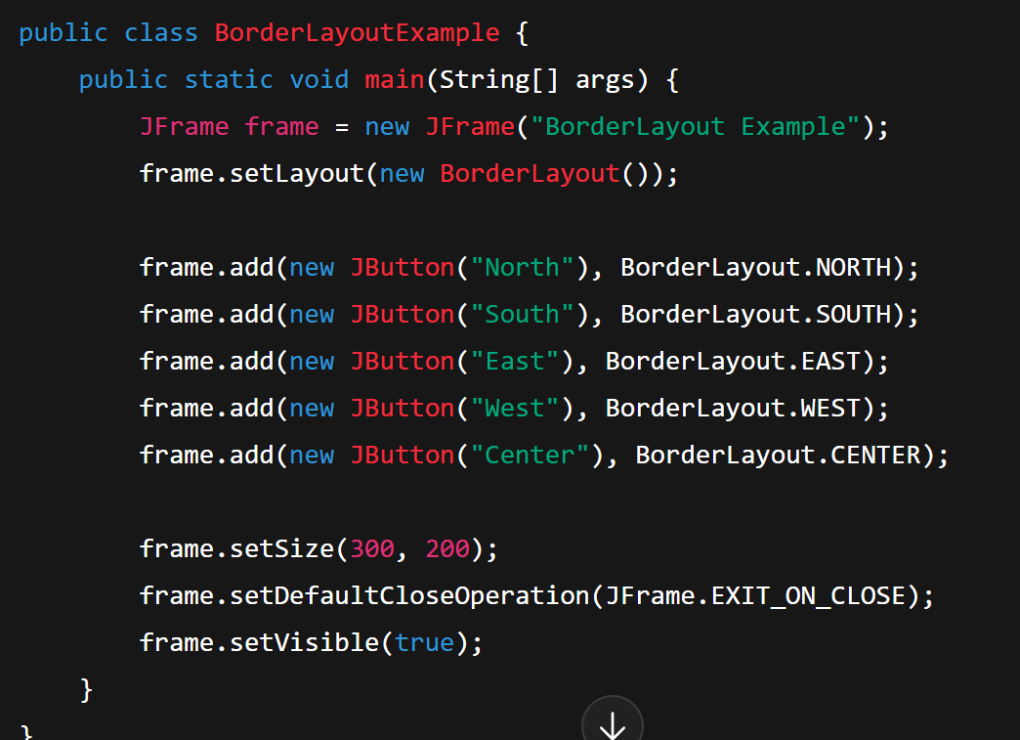
3. GridLayout
- Makes a grid of rows and columns (like a table).
- Every cell is the same size.
✔️ Good for calculators, tables, game boards.
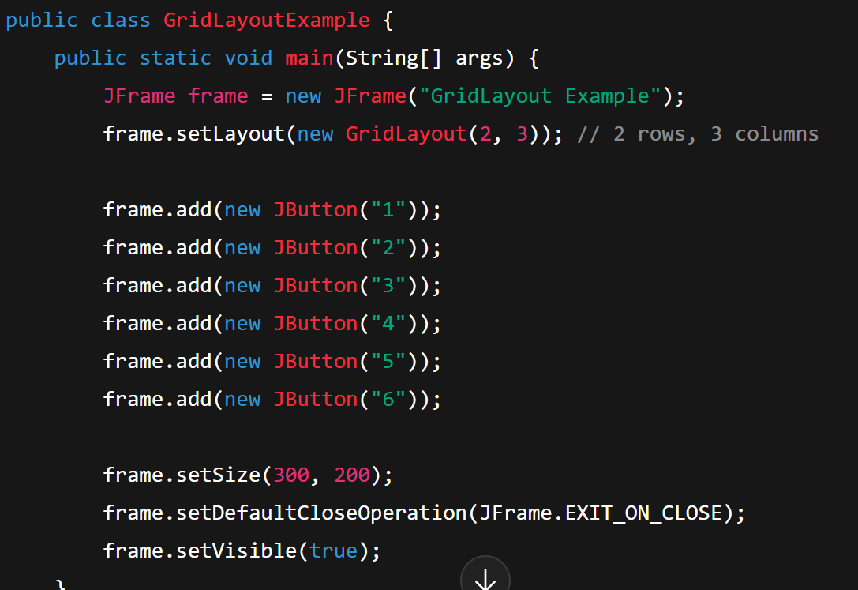
4. BoxLayout
- Places components in a single row (X-axis) or single column (Y-axis).
✔️ Good when you want components stacked neatly.
5. Null Layout (Absolute Positioning)
- You turn off layout managers and manually set positions with .setBounds(x, y, width, height).
- Beginners like this because it feels simple, but it’s not recommended for real apps (resizing breaks it).
🔹 Summary (Beginner’s View)
- FlowLayout → Left to right (like text)
- BorderLayout → Divide window into 5 areas
- GridLayout → Table/grid style
- BoxLayout → One row or one column
- Null Layout → Manual positions (not flexible)

GRAPHICS
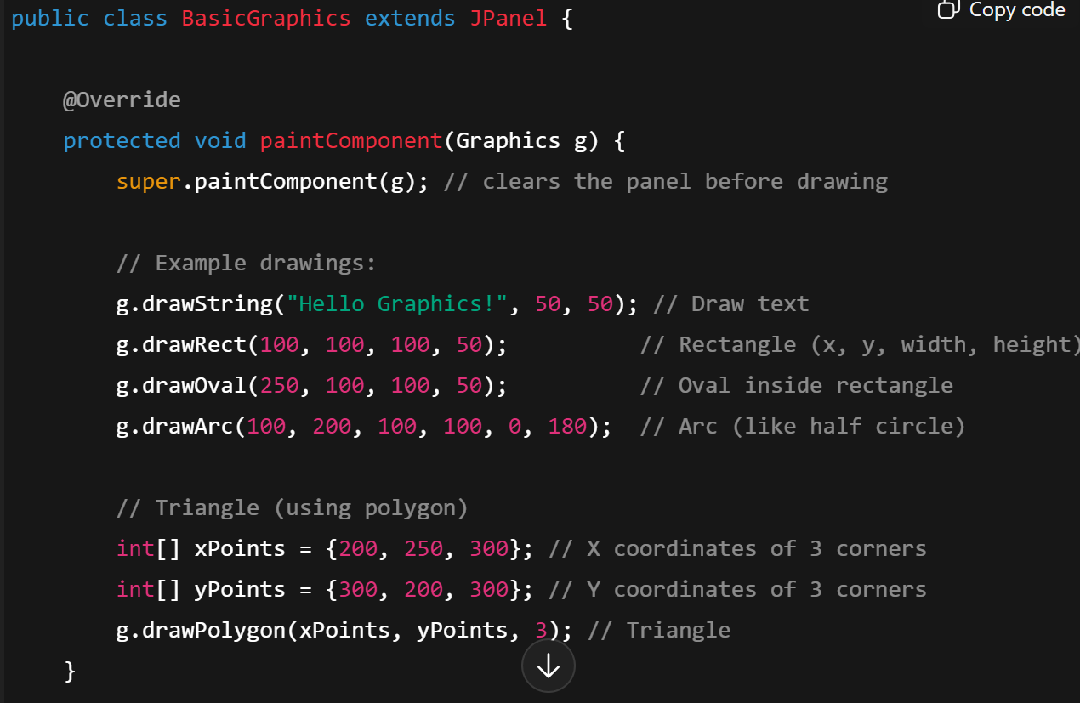
g.fillArc(int x, int y, int width, int height, int startAngle, int arcAngle); Starting angle. Angular extent of the arc, in degrees (positive = counterclockwise, negative = clockwise)
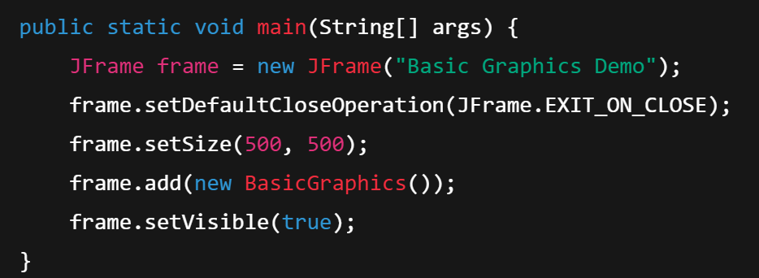

3. Filled Shapes
If you want filled shapes instead of outlines, use:
- g.fillRect(...)
- g.fillOval(...)
- g.fillArc(...)
- g.fillPolygon(...)

MAKING YOUR OWN COMPONENT
Main:
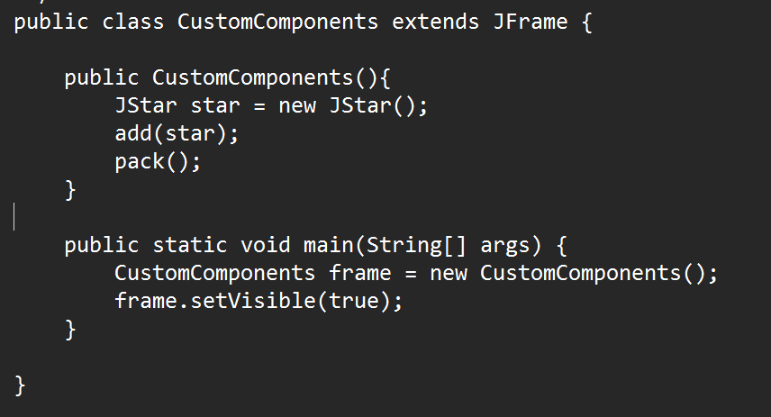
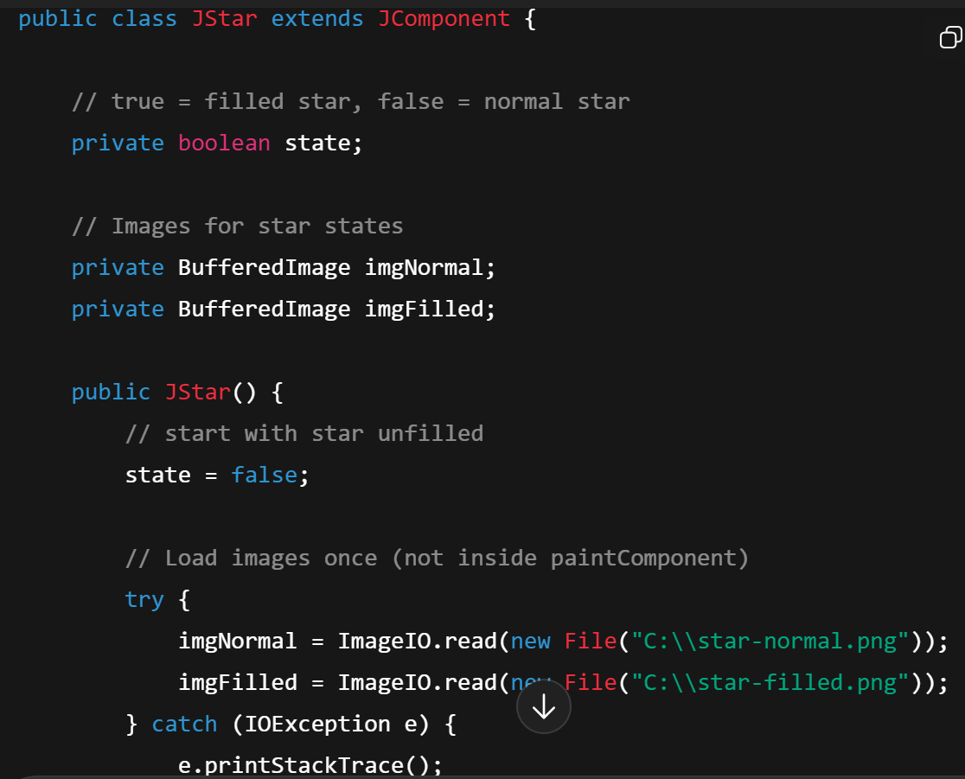
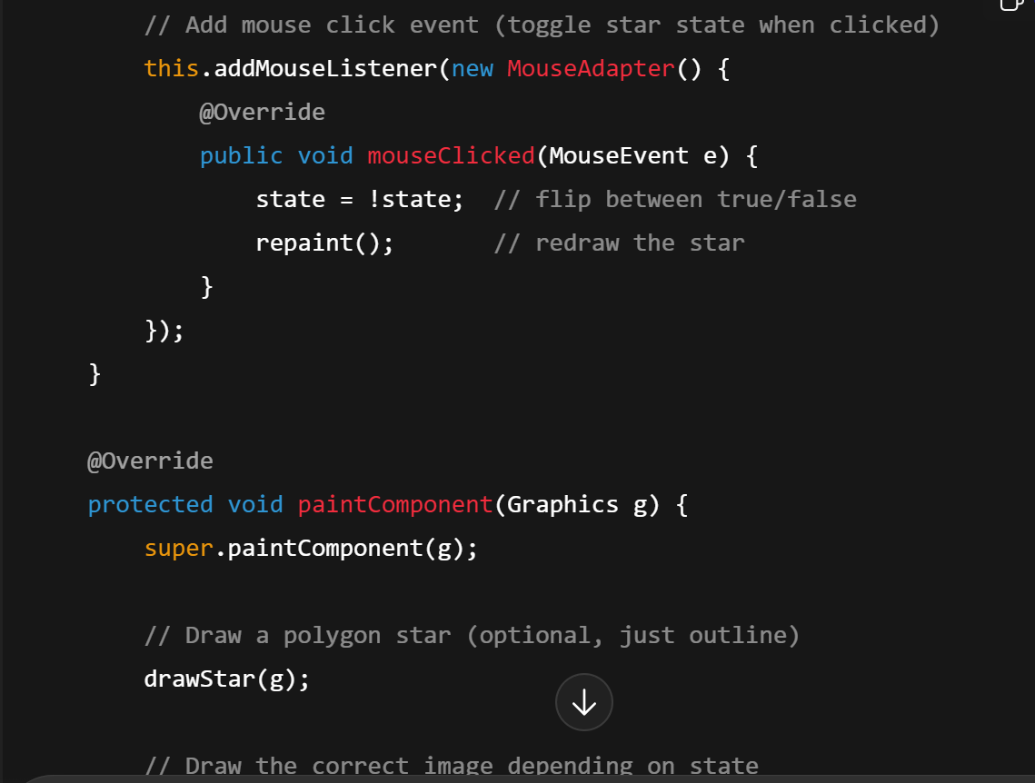
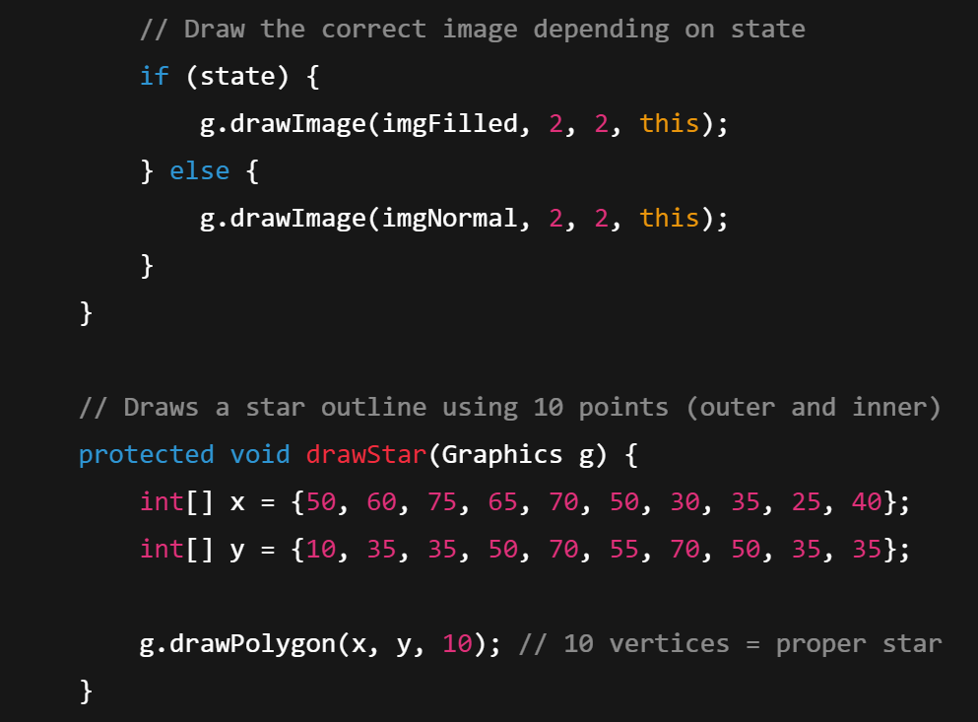
g.setColor(Color.RED); // this draws red line
g.drawLine(x1, y1, x2, y2);

MVC
🔹 1. What is MVC?
- Model (M) → Manages the data and business logic of the application.
- View (V) → Handles the user interface (what the user sees).
- Controller (C) → Connects the Model and View. It processes user input, updates the Model, and tells the View to refresh.
🔹 2. Example in Java Swing
Let’s say we are making a counter app:
- A label shows the current count.
- A button increases the count.
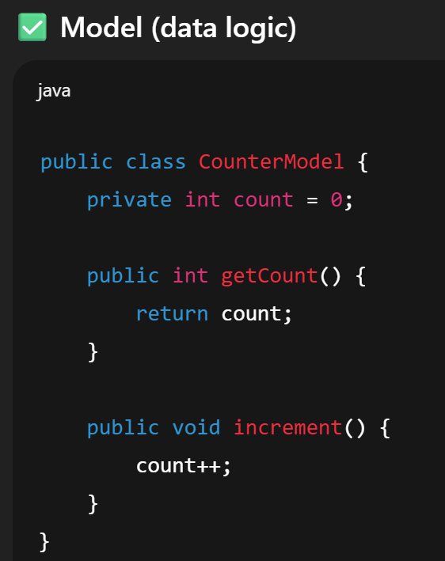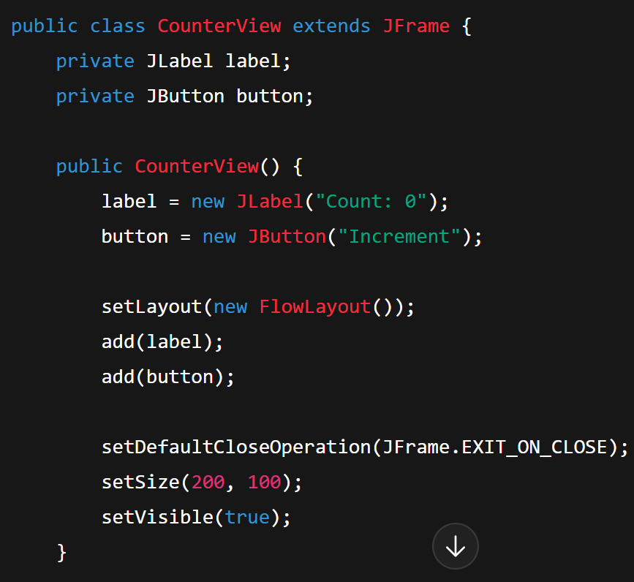
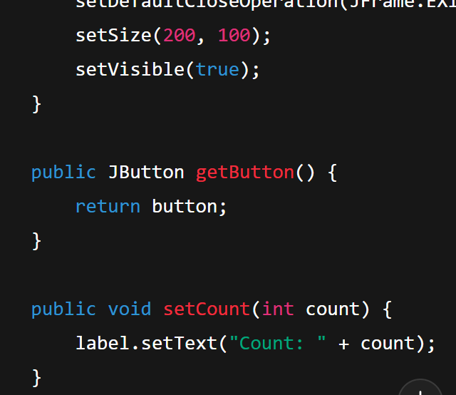
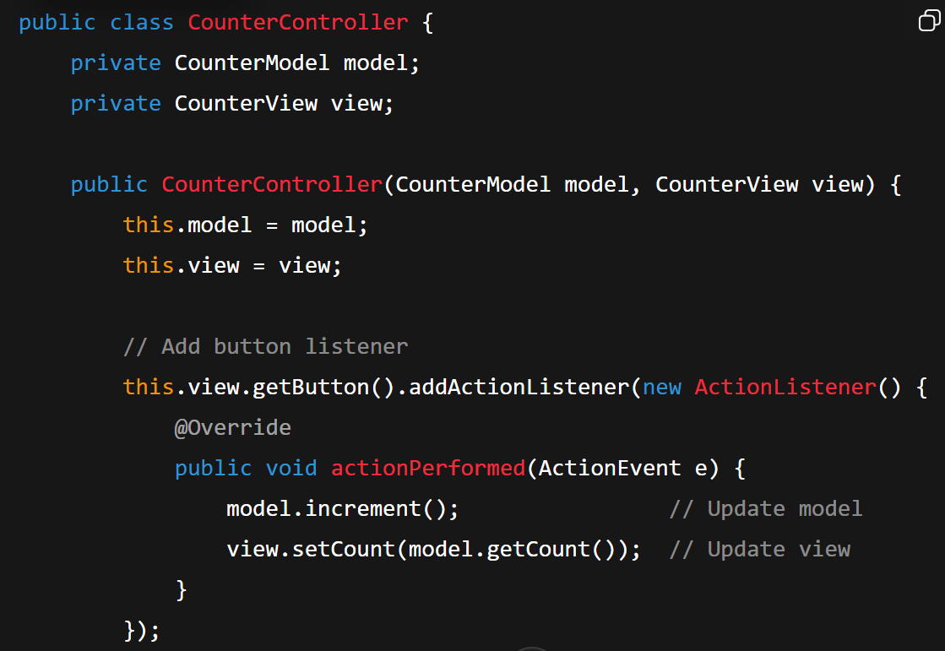
RADIO BUTTONS:
// Create radio buttons
JRadioButton maleButton = new JRadioButton("Male");
JRadioButton femaleButton = new JRadioButton("Female");
JRadioButton otherButton = new JRadioButton("Other");
// Group them together so only one can be selected
ButtonGroup genderGroup = new ButtonGroup();
genderGroup.add(maleButton);
genderGroup.add(femaleButton);
genderGroup.add(otherButton);
// Add buttons to frame
frame.add(new JLabel("Select Gender:"));
frame.add(maleButton);
frame.add(femaleButton);
frame.add(otherButton);
// Set default selection (optional)
maleButton.setSelected(true);
radioButton.isSelected()
QUANTITY SELECTOR BUTTON
JLabel label = new JLabel("Quantity:");
JTextField quantityField = new JTextField("1", 5); // • The initial text "1" (so the field starts with the value 1 already typed in). The column size 5, which sets the preferred width of the text field (roughly 5 characters wide).
quantityField.setHorizontalAlignment(JTextField.CENTER);
quantityField.setEditable(false); // user can’t type manually

JButton minusButton = new JButton("-");
JButton plusButton = new JButton("+");

// action for '+' button
plusButton.addActionListener(e -> {
int quantity = Integer.parseInt(quantityField.getText());
quantity++;
quantityField.setText(String.valueOf(quantity));
});

// action for '-' button
minusButton.addActionListener(e -> {
int quantity = Integer.parseInt(quantityField.getText());
if (quantity > 1) { // don’t allow less than 1
quantity--;
quantityField.setText(String.valueOf(quantity));
}
});
frame.add(label);
frame.add(minusButton);
frame.add(quantityField);
frame.add(plusButton);
--------
Combobox in java
// Create ComboBox items
String[] options = {"Option 1", "Option 2", "Option 3"};

// Create the ComboBox
JComboBox<String> comboBox = new JComboBox<>(options);

// Add an action listener
comboBox.addActionListener(e -> {
String selected = (String) comboBox.getSelectedItem();
JOptionPane.showMessageDialog(frame, "You selected: " + selected);
});

// Add ComboBox to the frame
frame.add(comboBox);
----
TextArea
JTextArea textArea = new JTextArea(5, 20); // 5 rows, 20 columns
textArea.setText("Enter your message here...");
String content = textArea.getText();
textArea.append("\nAdditional text added!");
textArea.setEditable(false); // make read-only
textArea.getText().trim().isEmpty()
returnDateField.setEnabled(false);
LAYERED ARCHITECTURE
Presentation Layer (UI)
↓
Business Layer (Logic/Service)
↓
Data Access Layer (Database handling)
↓
Database (Physical data storage)

Layer | Purpose | Example Files
Presentation (UI) Layer | Handles user interface — input/output. | ContactForm.java, ContactUI.java
Business / Logic Layer | Contains business rules and acts as a bridge between UI and data. | Contact.java
Data Access Layer (DAO Layer) | Handles how data is stored or fetched (file or database). | ContactDBDAO.java, ContactFileDAO.java, IDAO.java

DATA ACCESS LAYER:
File | Role | Layer
IDAO.java | Defines a common interface (blueprint) for data access. | Abstraction Layer (interface between business logic and persistence)
ContactFileDAO.java | Implements IDAO using file storage (data.txt). | Persistence Layer (File-based)
ContactDBDAO.java | Implements IDAO using database storage (via JDBC). | Persistence Layer (Database-based)

IDAO
public interface IDAO {
public boolean save(Hashtable<String,String> data);
public boolean delete(String id);
public Hashtable<String,String> load(String id);
public ArrayList<Hashtable<String,String>> load();
}
ContactDBDAO
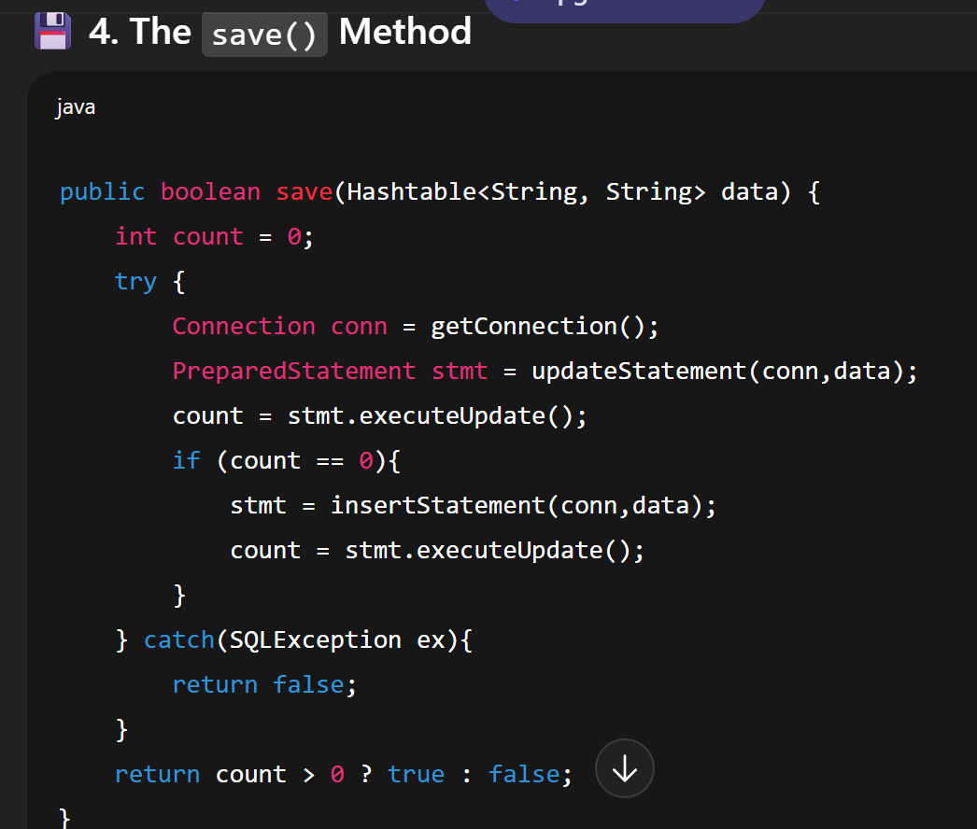
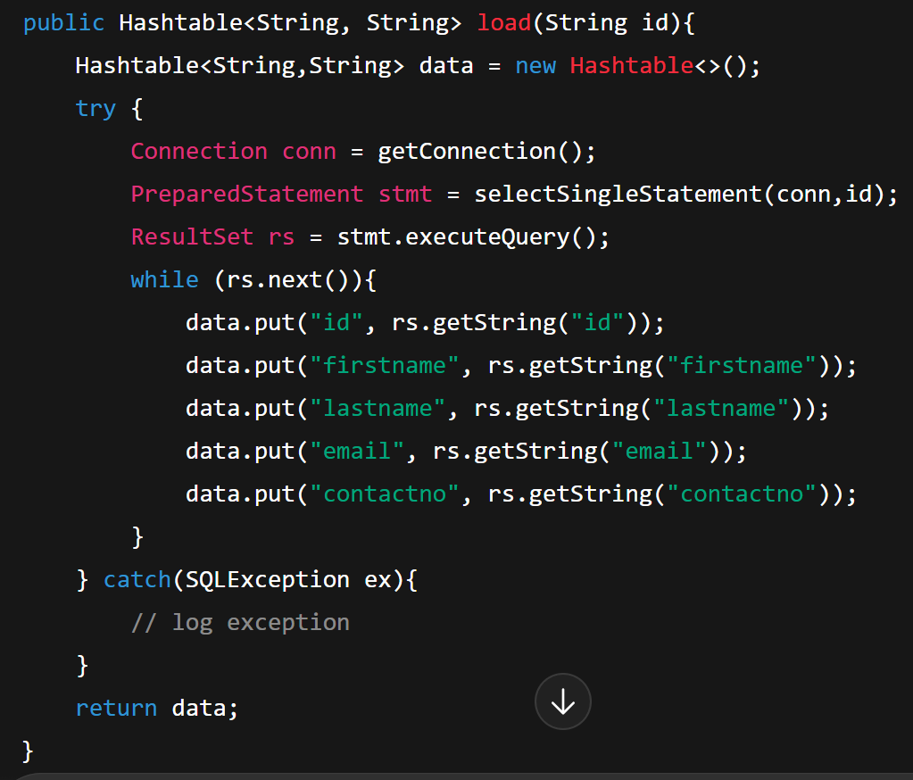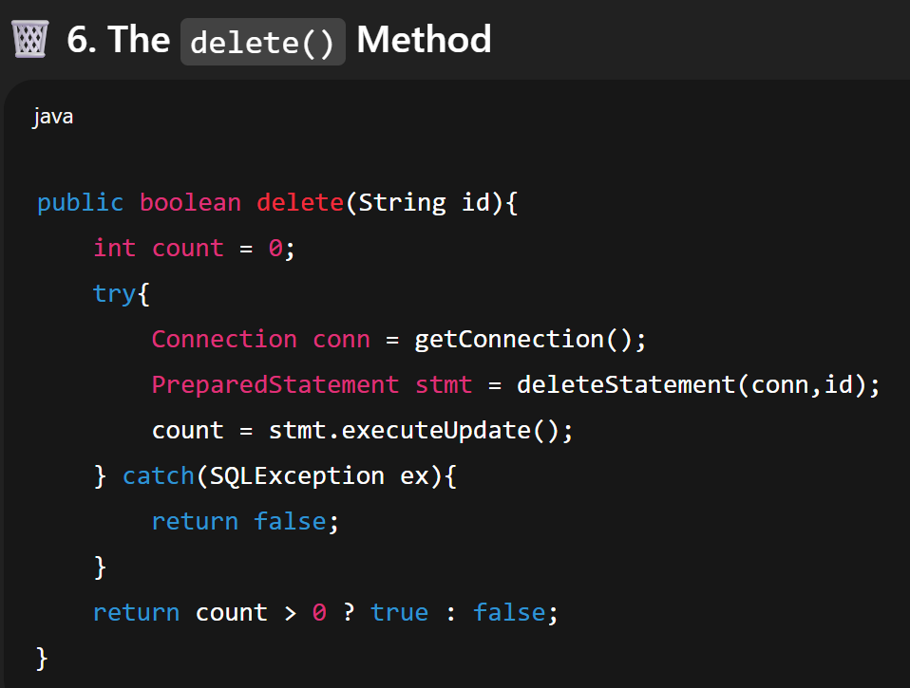
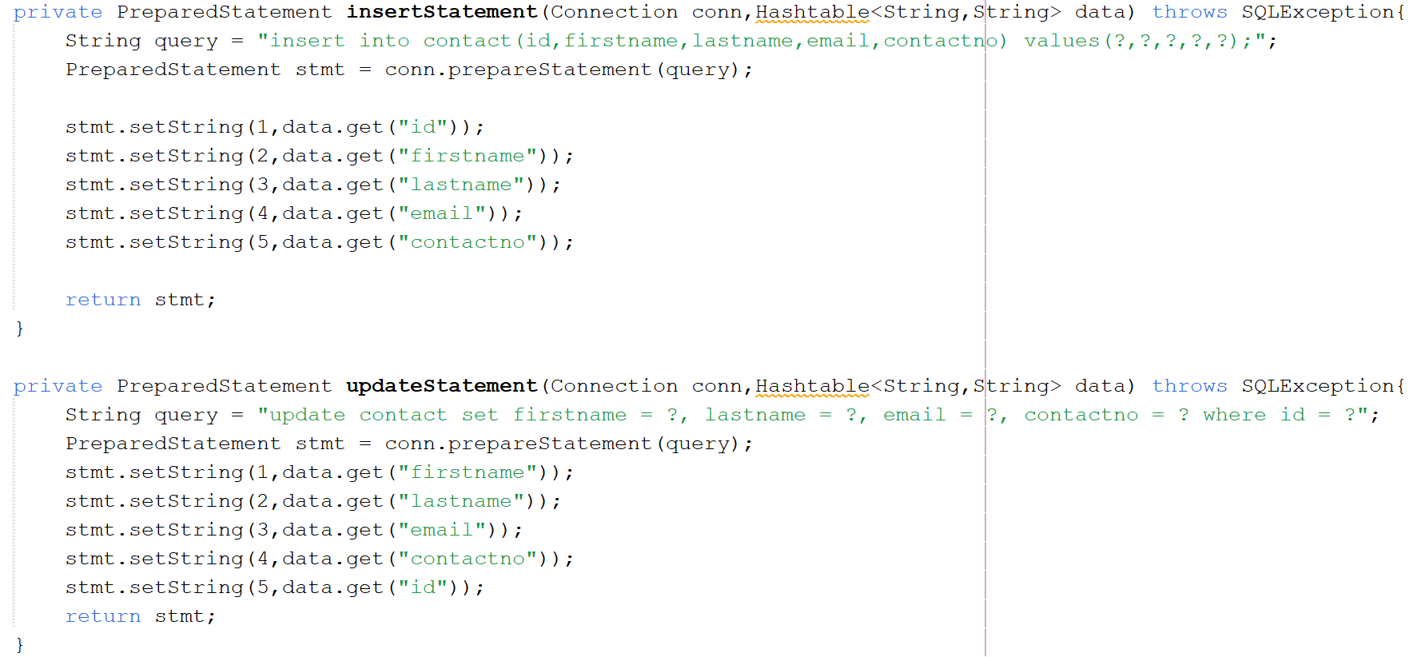
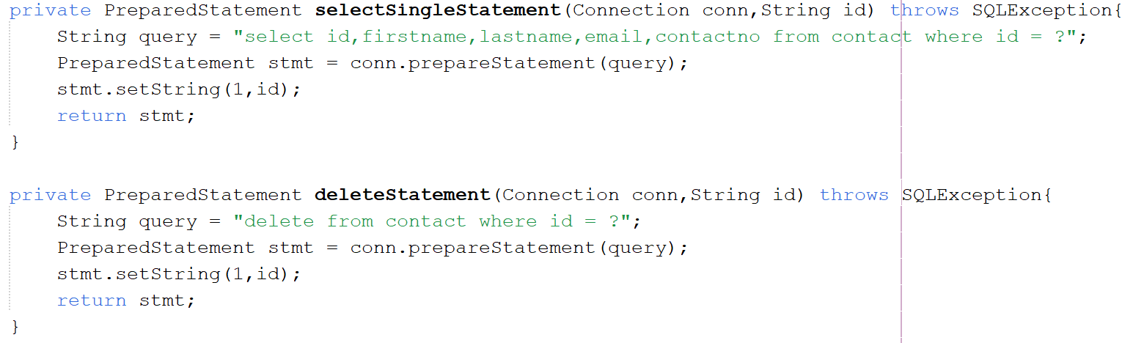
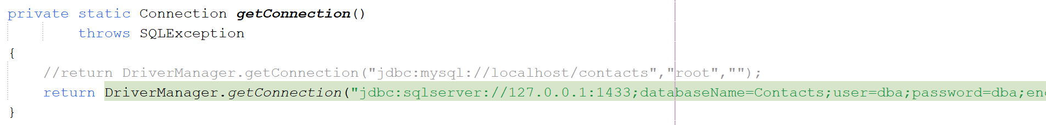
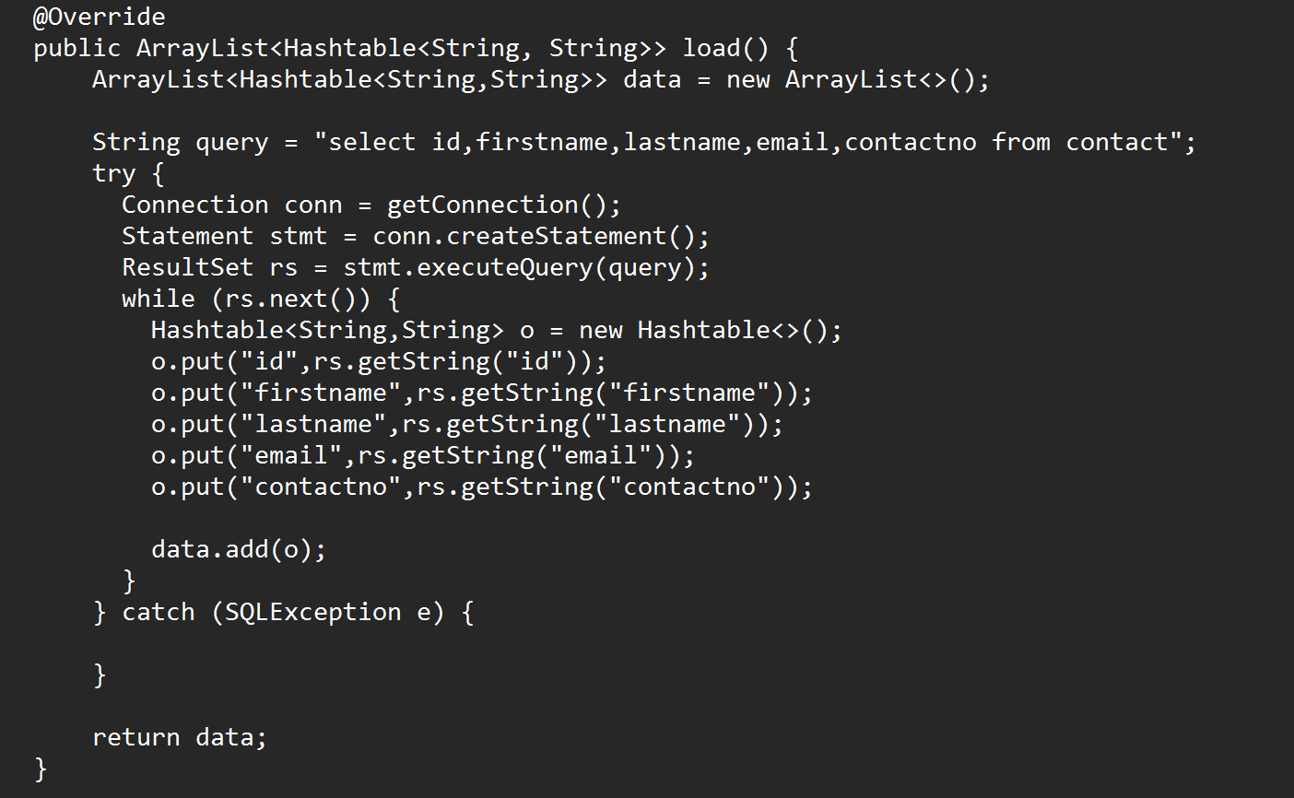
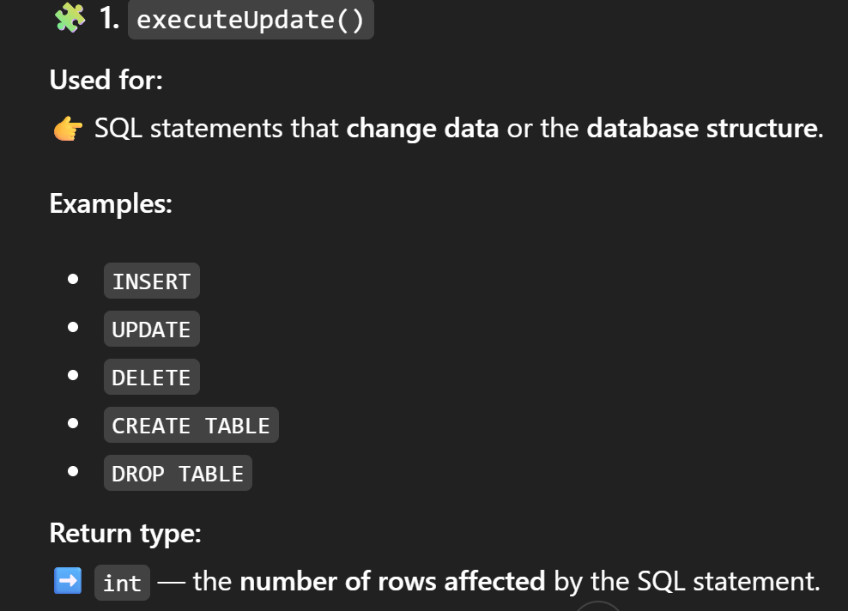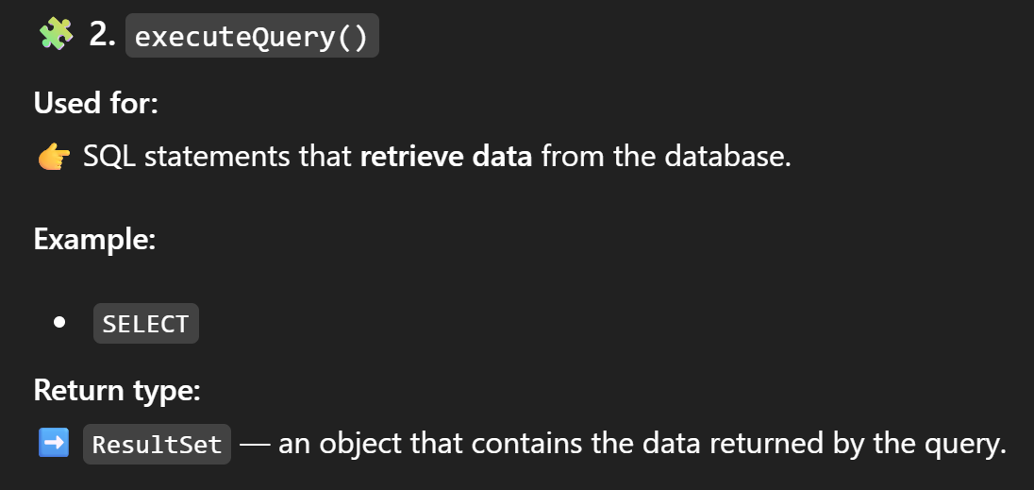
ContactFileDAO
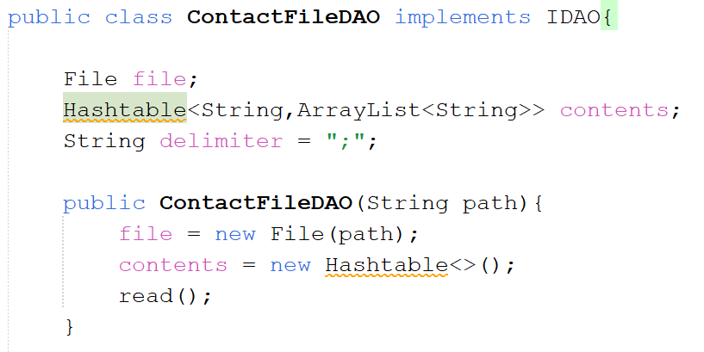
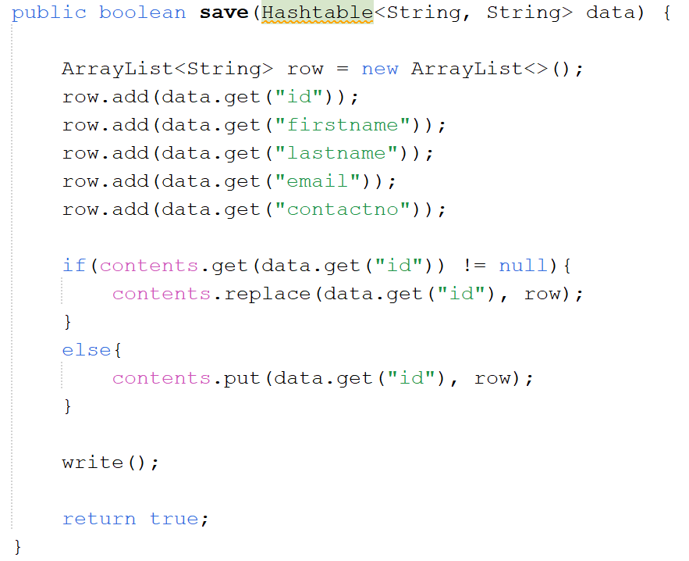
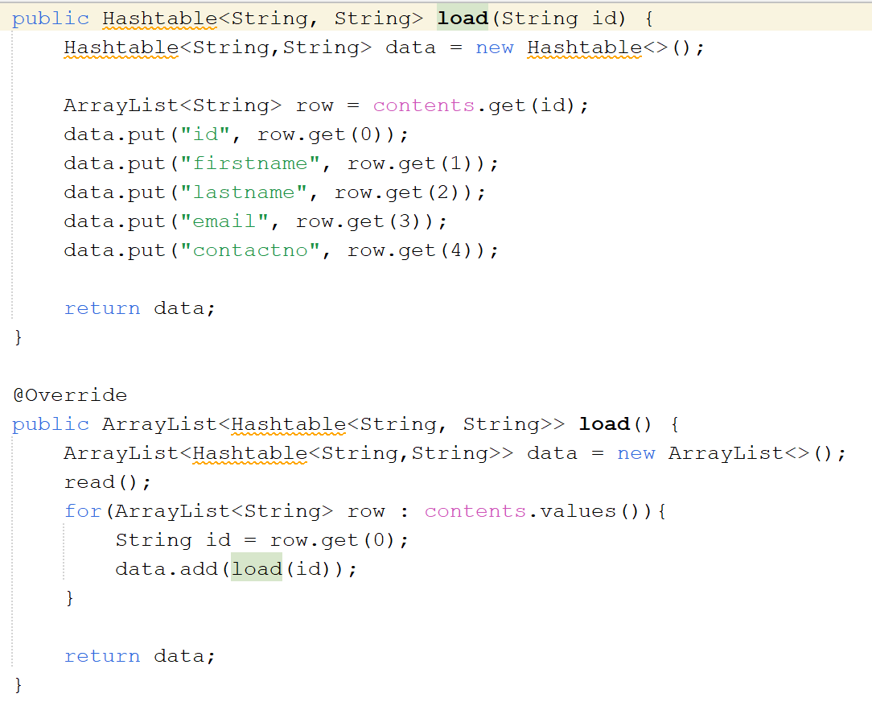

Add read and write functions too
Contacts class
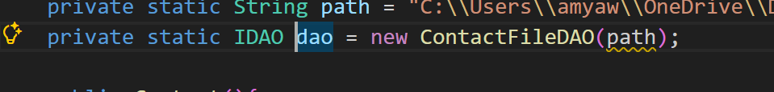
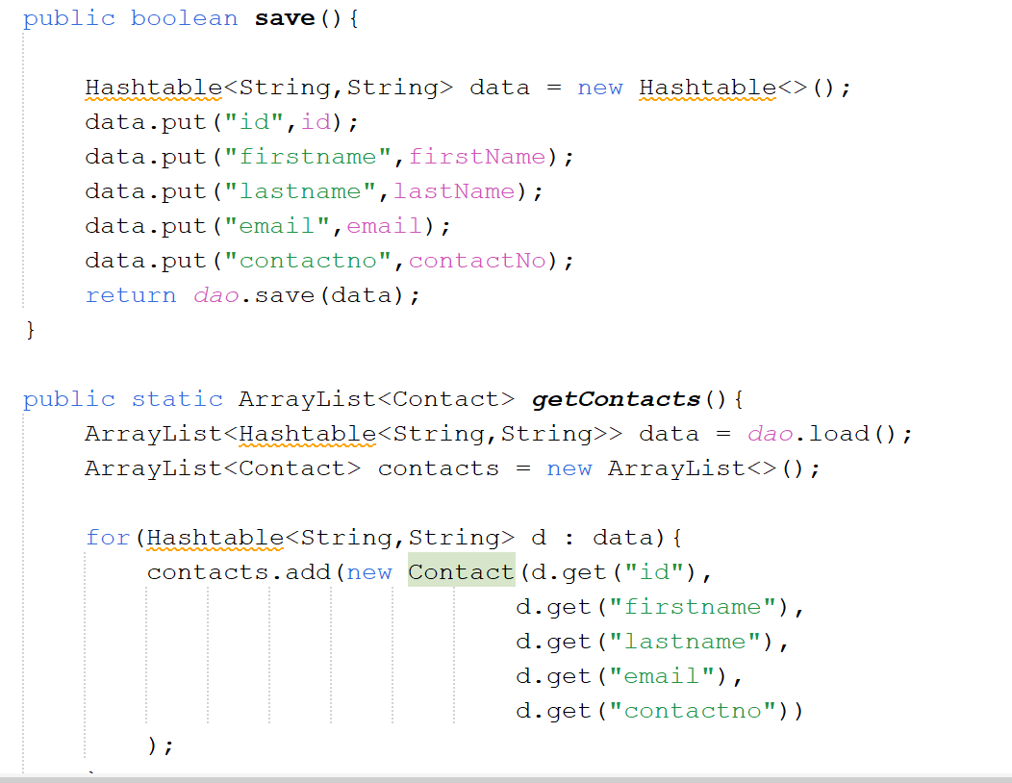
Database:

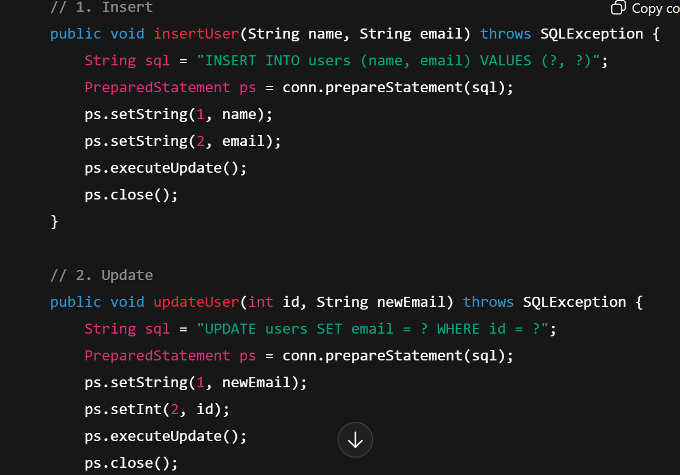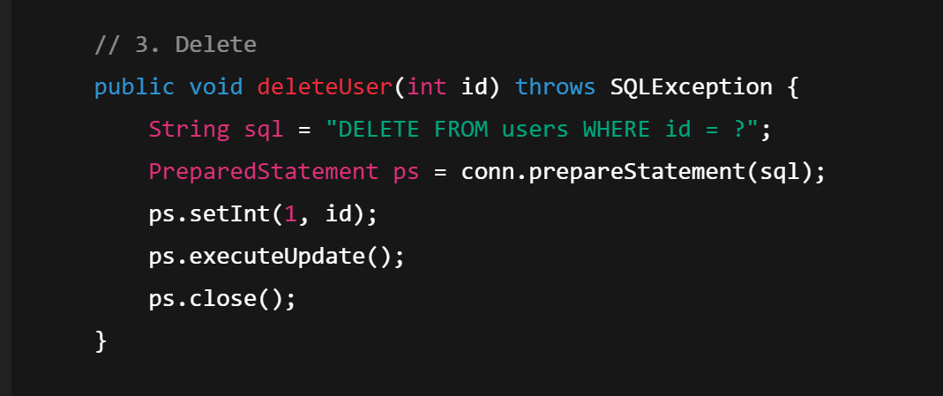
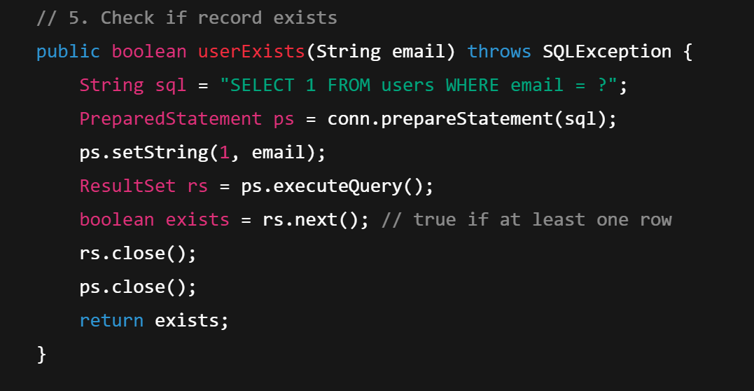
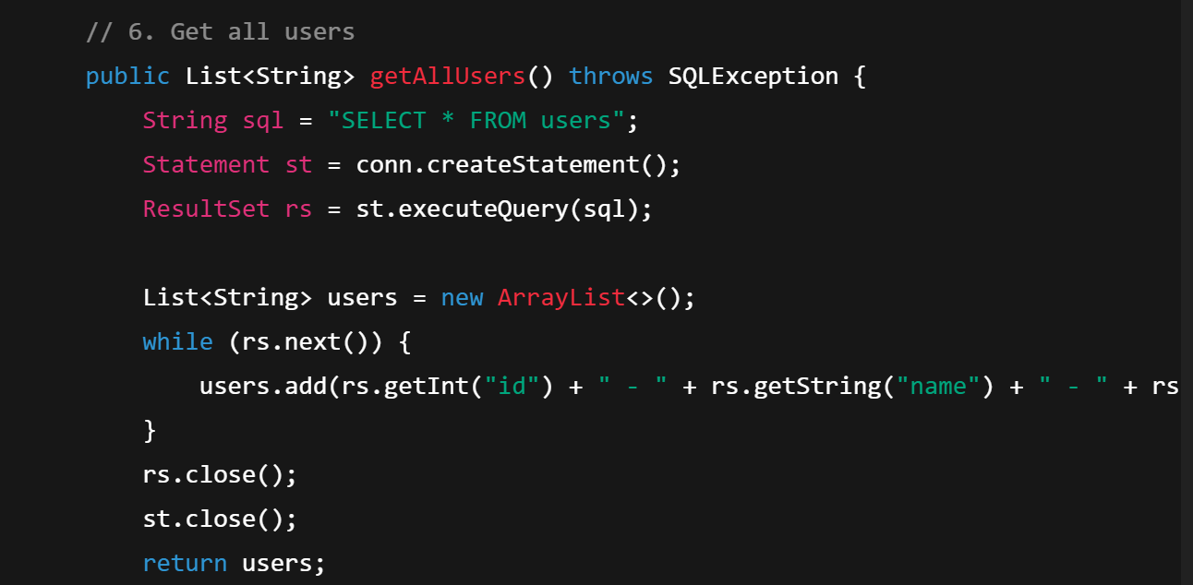

Junit testing (apun ka sqe ka project tha so isi liye notes nahi banaye is ke)
assertEquals(expected, actual, delta); // for floating-point numbers
delta is max difference allowed between expected and actual\
JUNIT PROVIDES COVERAGE TESTING
🧪 What is Coverage Testing?
Coverage testing answers one simple question:
👉 Did my tests actually run all parts of my code or not?

🪜 Coverage Testing Steps
1-Instrumentation (Preparing the code)
This means: Adding helpers inside your code to track what runs
In simple words:
- Your code is slightly modified
- Extra markers are added
- These markers record:
  - Which line ran
  - Which condition ran
You don’t see this code, tools do it automatically.
2️. Run Tests (JUnit)
Now you:
- Run your JUnit tests
- Code executes
- Markers record what was used
3️. Report
At the end:
- A report is generated
- It shows:
  - Which lines were tested
  - Which branches were tested
  - Percentage coverage
📊 Example:
- Line coverage: 85%
- Branch coverage: 70%
🛠 Build Management Tool → ANT
What is ANT? (Very easy)
ANT is like a remote control for your project.
Instead of typing many commands:
- Compile
- Test
- Generate report
👉 ANT does everything for you with one command.
ANT Commands in Notes
- ant instrument
👉 Adds tracking markers
- ant coverage-test
👉 Runs JUnit tests
- ant coverage-report
👉 Shows coverage result
So:
ANT + JUnit + Coverage Tool = Complete testing setup
🧠 Very Simple Analogy
- JUnit = Exam
- Coverage = Attendance sheet
- ANT = Teacher who manages everything

Serialization
● Process of writing the state of an object to an output stream (a serial sequence of bytes/characters)
● Generally used in context of writing to a more permanent form rather than transient(in memory)data
● Common uses include:
– Storage of objects to file systems
– Transportation of objects in case of distributed systems
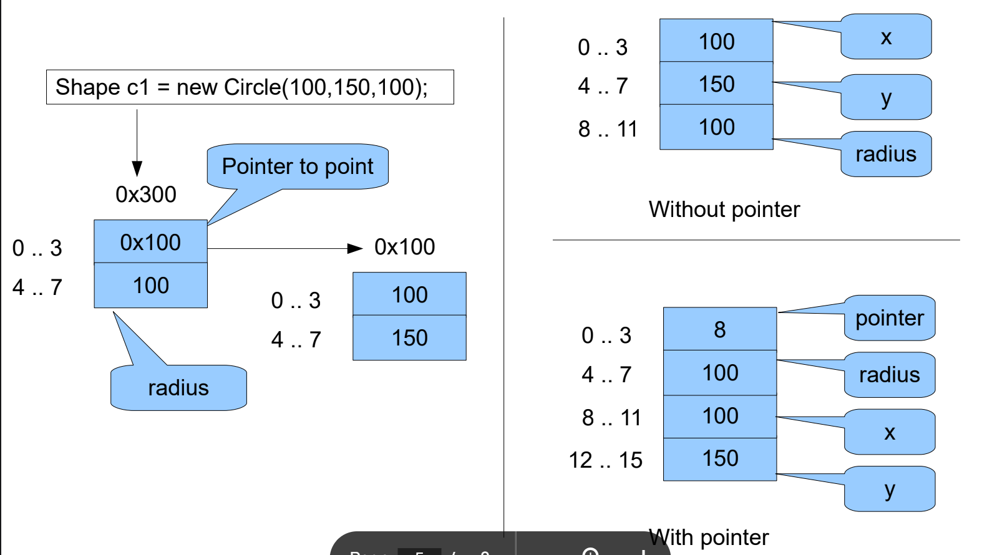

Serialization Formats
● Binary
– More compact and efficient
– Generally architecture dependent
– Not human readable, consequently secure from tampering
– Byte ordering / Memory layout based as well as independent
● Text-based
– More bloated but compression techniques can be applied
– Mostly architecture independent
– Human readable, more flexible but prone to tampering
– Examples : XML, JSON, etc.
to write one action listener for 4 buttons: (past paper question)
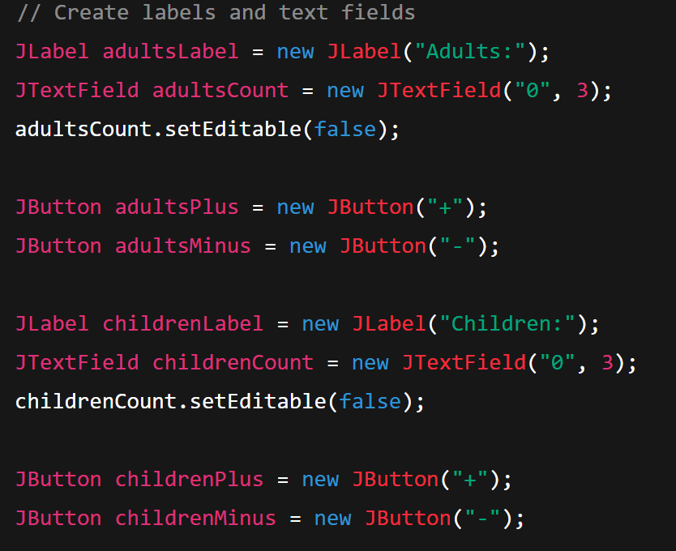
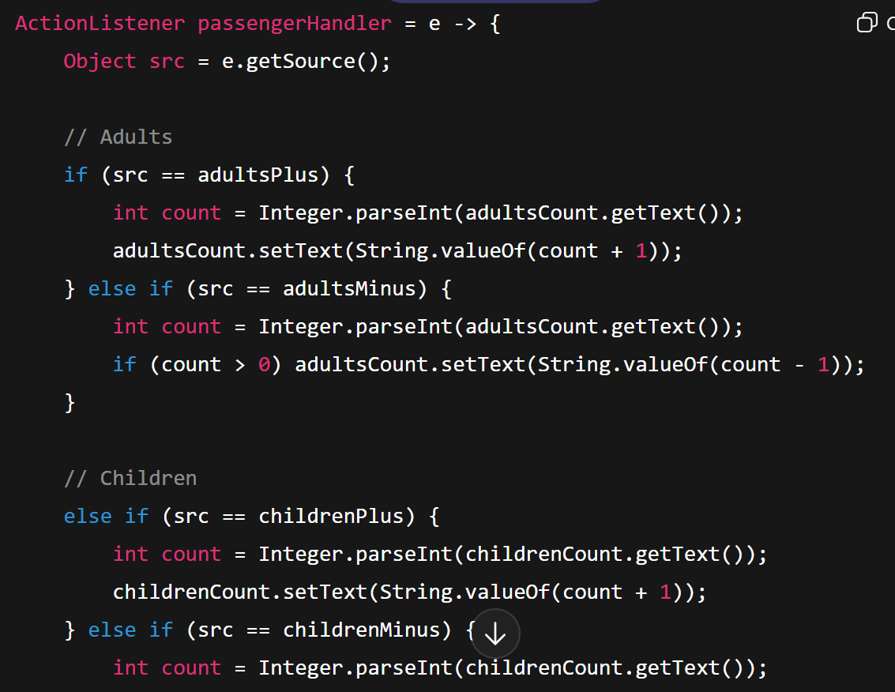
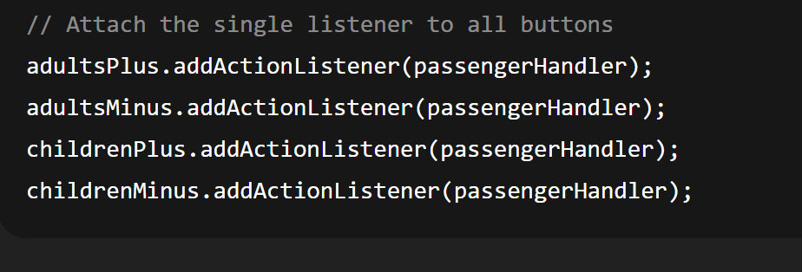
Or:
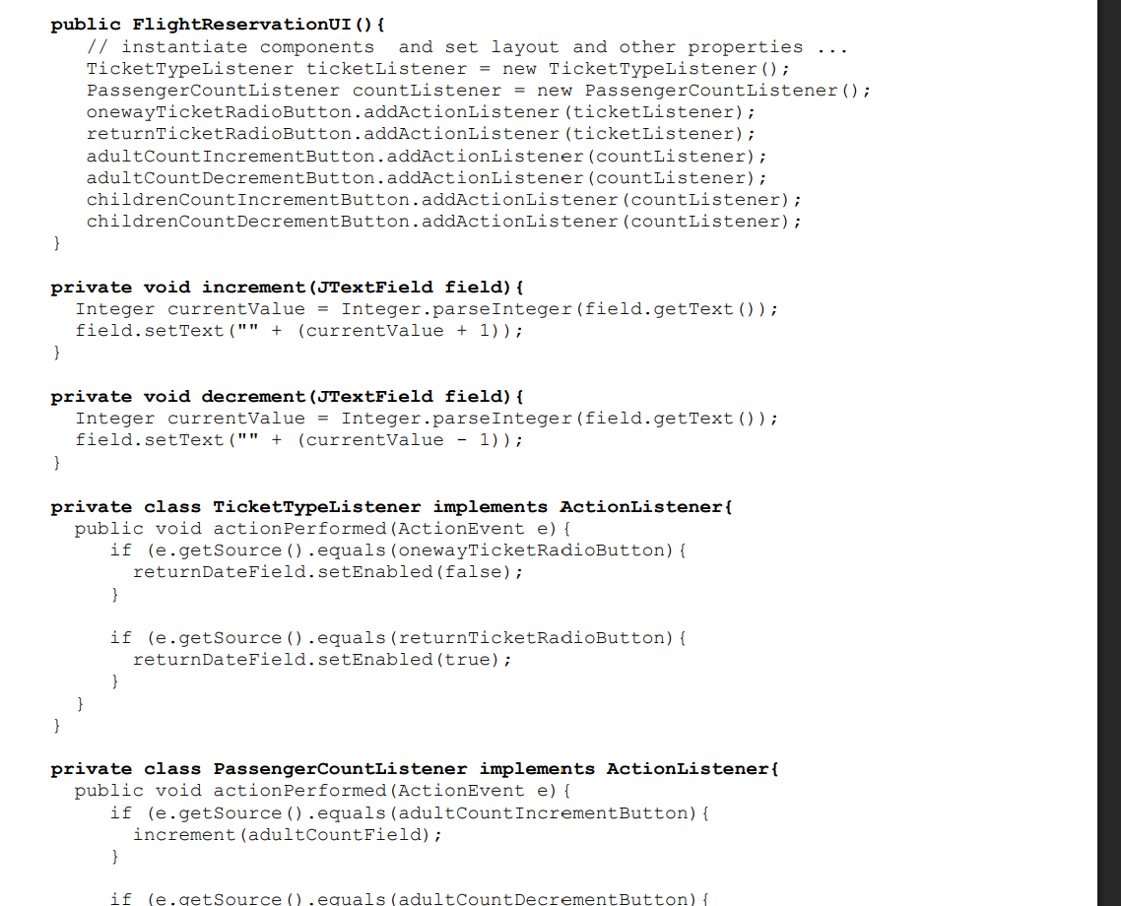
Joptionpane:
JOptionPane.showMessageDialog(null, "Flight booked successfully!");
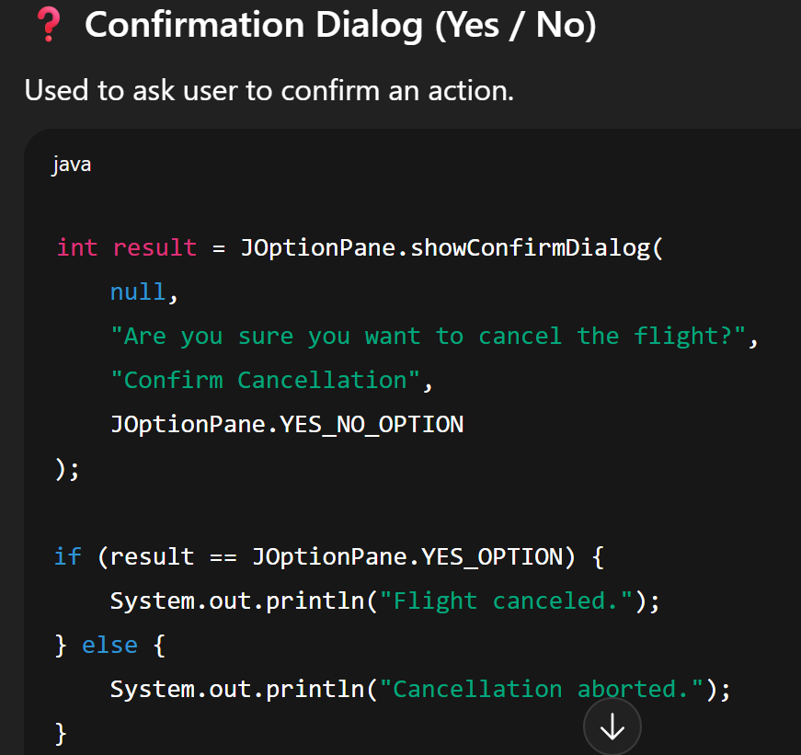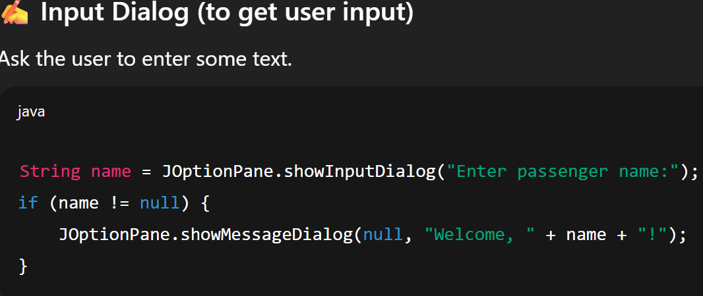
Multithreading
From book:
A Swing programmer deals with the following kinds of threads:
- Initial threads, the threads that execute initial application code. Their most essential job is to create a Runnable object that initializes the GUI and schedule that object for execution on the event dispatch thread.
- The event dispatch thread, where all event-handling code is executed. Most code that interacts with the Swing framework must also execute on this thread. Tasks on the event dispatch thread must finish quickly; if they don't, unhandled events back up and the user interface becomes unresponsive.
- Worker threads, also known as background threads, where time-consuming background tasks are executed.
Sir’s notes:
Monitor: is a high level locking structure. Using locks u might end up with deadlocks, so monitor ensures u dont.
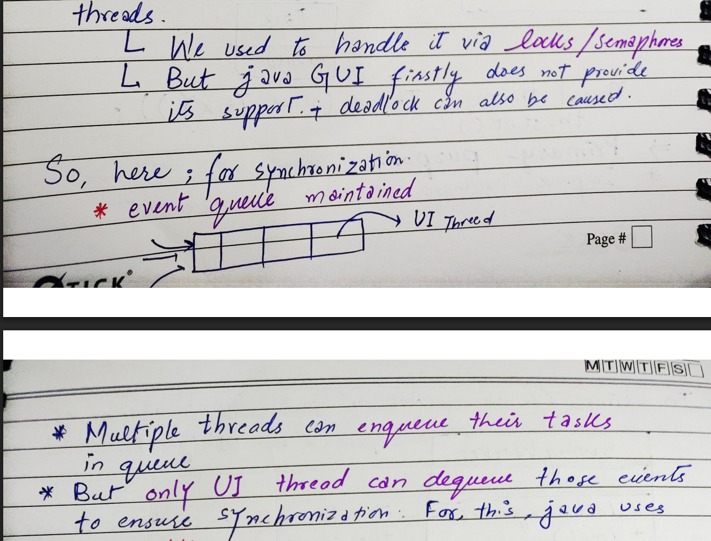
Threads are lightweight processes. because they share memory and resources, making them faster and cheaper than full processes. Their purpose is to run tasks in parallel and keep programs fast and responsive. (this was repeated by sir MULTIPLE TIMES)
Thread And Runnable
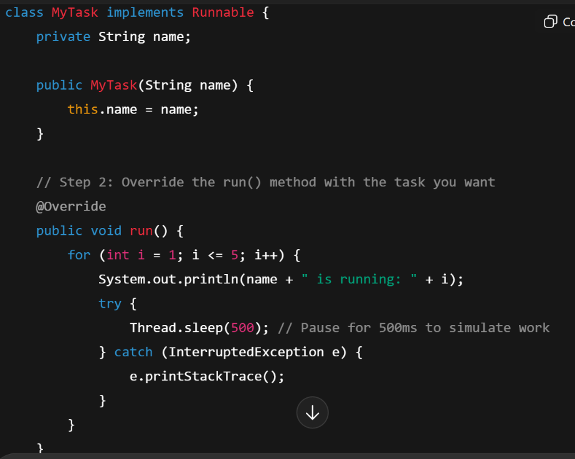

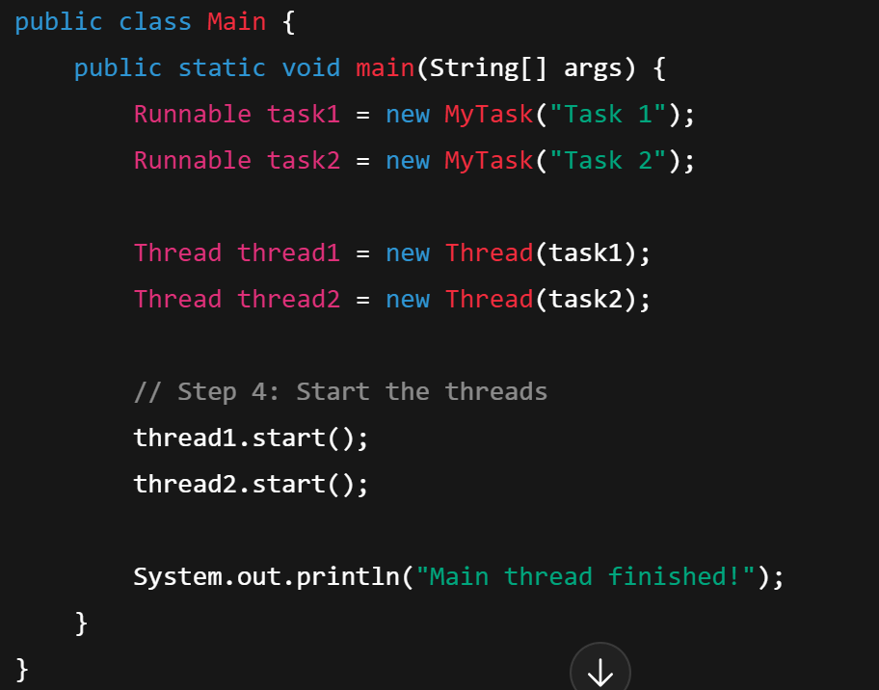
SYNCHRONIZATION (Producer Consumer)
Creating processes:
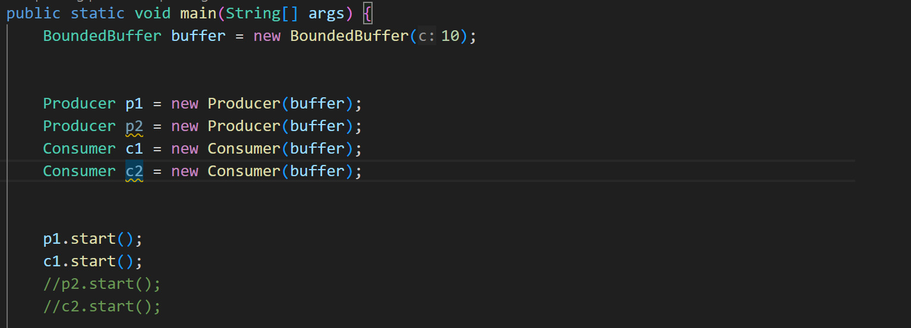
Buffer synchronization:
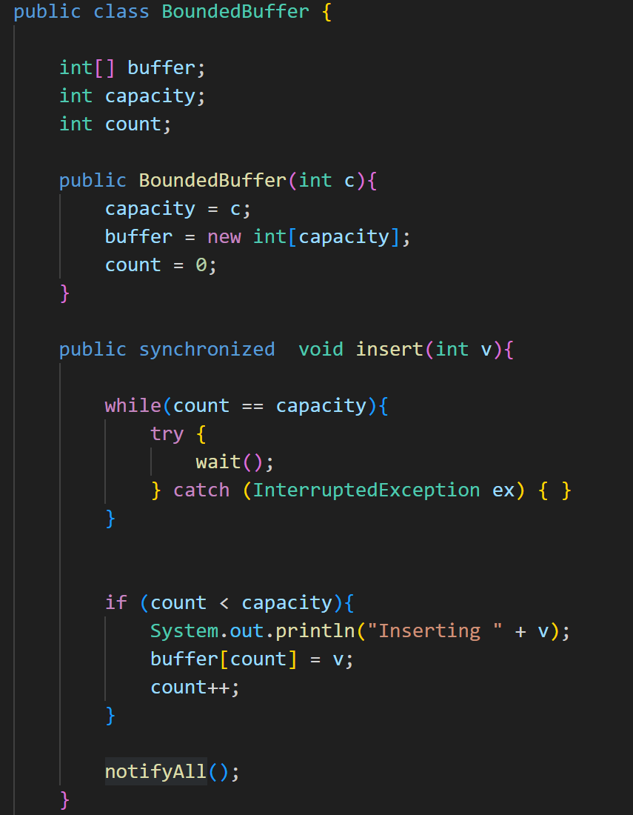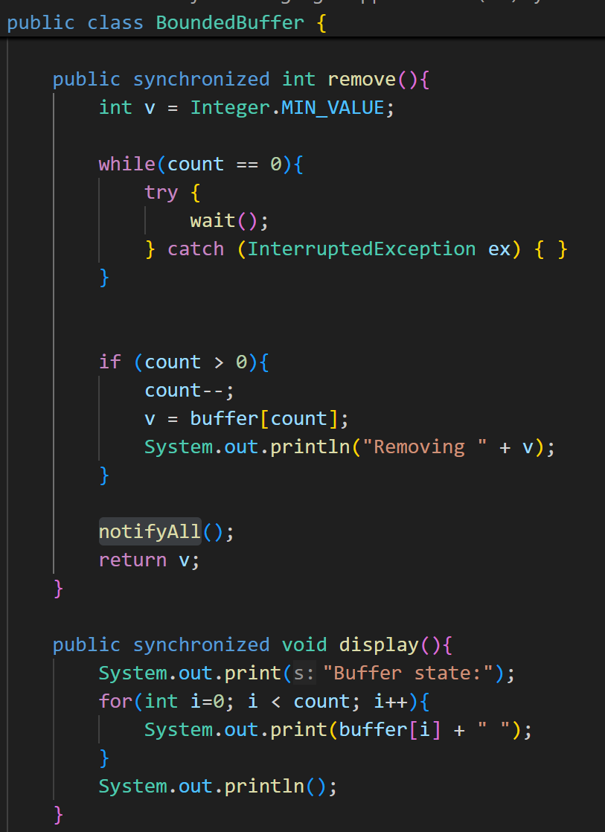
Consumer:
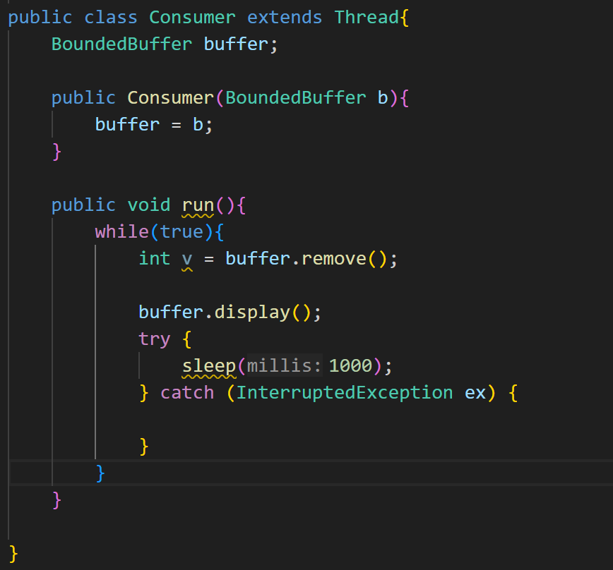

Multithreading in GUI

SwingWorker Code

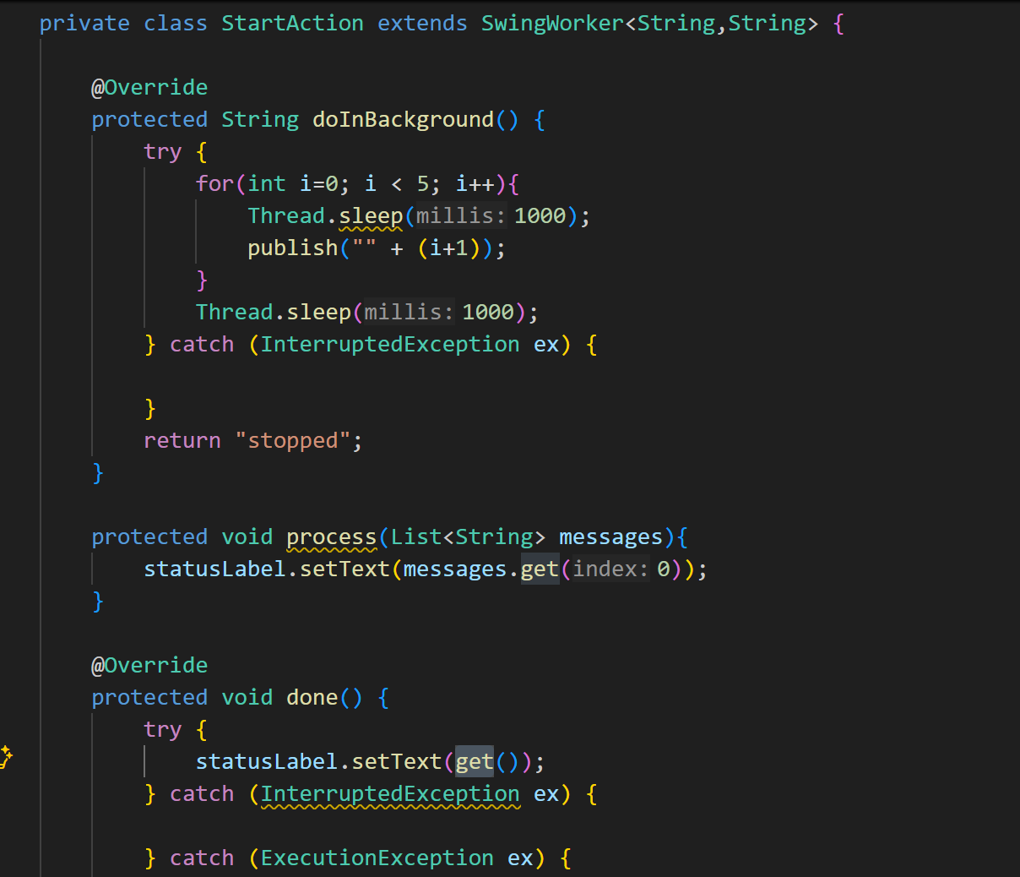
Call this in same class
• statusLabel.setText() is called only in process() and done().
• Avoids freezing UI and race conditions by updating only on EDT.
EDT = Event Dispatch Thread
👉 It is a special thread in Java Swing that:
- Draws the UI
- Handles button clicks
- Updates labels, text fields, tables, etc.
ALL Swing UI updates must happen on the EDT.

Method | Purpose
doInBackground() | Long-running task on background thread
publish() | Sends intermediate results to process()
process(List<>) | Runs on EDT, updates UI with intermediate results
done() | Runs on EDT, retrieves final result with get()

QUIZ QUESTION (SwingUtilities)
Use thread and runnable to call a download function in the event listener of a button download. If download successful, print a success msg on jframe else print failure.

Solution:
public class DownloadApp extends JFrame {
private JButton downloadButton;
private JLabel statusLabel;
public DownloadApp() {
downloadButton = new JButton("Download");
statusLabel = new JLabel("Status: Idle", SwingConstants.CENTER);
// add button and label to frame
// Button listener
downloadButton.addActionListener(new ActionListener() {
@Override
public void actionPerformed(ActionEvent e) {
statusLabel.setText("Status: Downloading...");
// Run download in a background thread
Thread worker = new Thread(new Runnable() {
@Override
public void run() {
boolean success = download(); // your download function
// Update GUI safely using invokeLater
SwingUtilities.invokeLater(new Runnable() {
@Override
public void run() {
if (success) { statusLabel.setText("Download successful!");}
else { statusLabel.setText(“Download failed!”); }
} //end of run
}); //end of invokelater
} //end of run
});//end of runnable of worker
worker.start();
}
}); // end of action listener
}

private boolean download() {
try {
Thread.sleep(3000); // 3 seconds
// Simulate success/failure
return Math.random() > 0.2; // 80% chance success
} catch (InterruptedException e) {
return false;
}
}
//main function to call download
public static void main(String[] args) {
SwingUtilities.invokeLater(() -> {
new DownloadApp().setVisible(true);
});
}
}
// in java u can only extend one single class but can implement many

JAR FILES (Java Archive Format)
Allows bundling multiple (class) files into a single archive
Can be used as a library or as an executable (through a manifest file)
Can reference other JAR files on the program's class path
Uses jar tool (part of JDK) for creating the archive
Manifest file
Part of the jar file
Provides meta information regarding the jar file
Generally used to specify application's entry point (i.e. main class) and other classes / jars on the classpath
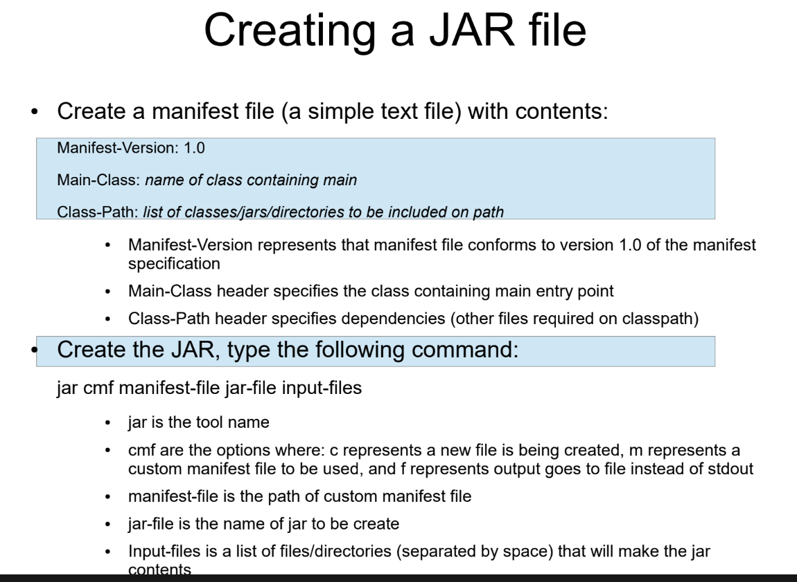

Signing and verification
1. Ensures integrity of your distribution
2. Process
– Vendor signs the JAR file using her digitial signatures (based upon private key)
– Signed JAR contains necessary signature (digest and public key certificate information)
– User can verify the integrity of the signed file by matching the digest (using public key)
Process of verification: encrypt using private key, the decrypt using public key.
3. Tools
– keytool: for generating public and private keys
– jarsigner: for signing and verification
!! Asymmetric: different keys for encryption and decryption.
!!symmetric: same keys
Slides to take a look at:
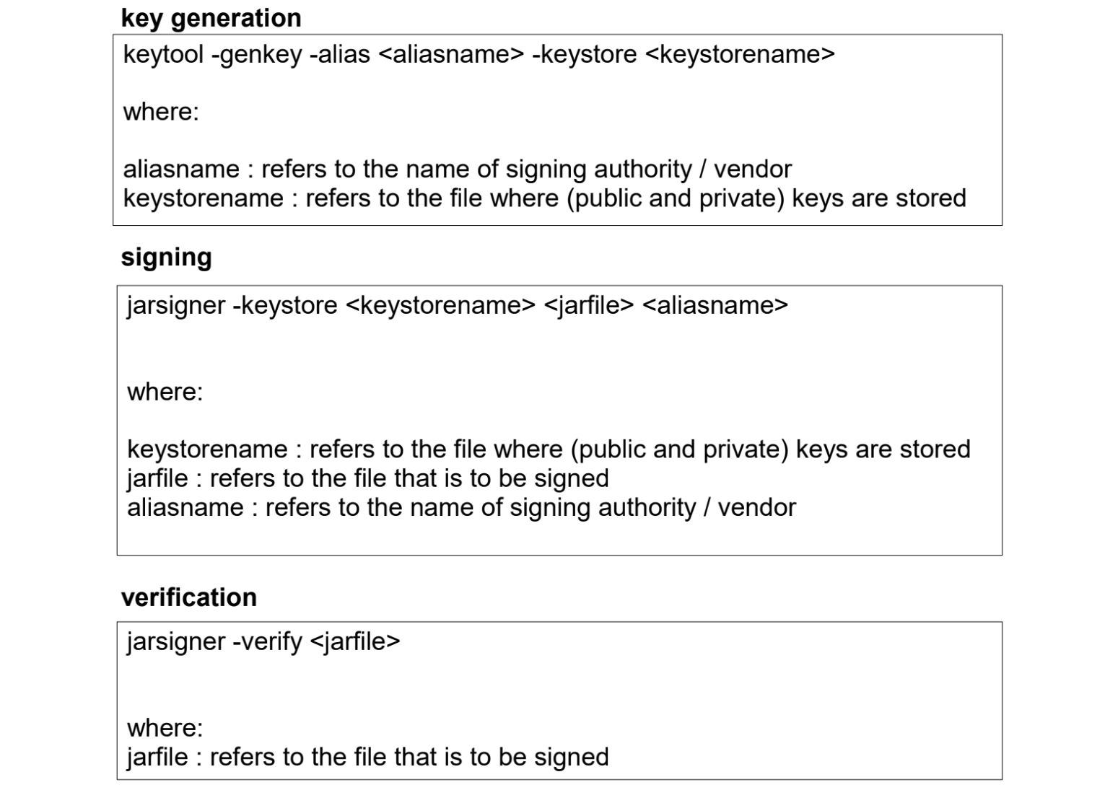
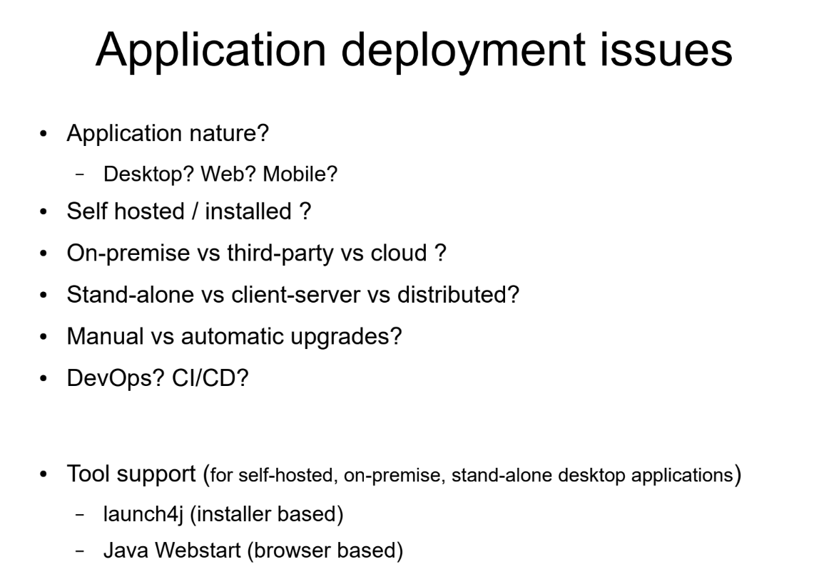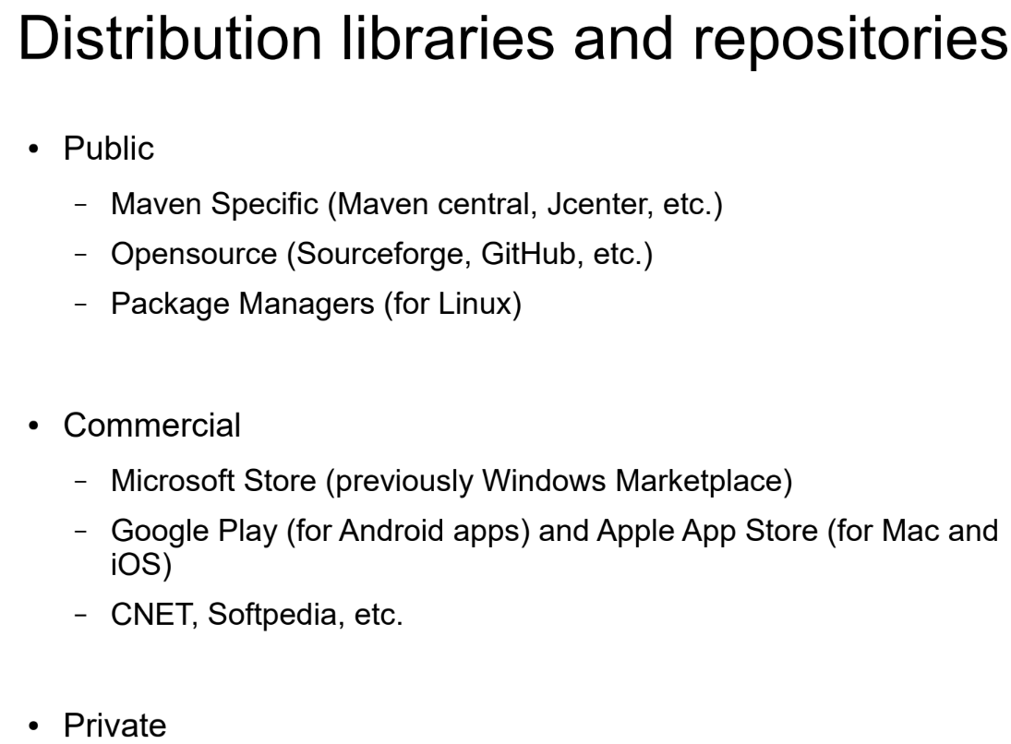
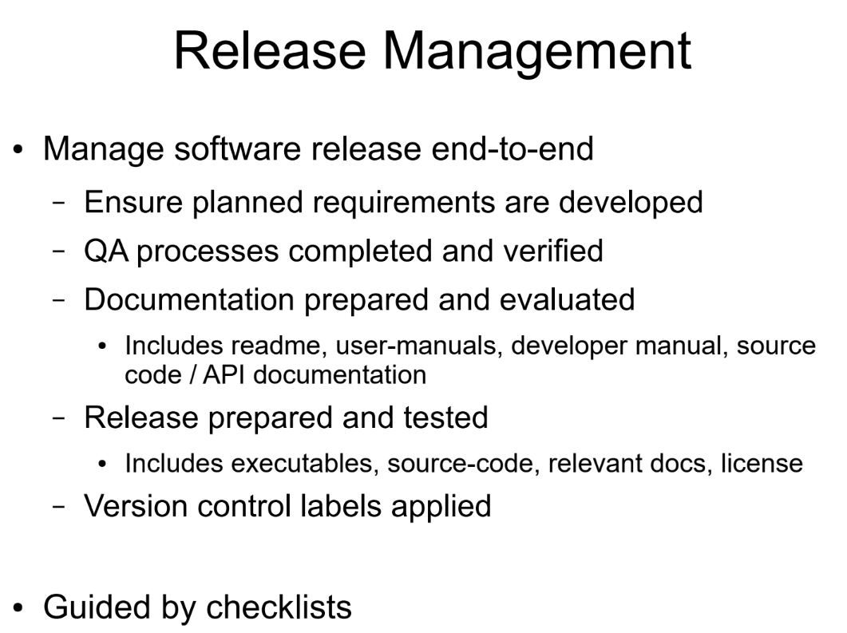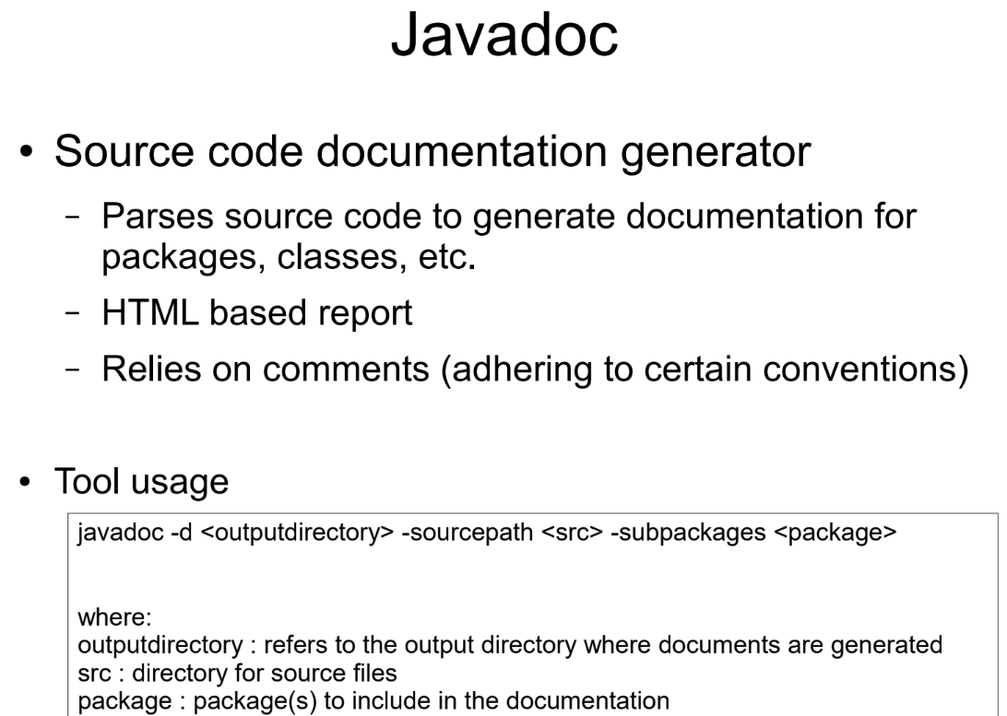

JAVA BEANS: A Java Bean is a simple Java class used to store data. It provides Component-Based development and provides resuability and interoperability.
📦 What does a Java Bean contain?
A Java Bean usually has:
- Private variables (data)
- Public getters and setters (to access data)
- A no-argument constructor
🧠 Why use Java Beans?
- To store data safely
- To share data between classes

📏 Java Bean Rules (Easy)
✔ Class must be public
✔ Variables must be private
✔ Getter & Setter methods
✔ Must have no-argument constructor
✔ Usually Serializable (optional but common)
@Entity used for mapping classes to tables.

🌐 What is Socket Programming?
Socket programming lets two programs talk to each other over a network (like the internet).
• One person calls → server
• Other person answers → client
• They send and receive messages

🧩 What is a Socket?
A socket is an endpoint (connection point) used to send or receive data.
• Phone number + phone = socket
• IP address + port = socket

🖥️ Client–Server Model
- Server waits and listens
- Client connects to the server
- They exchange data

Server side code:
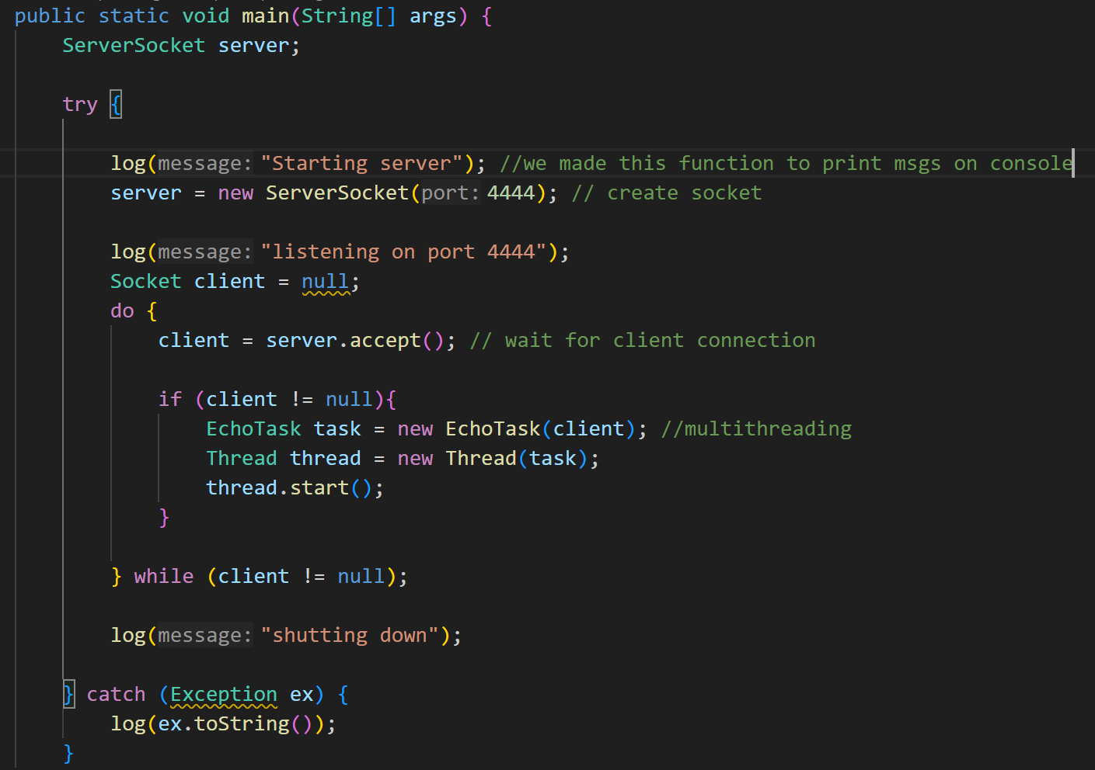
private static void log(String message){ System.out.println(message); }
Client side code:
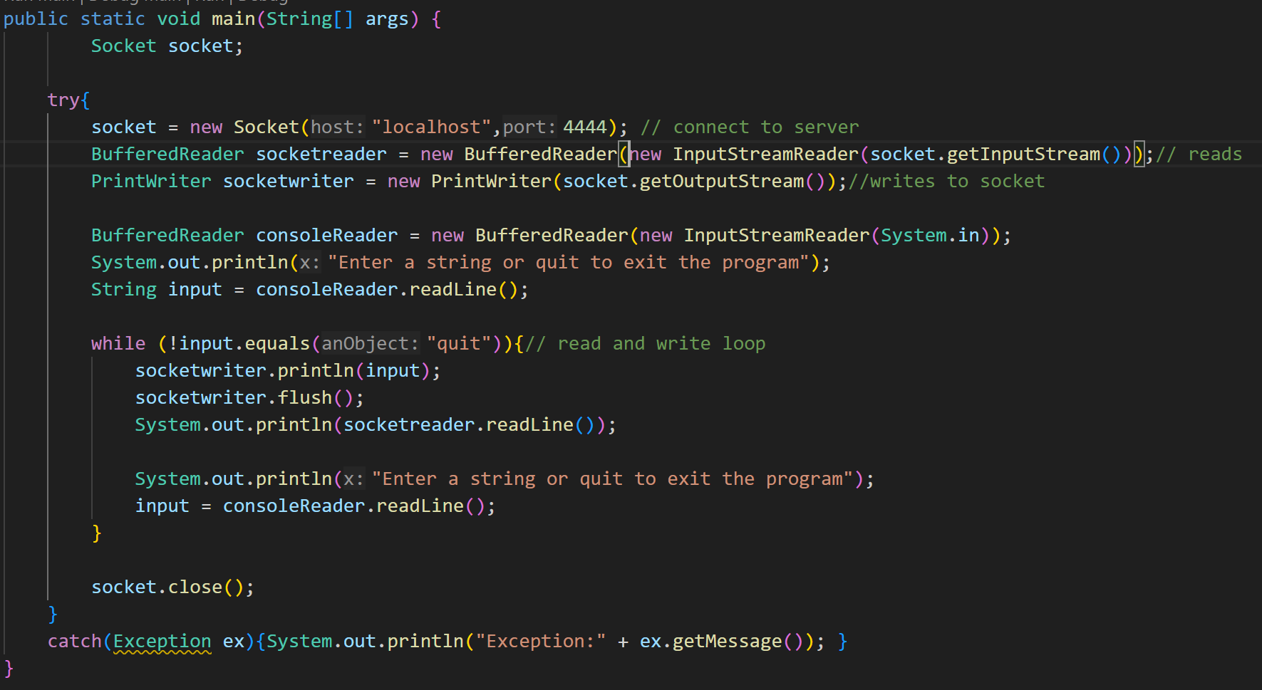
Task code:
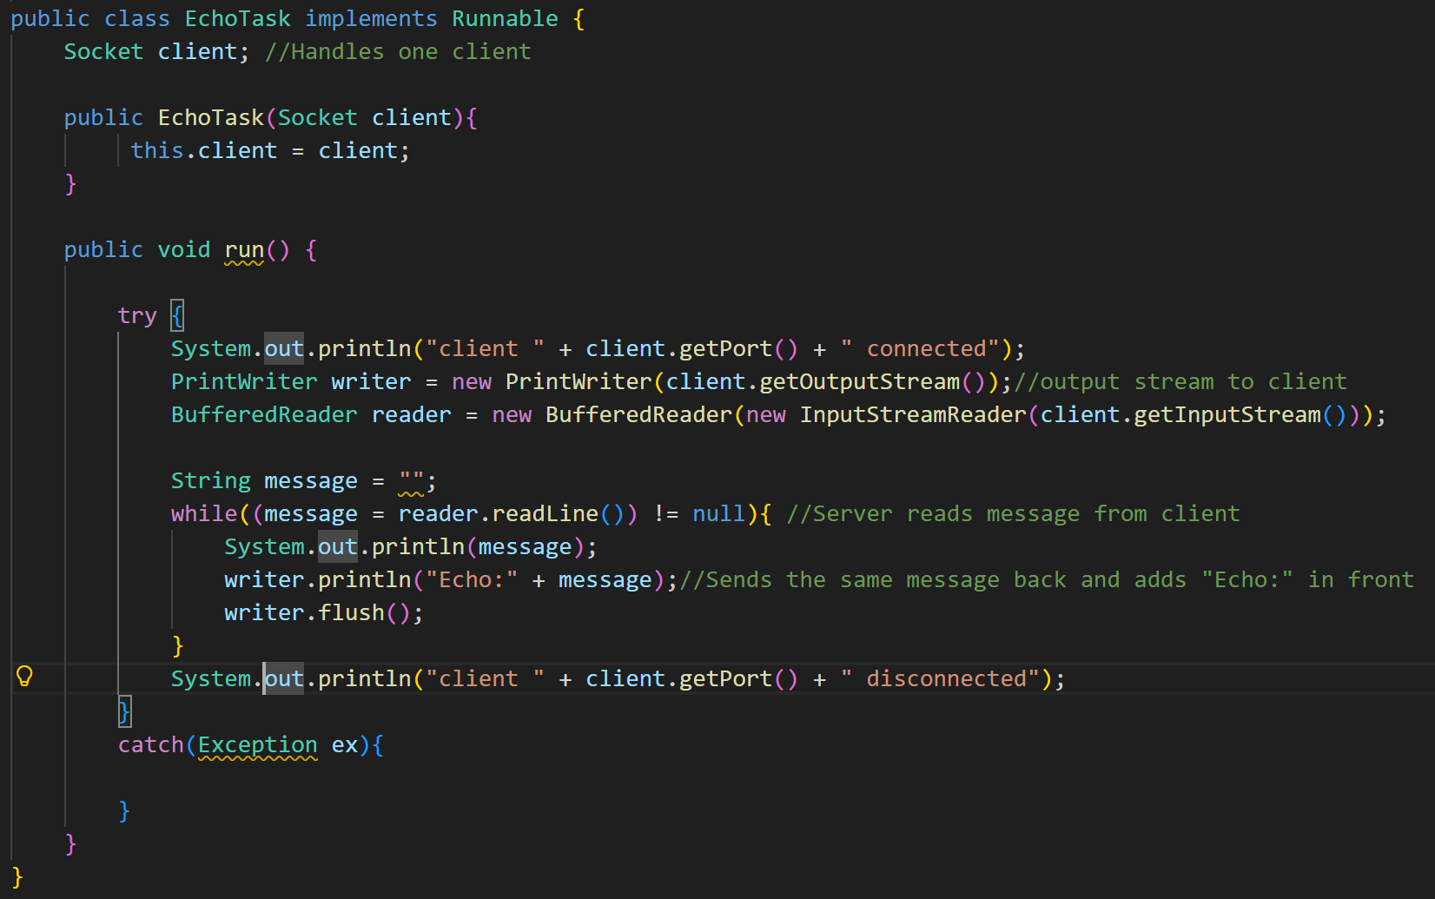---------

WEB CONNECTIVITY
🌍 What is the Web?
The Web is just a huge collection of information (pages, images, data) available on the internet.
📡 HTTP (Very Important)
HTTP is the language used by client and server to talk.
Think of it like:
- Client: “Give me this page”
- Server: “Here you go”
🔁 Web Services
- Apps can talk to other apps
- Not just browsers
- Data is exchanged automatically
📄 Resource Formats (Types of Data)
Server can send data as:
- HTML → web pages
- JSON → app data (most common)
- XML
- Images
WEBSERVICE CLIENT CODE:
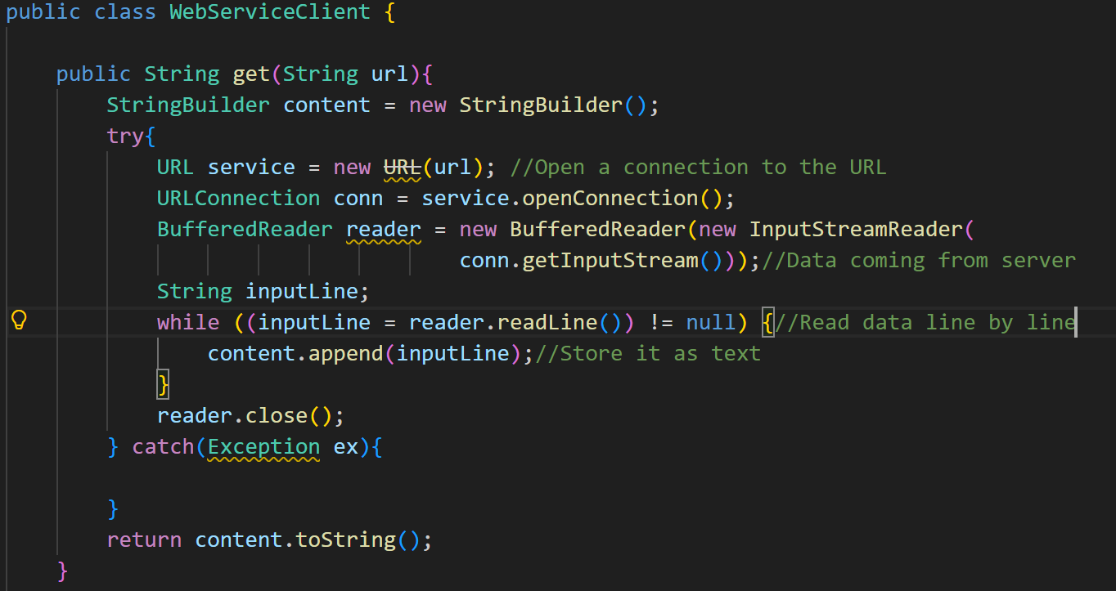
What happens here? (above code)
- Open a connection to the URL
- Read data coming from the server
- Store it as text
- Return the text
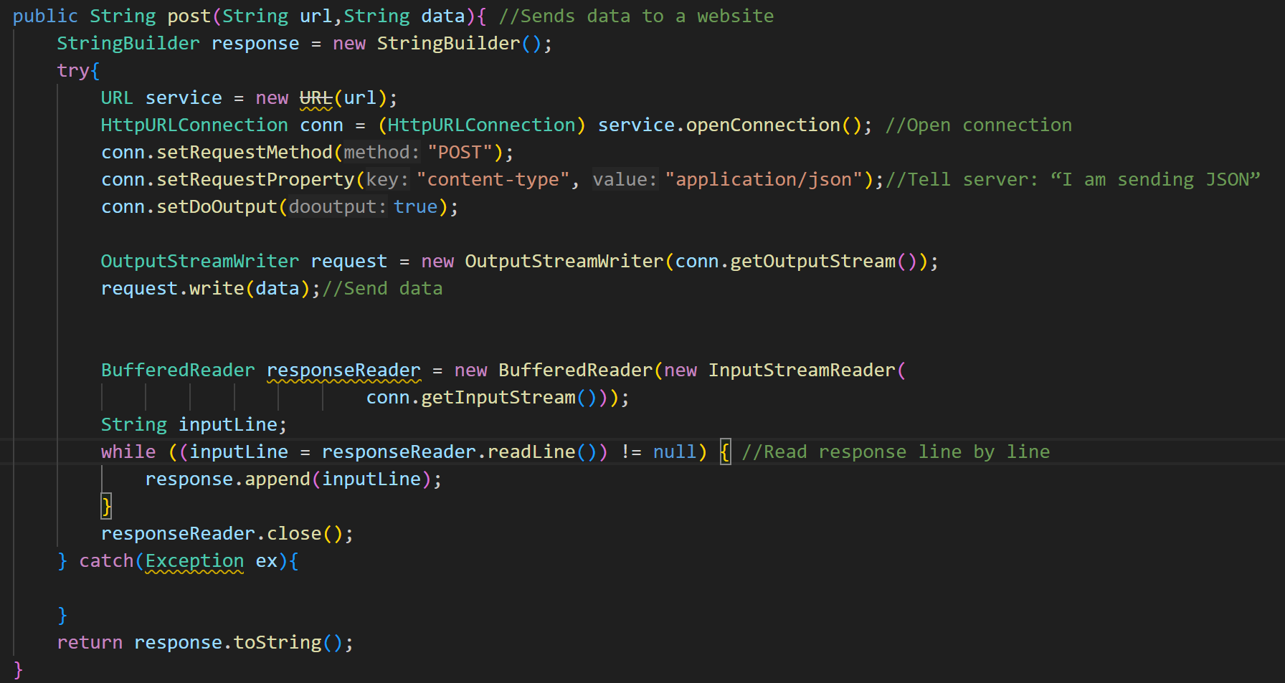

What happens? (above code)
- Open connection
- Tell server: “I am sending JSON”
- Send data
- Read response

MAIN CLASS TO CALL THIS WEBSERVERCLIENT
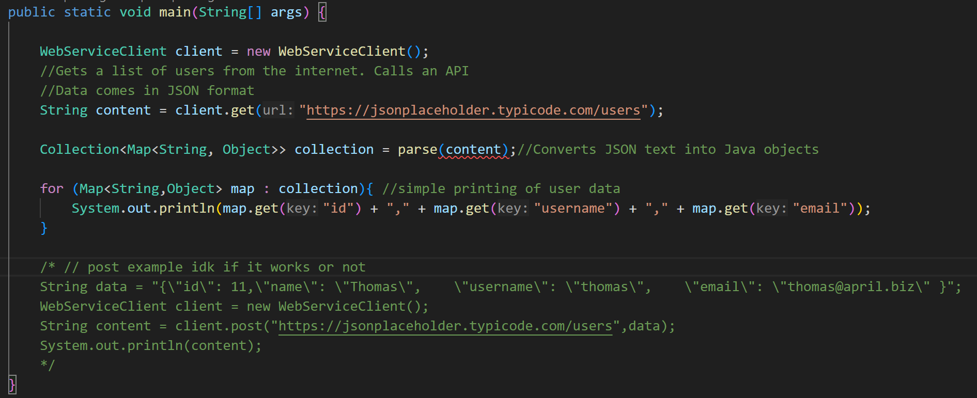
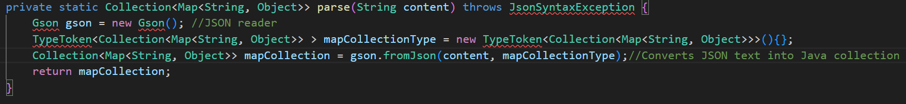

RMI
👉 RMI means:
Call a method that runs on another computer as if it was local.
🧠 Simple idea (super easy)
- Client has numbers
- Server has sorting logic
- Client says:
👉 “Server, please sort my list”
- Server sorts it and sends it back

ISORT CODE (COMMON INTERFACE):
In server code:
public interface ISort extends Remote {
List<Integer> sort(List<Integer> data) throws RemoteException;
}
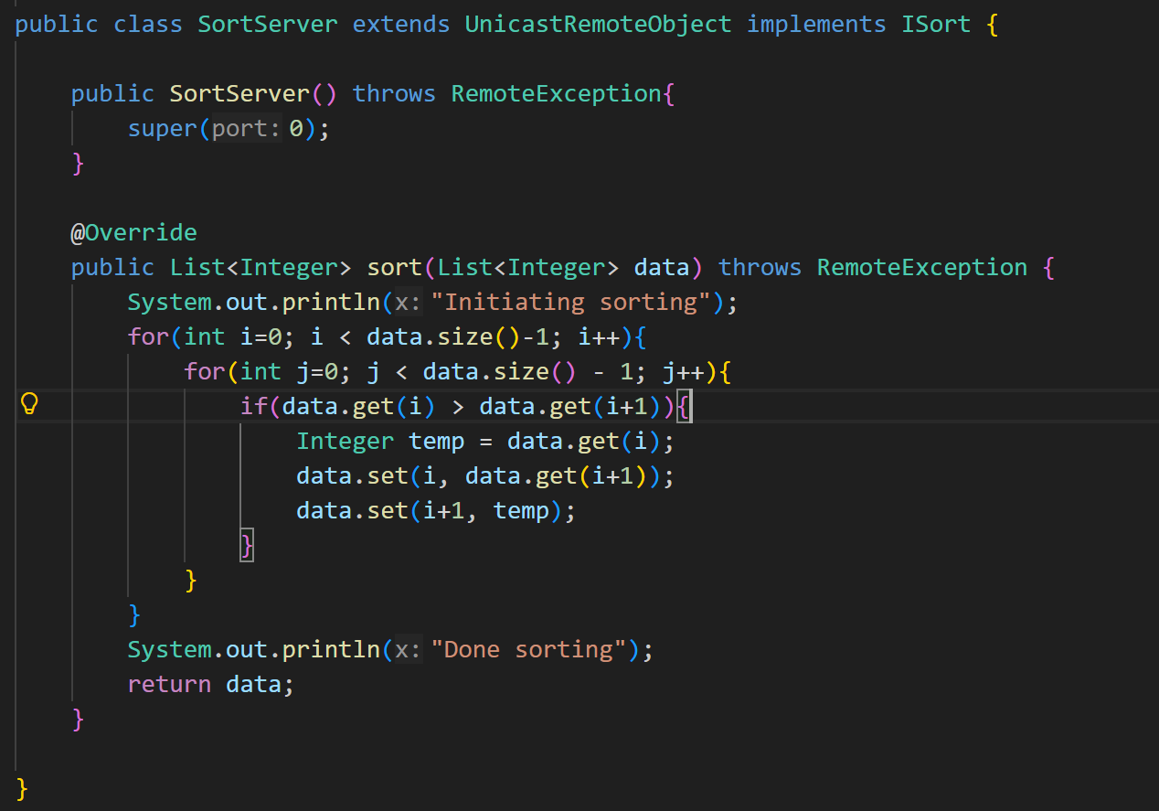
In client code:
public interface ISort{
public List<Integer> sort(List<Integer> data);
}

SERVER SIDE CODE:
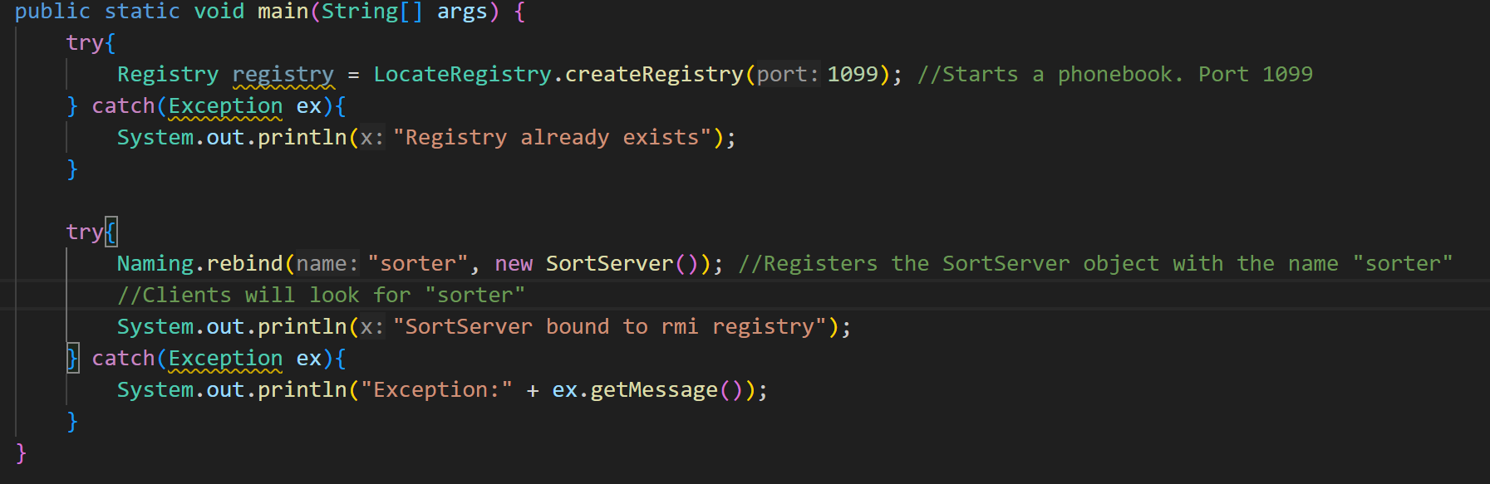
CLIENT SIDE CODE:
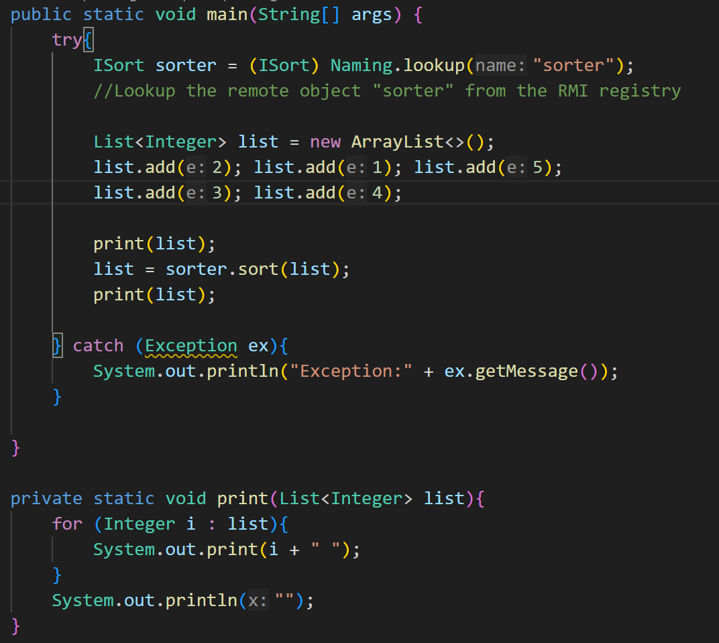
Purpose of rmi?
U dont have to make sockets your self. Rmi is high level work while socket programming was low level.
IMP: RMI uses underlying concept of serialization.

Past paper questions:
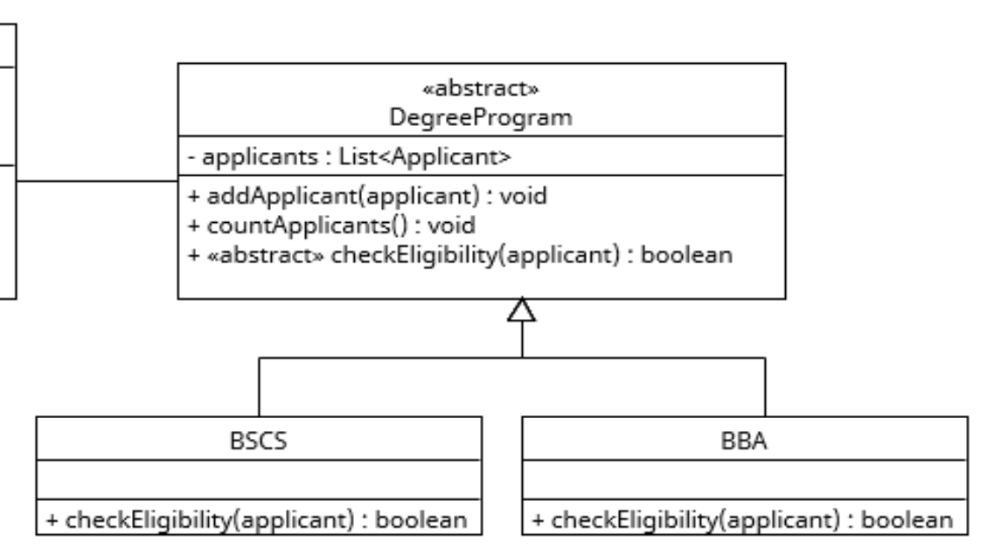
When writing test for addApplicant you cant directly make degreeprogram object but do:
DegreeProgram prog = new BBA(); // or any other concrete subclass e.g. BSCS
----------------------------
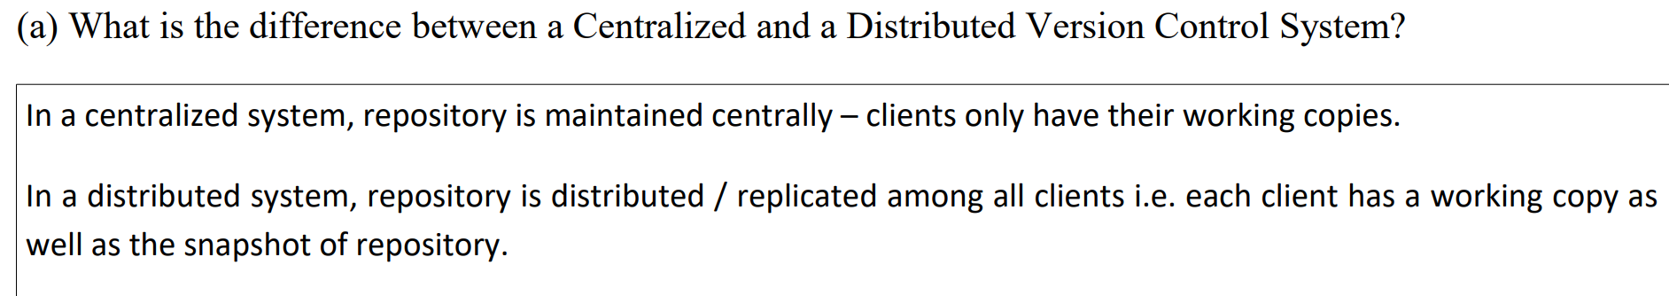
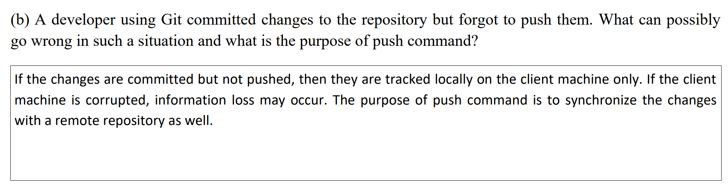
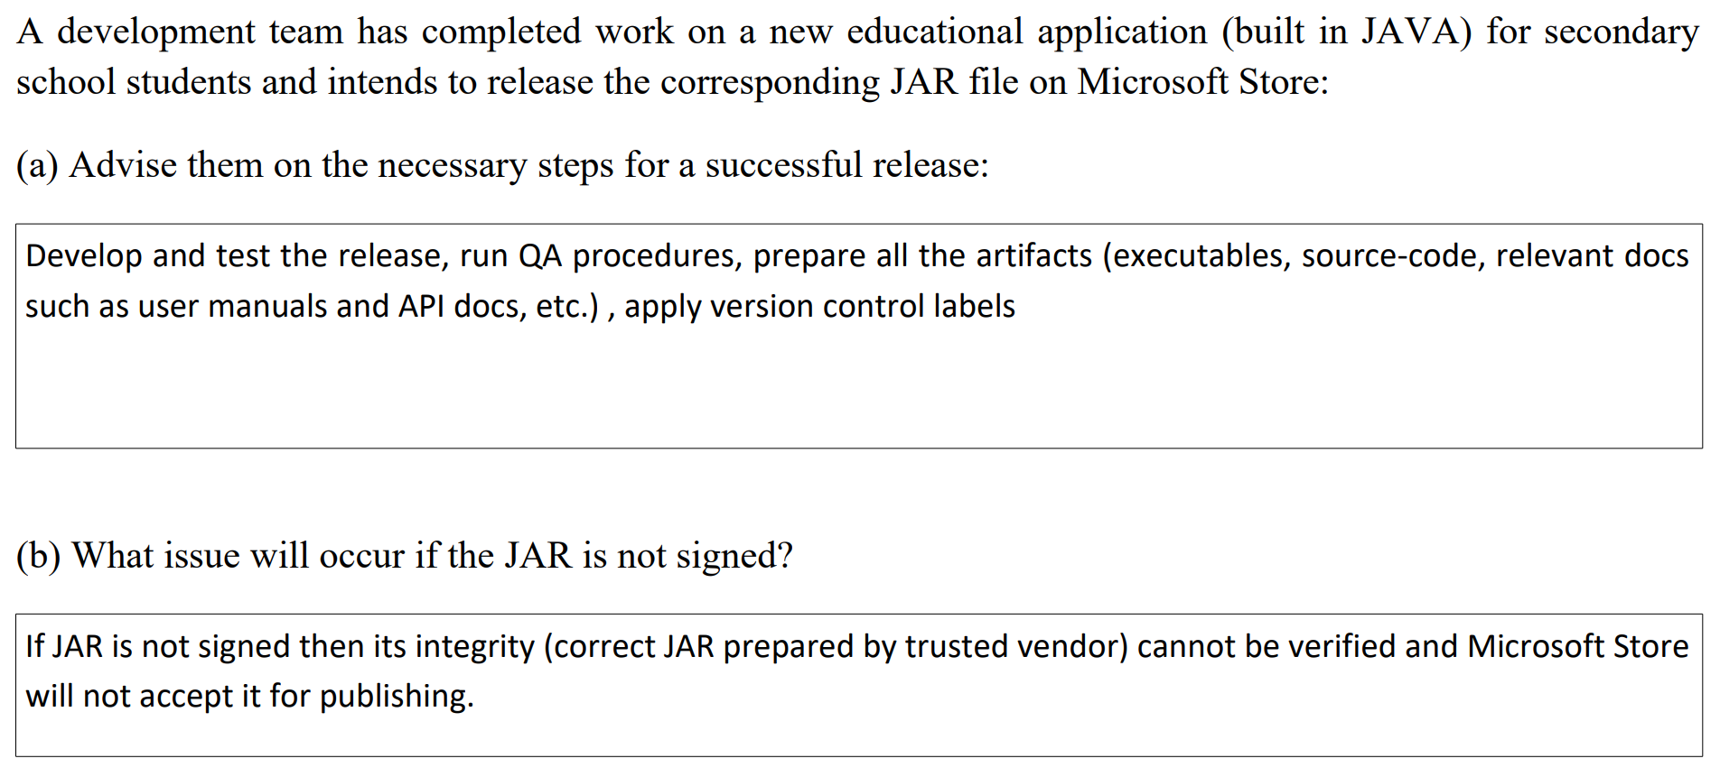
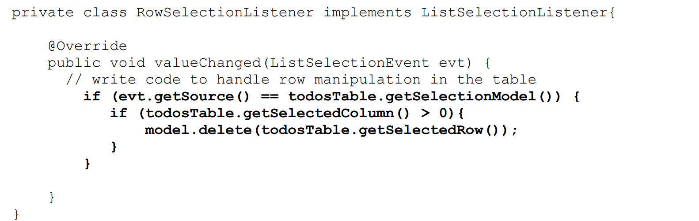
Searching in default table model:
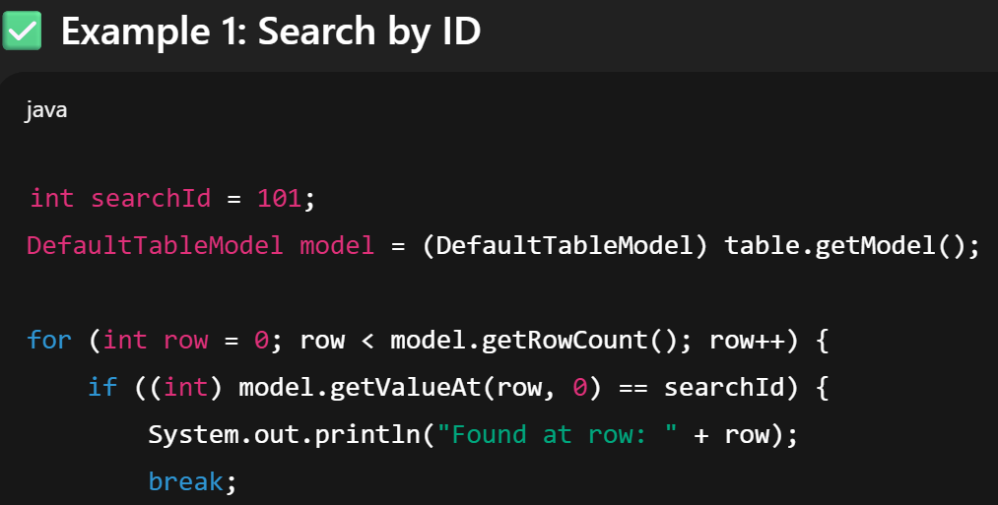
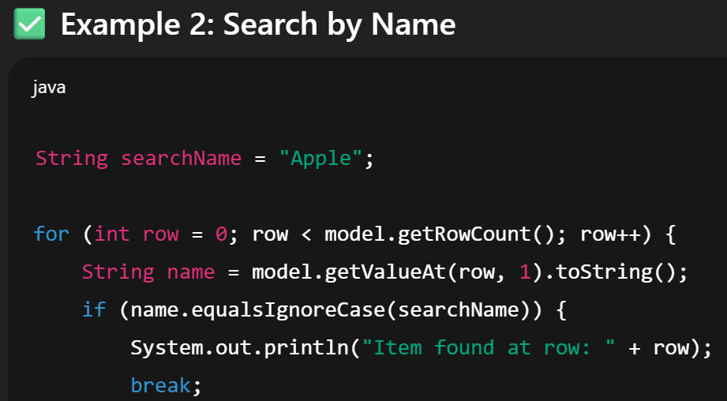
Searching in custom table:
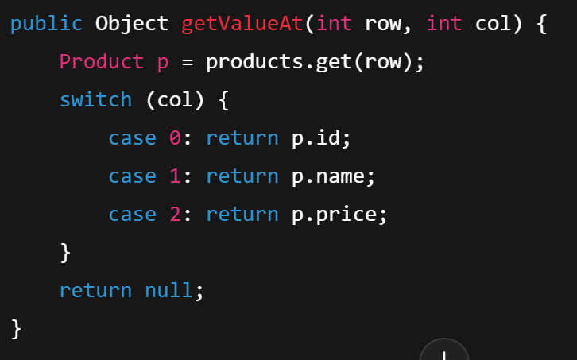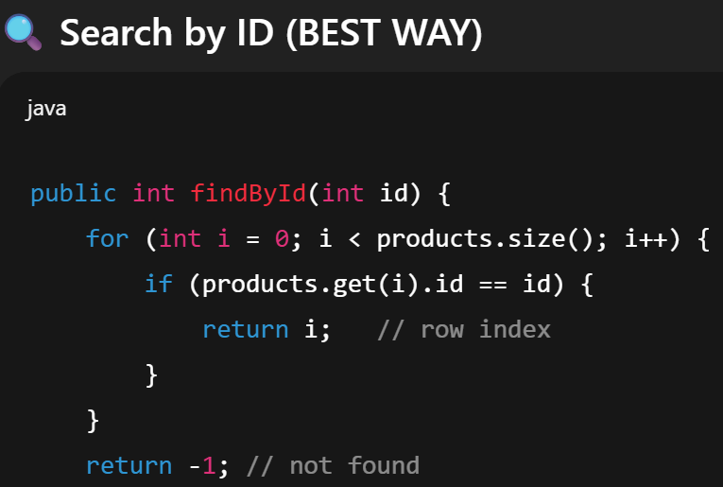

Socket programming codes:
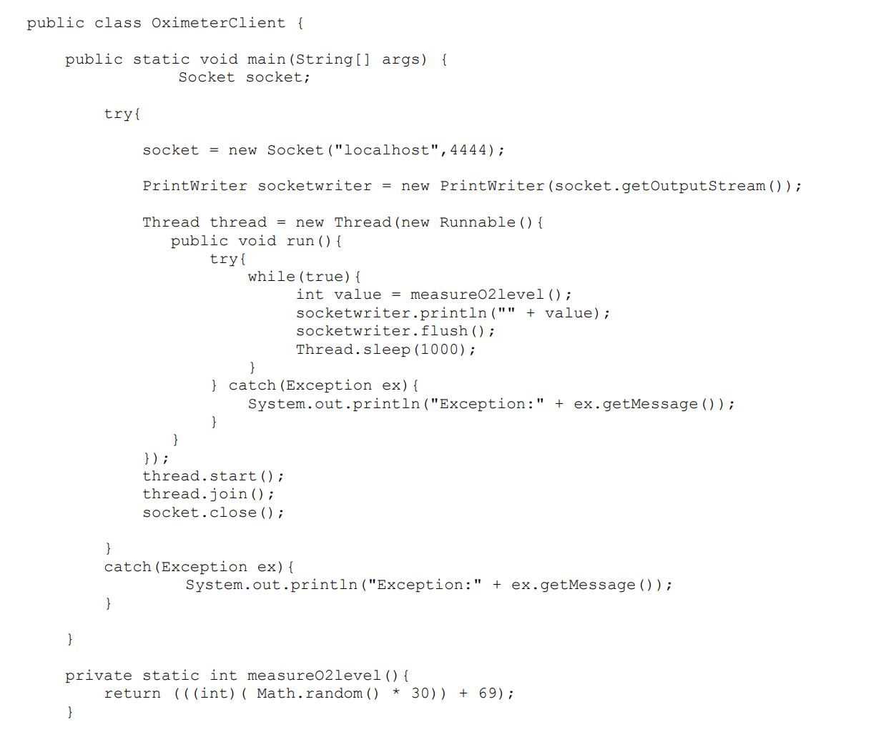
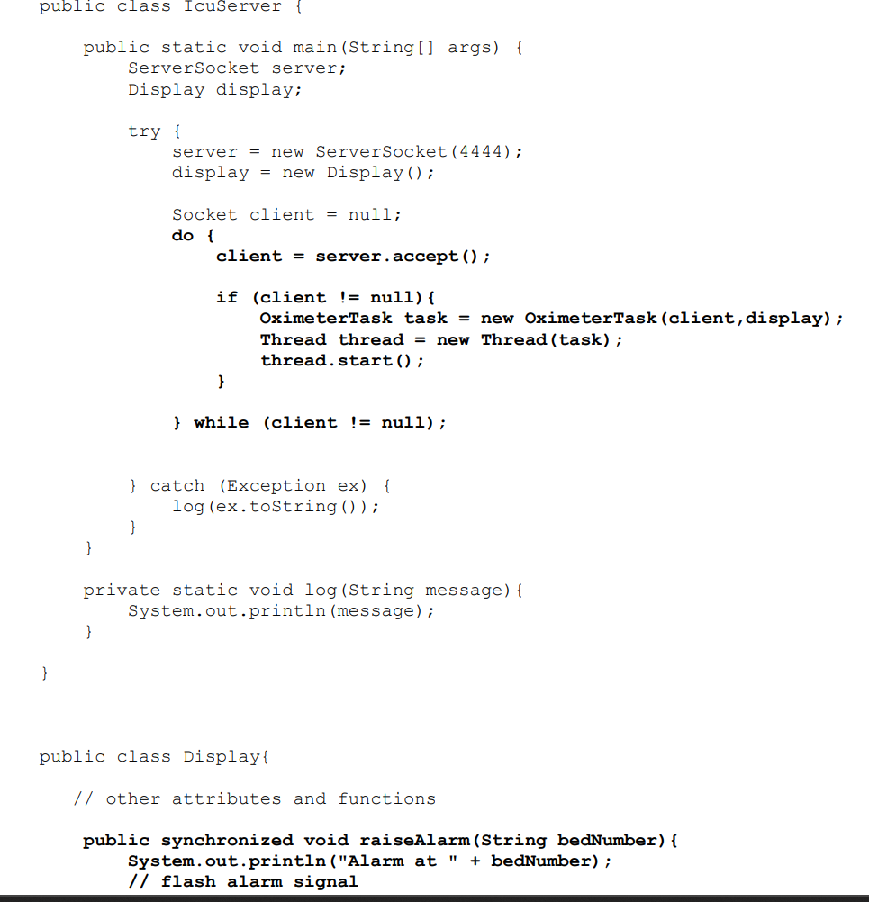
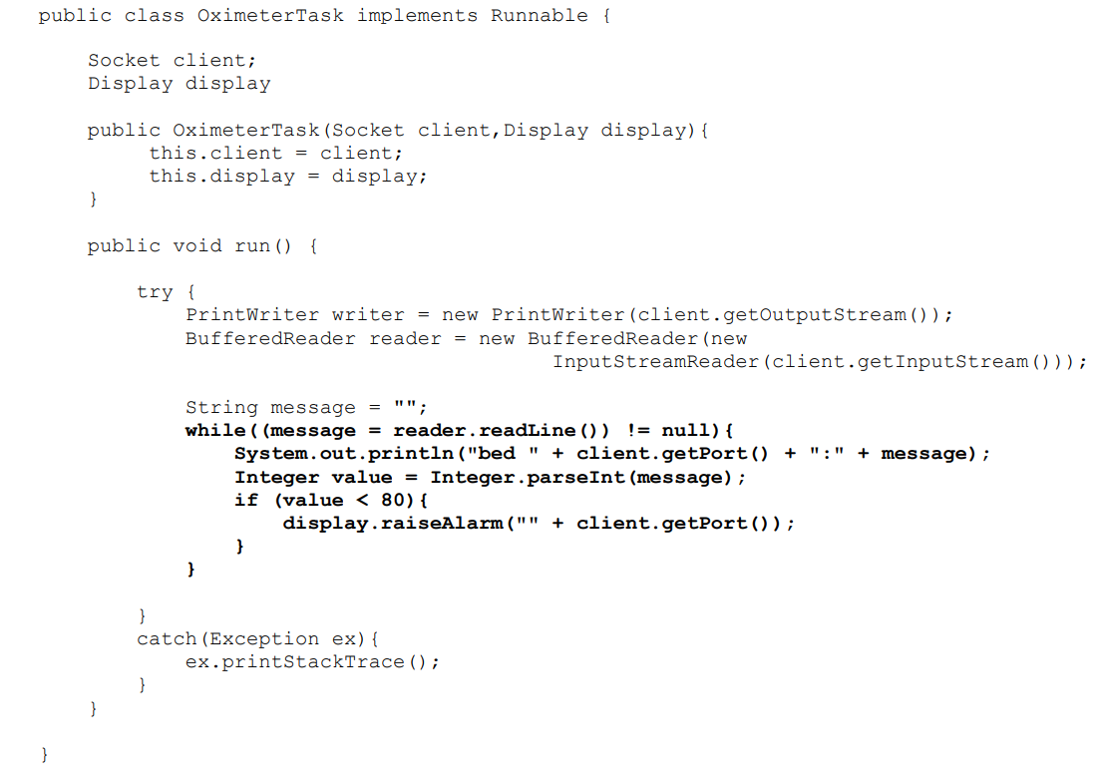

What is the purpose of using tags in Git version control system? Explain in comparison with commit messages and revision numbers.
✅ Purpose of Tags in Git
Tags in Git are used to mark important points in a project’s history, usually:
- Releases (v1.0, v2.0), Stable versions, Milestones
👉 A tag is like a permanent label attached to a specific commit.
Difference:
Feature | Tags | Commit Messages
Purpose | Mark important versions | Describe changes
Permanence | Fixed to a commit | Just text info
Navigation | Easy checkout (git checkout v1.0) | Not used for navigation
Used for releases | ✅ Yes | ❌ No

🔢 Comparison with Revision Numbers
Feature | Tags | Revision Numbers
Readability | Human-friendly (v1.2) | Long hashes (a3f9c2…)
Stability | Fixed | Hard to remember
Meaning | Semantic (release) | No meaning
Use case | Releases & milestones | Internal identification

What problems can occur while.merging one branch to the other and how to handle them?
1️. Merge Conflicts (Most Common)
❓ What happens
- Two branches change the same file
- Or the same line differently
Git doesn’t know which change to keep.
✅ How to handle
- Git marks conflict in file:
<<<<<<< HEAD
code from current branch
=======
code from other branch
>>>>>>> branch-name
- Manually edit and choose correct code
- Save file
2️. Code Breaks After Merge
❓ What happens
- Merge succeeds
- But code does not compile or crashes
✅ How to handle
- Run tests after merging
- Fix bugs
- Commit fixes
3️. Deleted vs Modified File Conflict
❓ What happens
- One branch deletes a file
- Other branch modifies the same file
✅ How to handle
- Decide:
  - Keep file → restore it
  - Remove file → accept deletion
- Then commit decision
4.Uncommitted Changes Block Merge
❓ What happens
- Git refuses merge due to local changes
✅ How to handle
- Commit changes
- Or stash them:

Digital signatures are important during the release distribution process because they ensure trust, security, and integrity of the software being released.
🔐 Why Digital Signatures Are Important
1️.Authenticity (Who made it?)
- Confirms the software was released by the real developer/company
- Prevents fake or malicious releases
👉 Users know the software comes from a trusted source
2️. Integrity (Was it changed?)
- Ensures the software has not been modified
- If even one byte changes, the signature becomes invalid
👉 Protects against tampering during download
3️. Security Against Attacks
- Prevents attackers from inserting malware or backdoors
- Protects users from installing corrupted software
4️. Trust & User Confidence
- Operating systems and package managers show:
  - “Verified Publisher”
  - “Trusted Source”
👉 Users feel safe installing the release
5️. Non-Repudiation
- Publisher cannot deny releasing the software
- Signature is proof of origin
API doc is basically just like java doc. Add comments in files and automatically generate doc.
📘 Significance of Generating API Documentation
API documentation explains how to use an API — its methods, inputs, outputs, and examples.
⭐ Why API Documentation is Important
1️. Easy to Understand
- Helps developers quickly understand how the API works
- Reduces confusion and mistakes
2️. Saves Time
- No need to read source code
- New developers can start using the API faster
3️. Better Integration
- Other applications can easily connect and use the API
- Ensures correct usage of endpoints and methods
4️. Improves Maintenance
- Makes future updates easier
- Acts as a reference for debugging and enhancements
5️. Standard Communication
- Serves as a contract between API provider and users

JAVAFX
Complete Flow (VERY IMPORTANT)
JavaFX always runs like this:
Application → Stage → Scene → Parent → Nodes
1️. Stage (Window)
🪟 What is Stage?
- Stage is the main window of your app
- Without a Stage → nothing appears
2️. Scene (What’s inside the window)
🎬 What is Scene?
- Scene holds all UI content
- A Stage can have only ONE scene at a time
3️. Node (UI Components)
🧩 What is a Node?
- Every visible thing is a Node
- Buttons, Labels, TextFields = Nodes
4️. Parent (Container for Nodes)
📦 What is Parent?
- Parent can contain other nodes
- Used for layout
--------------

